My node git credentials

Username- hemanthkaravalla

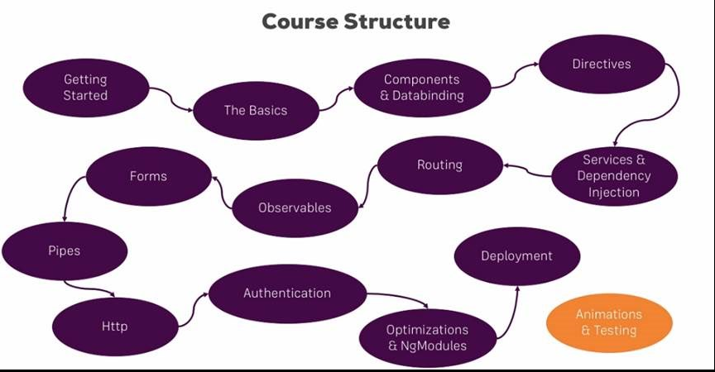

Specifically you will learn:

* + Which architecture Angular uses
  + How to use TypeScript to write Angular applications
  + All about directives and components, including the creation of custom directives/ components
  + How databinding works
  + All about routing and handling navigation
  + What Pipes are and how to use them
  + How to access the Web (e.g. RESTful servers)
  + What dependency injection is and how to use it
  + How to use Modules in Angular
  + How to optimize your (bigger) Angular Application
  + We will build a major project in this course
  + and much more!

Course started on may 22nd,should complete around june 18 may june 30th.

Start date -May 22nd

End date -June 18 th

Duration - 30 days

**1 week- 6:30 hrs. -revision on Thursday**

Basics, components and data binding, Directives, services, dependency injection, Type Script introduction, Course Roundup, Angular changes and new features.

**2 week-6:30 hrs. -revision on Thursday**

Routing, observables, forms **.**

**3rd week-6.30 hr -revision on thursday**

Pipes, Making HTTP requests, authentication and route protecting in angular app, using angular modules and optimizing apps, deploying and http client, Custom project and work flow setup.

**4th week-6.30 hr -revision on Thursday**

|  |  |  |  |  |  |
| --- | --- | --- | --- | --- | --- |
| topic | No of lectures | days | Time required  (30 hrs) | Examples practice time | Things to revise |
|  |  | |  | | --- | | **1 week- 300min -6:30 hrs**  Basics,components and data binding,Directives,services,dependency injection, Type Script introduction, Course Roundup, Angular changes and new features. | |  |  | -Typess of data binding and syntaxes. |
| Getting started | 10 |  | 36 min |  |  |
| The basics | 33 | Wednesday | 1.53 hrs |  | -internal and external template and styling  -String Interprolation  -Property binding,  -event Binding  -Two way data Binding  -Directives(ng)  - |
| Course project basics | 18 | Thursday | 1.03 hrs |  | -Creating a Recipie model,Adding Contents to the recepie Components,outputting the list of recepies with ngfor ,Displaying Recepie details. |
| debugging | 3 |  | 12.09min |  |  |
| Components and data binding deep dive | 20 | Friday | 1.24 hrs |  |  |
| Course project component and data binding | 6 | Saturday | 31 min |  |  |
| Directives deep dive | 11 | Saturday | 47 min |  |  |
| Project directives | 1 | Sunday | 6.25min |  |  |
| Using services and dependency injection | 12 | Sunday | 43 min |  |  |
| Course project services and dependency injection | 8 | sunday | 30.48 min |  |  |
|  |  | |  | | --- | | 2nd week - 6 :30HRS  Routing,observables,forms | |  |  |  |
| Changing pages with routing | 31 | Wednesday, Thursday | 2.18 hrs |  |  |
| Course project Routing | 15 | Friday | 45min |  |  |
| Understanding observables | 11 | Saturday | 38min |  |  |
| Course project observables | 1 | Saturday | 4 min |  |  |
| Handling forms in angular app | 34 | Sunday | 2.02 hrs |  |  |
| Course project forms | 22 | Monday and Tuesday | 1.14 hrs |  |  |
|  |  | |  | | --- | | 3 rd week - 6 :30HRS  Pipes,Making HTTP requests,authentication and route protecting in angular app,using angular modules and optimizing apps,deploying and http client | |  |  |  |
| Using pipes to transform output | 10 | Wednesday | 37 min |  |  |
| Making HTTP request | 14 | Thursday | 40 min |  |  |
| Course project Http | 5 | Thursday | 21 min |  |  |
| Authentication and route protecting in angular app | 15 | Friday | 45 min |  |  |
| Using angular modules and optimizing apps | 25 | Saturday | 1.27 hrs |  |  |
| Deploying an angular app | 4 | Sunday | 11.49 min |  |  |
| **Bonous**-The http Client | 14 | sunday | 52min |  |  |
|  |  | |  | | --- | | 4TH WEEK – 6 .30HRS | |  |  |  |
| Working with NGRX in our project | 49 | Wednesday,thrusday,Friday | 3.41 hrs |  |  |
| Angular Universal | 9 | Saturday | 27 min |  |  |
| Angular Animations | 12 | Saturday | 39.22 min |  |  |
| Adding office capabilities with service workers | 5 | Sunday | 27 min |  |  |
| A basic introduction to unit testing in Angular apps | 11 | Sunday | 45.19 |  |  |
|  |  | Topics remaining adjusted in every week |  |  |  |
| Angular changes and new features | 3 | 1 WEEK -Monday | 35 |  |  |
| Course Roundup | 2 | 1 WEEK -Monday | 2 min |  |  |
| Custom project and work flow setup | 13 | 3 RD WEEK -Monday | 51 min |  |  |
| Type Script introduction | 7 | 1 –WEEK –Tuesday and overall recall | 26 min |  |  |

Working with NGRX in our project, Angular Universal, Angular Animations, Adding office capabilities with service workers, A basic introduction to unit testing in Angular apps

Introduction

* 1. Angular Introduction
  2. Introduction to SPA framework
  3. Node Installation
  4. AngularJS vs Angular Comparison

1. TypeScript
   1. Introduction to Type Script
   2. TypeScript compiler
   3. TypeScript Data Types
   4. TypeScript Statements
   5. TypeScript functions and Classes
   6. Modules and Namespaces
   7. Decorators
   8. Generics
   9. Example codes
2. Angular Project setup
   1. Introduction to Angular/CLI
   2. Angular Project Structure
3. Module and Component
   1. Module
      1. Module Introduction
      2. Module Decorator
      3. Import and Export of Modules
      4. Example
   2. Component
      1. Component Introduction
      2. Component Decorator
      3. Template
      4. Typescript class
      5. Example
4. Databinding
   1. String Interpolation
   2. Property
   3. Event
   4. Two Way Data Binding
5. Component Communication
   1. Introduction to Component Hierarchy
   2. @Input Decorator
   3. @Output Decorator
   4. Event Emitter
6. Dependency Injection
   1. Introduction to DI
   2. Introduction to Services
   3. Component communication using Services
7. Directives
   1. Introduction to Directives
   2. Built-in-Directives
   3. Attribute Directives
   4. Structural Directives
8. Custom Directives
   1. @Directive decorator
   2. Custom Attribute Directives
   3. Custom Structural Directives
   4. @Input and @Output usage
   5. @HostListner
   6. Example Code
9. Lifecycle Hooks
   1. Component Lifecycle Hooks Overview
   2. Lifecycle hooks Sequence
10. Pipes
    1. Pipes introduction
    2. Built-In-Pipes
    3. Custom Pipes
    4. Angular-pipes
    5. Custom pipes Example
11. Forms
    1. Introduction to Forms
    2. NgForms
    3. Reactive Forms
       1. Forms Controls
       2. Form Group
       3. Form Array
       4. Validators

12.4 Example Code

1. Pages with Routing
   1. Introduction to Routing
   2. Setting up and Loading Routing
   3. Navigating with Router Links
   4. Working with Route Parameters
   5. Router Outlet
2. Observables
   1. Introduction to Observables
   2. Reactive Programing
3. Http
   1. Introduction to Http
   2. CURD Operations
   3. GET
   4. POST
4. HttpClient
5. Build and Optimization
   1. ng build
   2. ng build vs ng serve
   3. AOT
   4. JIT
   5. Build Optimizer
6. Debugging
   1. Understanding angular messages
   2. Debugging code using Augury
7. Angular Best Practices



36min -

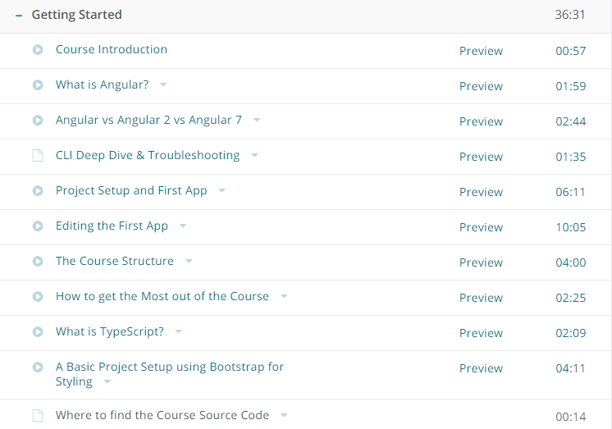

-Angular is a framework which allows you to create reactive, single page applications

Files you need to have a knowledge while learning Angular js

1. **app.component.html**
2. **app.component.ts**
3. **app.module.ts**
4. **index.html**
5. **main.ts**

**app component.html**

**<div class="container">**

**<div class="row">**

**<div class="col-xs-12">**

**<h3>I'm in the AppComponent!</h3>**

**<hr>**

**<app-servers></app-servers>**

**<!--<div app-servers></div>-->**

**<!--<div class="app-servers"></div>-->**

**</div>**

**</div>**

**</div>**

1. **app.component.ts**

**import { Component } from '@angular/core';**

@Component({

selector: 'app-root',

templateUrl: './app.component.html',

// styleUrls: ['./app.component.css']

styles: [`

h3 {

color: dodgerblue;

}

`]

})

export class AppComponent {

}

**app.module.ts**

import { BrowserModule } from '@angular/platform-browser';

import { NgModule } from '@angular/core';

import { FormsModule } from '@angular/forms';

import { HttpModule } from '@angular/http';

import { AppComponent } from './app.component';

import { ServerComponent } from './server/server.component';

import { ServersComponent } from './servers/servers.component';

@NgModule({

declarations: [

AppComponent,

ServerComponent,

ServersComponent

],

imports: [

BrowserModule,

FormsModule,

HttpModule

],

providers: [],

bootstrap: [AppComponent]

})

export class AppModule { }

**index.html**

<!doctype html>

<html lang="en">

<head>

<meta charset="utf-8">

<title>MyFirstApp</title>

<base href="/">

<meta name="viewport" content="width=device-width, initial-scale=1">

<link rel="icon" type="image/x-icon" href="favicon.ico">

</head>

<body>

<app-root></app-root>

</body>

</html>

Main.ts file

**import { enableProdMode } from '@angular/core';**

**import { platformBrowserDynamic } from '@angular/platform-browser-dynamic';**

**import { AppModule } from './app/app.module';**

**import { environment } from './environments/environment';**

**if (environment.production) {**

**enableProdMode();**

**}**

**platformBrowserDynamic().bootstrapModule(AppModule)**

**.catch(err => console.log(err));**

1)app

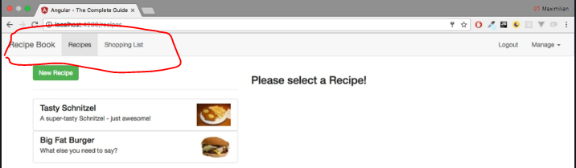

you can see that we seem to visit different pages,but in the end, our page never changes.

* It's only one HTML file and a bunch of JavaScript code we got from the server and everything which you see here, every change, is rendered in the browser.
* JavaScript is much faster than having to reach out to a server for every page change and for every new,piece of data you want to display. Therefore, this approach allows you to create web applications, which look and feel almost like mobile applications; very fast!
* Well, JavaScript changes the DOM, changes whatever is displayed here (in the browser), by changing the HTML code during runtime,(so to say). That is why you never see the refresh icon on the top-left spin; because we're only changing

->the currently-loaded page. You can even see that if you inspect the source code of a page like this.That is the HTML fileand as you can see, it doesn't seem to contain the content you are seeing on this page.We only have one single HTML element which doesn't seem to be a built-in one (a native one), but that's Angular doing its job.

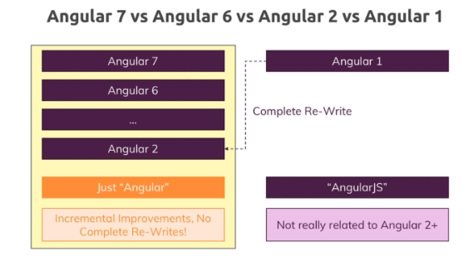

-complete re-write of angular1

- When it came to using browser side javascript to reach rendered a Dom to update the dom at runtime and,therefore provide highly interactive user experiences without reloading the page angular or was a complete

-angular 2 and it later versions started in 2016

-

Creating first project in Angular

npm i -g @angular/cli

ng new projectname ex-ng new my-app

Basic project setup using Bootstrap for styling

Downloading npm install –save bootstrap@3

but to be able to use it, we also need to make Angular aware of this styling package we want to use and we do that in one of the config files

(the most important one actually) the angular.json file. This configures the CLI project.

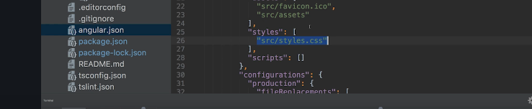

-styles.css is a file you can use to define some global styles you want to use application-wide.

-But if you access the Elements tab in the Developer Tools, you should see that in the head section there

are two styles imports and the first one should be Bootstrap v3.3.7.

Now, this is the import you need there and with that, everything we do in the course will look correct.

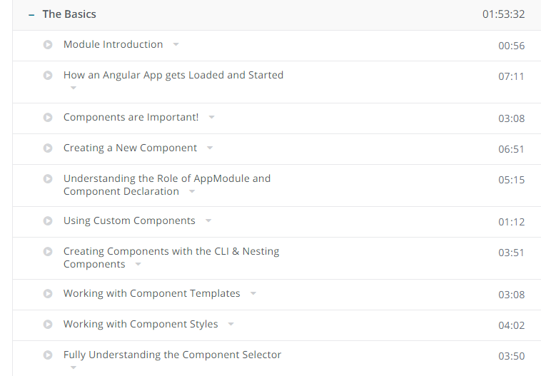

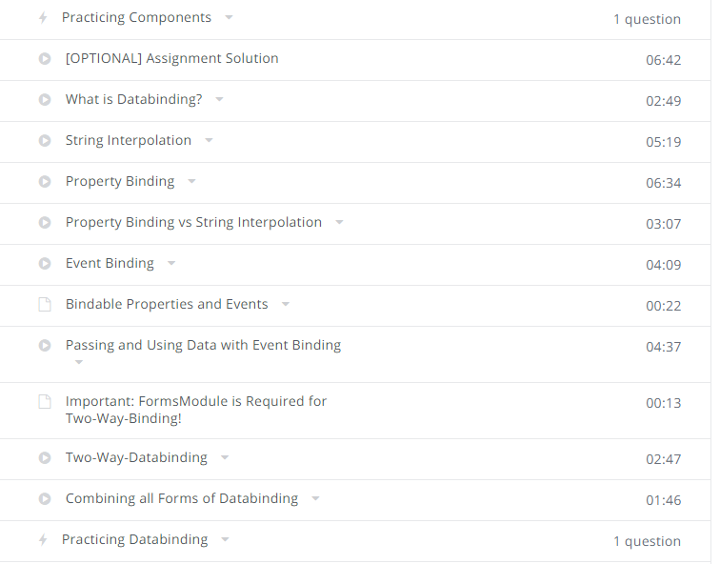

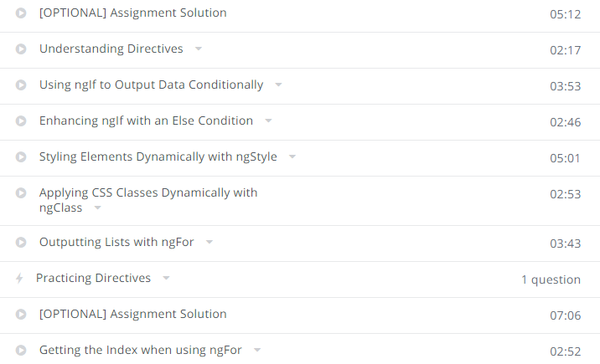

Basics

Module Introduction

-how angular app gets started

-By the end of this section, you will understand how you can build your basic Angular application, what it then does and what you need to change to reach a different result

How angular app get started and loaded

-this is where our development

server hosted by the CLI or spun up by the CLI will host our Angular application.

- the index.html file here is served by the server and remember that I told you that Angular

is a framework which allows you to create single page application,this is the single page which is served, the index.html file.

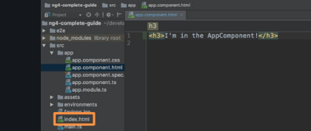

the CLI created one for us,

the root component of our application, the component which will tie together our whole application in

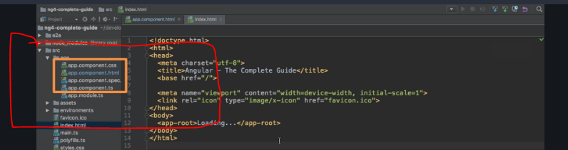

look at the app.component.ts file, the TypeScript file here.

Here you can see that we have this @component decorator, this seems to be important but more importantly

right now, you'll see that there, we have this selector property which assigns a string as a value and this string holds app-root. Now this clearly is the same text as in our index.html file

and this actually is the information Angular needed to be able to replace this part here in this index.html

**how is Angular triggered?**

how is it kicked off to actually run over our body here of this index.html file?

And the answer is in the final index.html file, getting served in the browser and we can verify

this by inspecting the source code here,



we got a couple of script imports at the end.These are injected by the CLI automatically,so that is why we don't see it here in the raw index.html file, here we don't have any script imports but whenever this **ng serve process rebuilds**

**our project, it will create bundles,Javascript script bundles and automatically add the right imports in the index.html file, a little convenience functionality for us.**

So in the final file, these script imports here are present and these script imports will contain our own code too.

So these script files are **therefore executed and they're actually the first code to be executed,and that is just something you have to keep in mind, is the code we write in our main.ts file,that is why it's called main,**

this is the first code which gets executed.

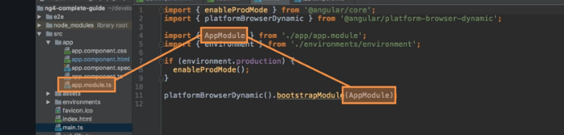

this line, this now bootstraps starts our Angular application by passing an app

module to this method and app module refers to this file here.

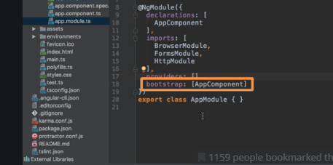

**here we get this bootstrap array which basically lists all the components**

**which should be known to Angular at the point of time it analyzes our index.html file and here**

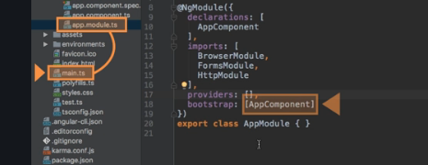

we bootstrap an Angular application and we pass this module as an argument. In this module, we tell Angular

hey there is this app component which you know when you try to start yourself and Angular

now analyzes the app component, reads the set up we pass here and therefore knows this selector, app-root

and now Angular is able to handle app-root in the index.html file

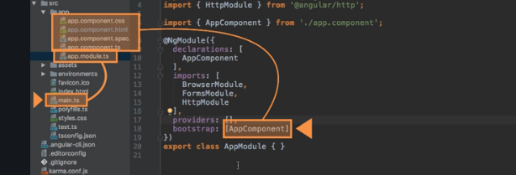

**So Angular gets started, this main.ts file gets started, there**

**we bootstrap an Angular application and we pass this module as an argument. In this module, we tell Angular**

**hey there is this app component which you know when you try to start yourself and Angular**

**now analyzes the app component, reads the set up we pass here and therefore knows this selector, app-root**

**and now Angular is able to handle app-root in the index.html file and it knows**

**all right this is the selector I know, you told me that I should know it because it was listed in this**

**bootstrap array in the app module, this component.**

**Last section overview**

In the last lecture, we had a close look at what happens at the point of time we visit localhost:4200

here in the browser.

We understood that the index.html file is served, that it will contain a bunch of scripts here which get executed which then basically start the Angular app, the Angular app gets the important information,that it should know, the app component that it should analyze it with that information the Angular code is able to parse this here, this app-root component here

understand it and insert our Angular application at this point and that is why we don't see loading...

which would still be in the source code of this page as you can see

but instead why we see this because Angular overwrites this at runtime because that is what it does,

Components are important

So this root component, this app component will be the component where we later nest or add our other components too,

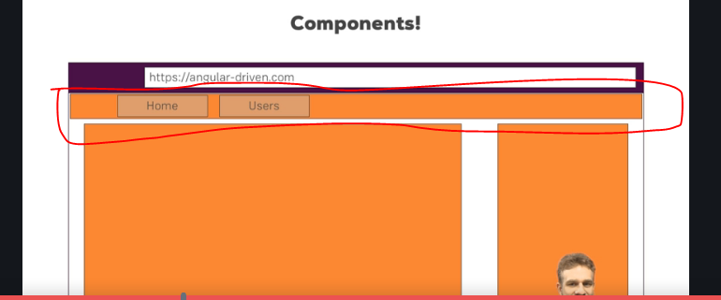

-Header may be a component

-home and users may be other components

each component has its own template, its own HTML code, maybe its own styling

and more importantly also, its own business logic and this is the great benefit.

It allows you to split up your complex application, your complex webpage into reusable parts,

you may use a component more than once and that allows you to easily replicate that business logic,

replicate that styling or in general, make a finely controlled piece in your application without having

to crunch everything into one single script file, one single HTML file, instead

it's very easy to update, very easy to exchange and again re-usable.

Creating a new component

-in appmodule.ts we will mention in bootstrap array that our root component is this.Ask angular to bootstrap the application with this.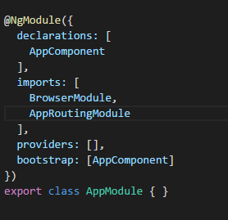

-if we want to add new component,it will be added in appcomponent.html and not appmodule.ts.

-A good practice is having a foldername = componentname.

Decorators

-ts feature that helps in enhancing elements that you use in code,ex -@component

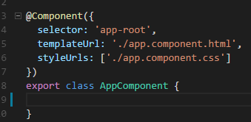

**-selector –by which name you will be using in code**

**-templateurl-url which html template need to use**

**Stylesurl- url which style file template need to use**

Understanding the role of appmodule and component

-appcomponents are used in angular to build web pages.

**-appmodules helps to bind components to your application package.**

-we will say this component is part of our modules.

@ngmodule

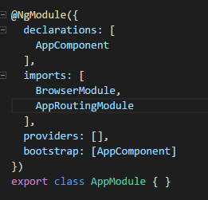

Imports adds other components into our module.

Using custom components

**emmet**-one of the plugin which is used to write the html code much faster.

Working with components template

-template we can write code.

-We can inline your impliments:

Working with componts styles

-external & internal for template.

-same way we can do it for styling.

Fully understanding the component selector

-Angular selector by attribute also like example selector:’[app server]’

Now by <div app-server>

Data Binding

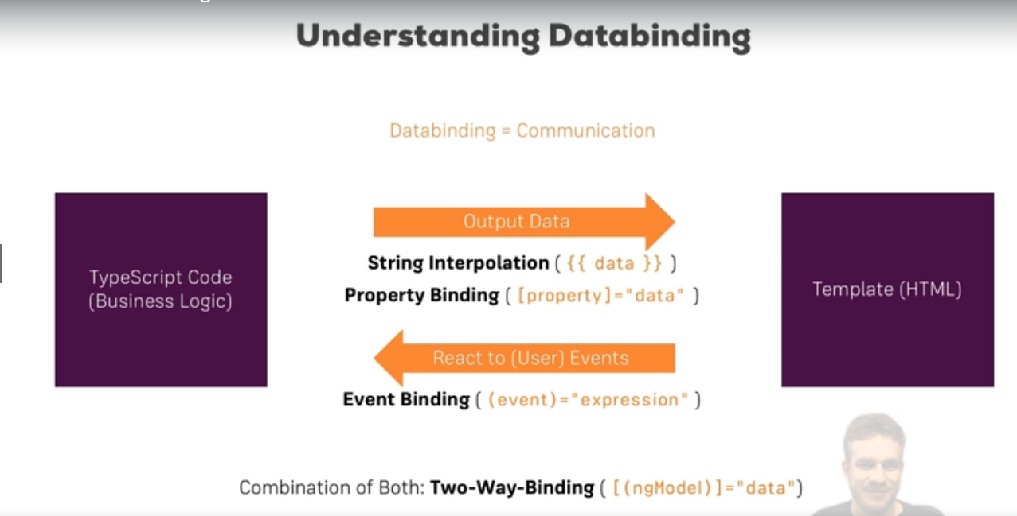

What is data binding?

- You could basically translate data binding with communication. Communication between your TypeScript code of your component, your business logic and the template.

We get different ways of communication now

-  for example we want to output data from our TypeScript code

in the HTML code in the template. We can use string interpolation for this,

- some property name or some expression in between or property binding.

syntax basically uses these strange square brackets around HTML attributes

Sometimes though, the other direction is interesting too,

- So if we click a button, we maybe want to trigger something in our TypeScript code,

so now we need the other direction and we can get this other direction,

we can react to user events with event binding. So we can bind to for example a click event to execute

- and we also have one additional form of data binding where we combine both directions, two-way data binding,

where we are able to react events and output something at the same time

- STRING Interprolation

-server.compoent.html

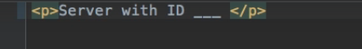

Scenario where he want to display server with id (dynamic content) and status is (active)?

Server component.ts

-we will write the type script code.

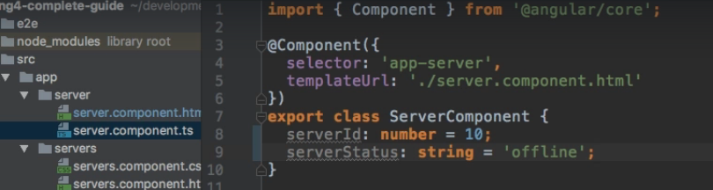

-**Use case 2-**

you could also for example here for server simply hardcode a string in there.

any expression which canbe resolved to a string in the end,that's the only condition for a string interpolation syntax here.

So whatever you have between the curly braces, in the end it somehow has to return a string,

so you could call a method here which returns a string in the end. The only other restriction is you

can't write multi-line expressions here,



So yes, you have to get a string in the end or something which can be converted to a string to reallybe correct here.

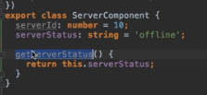

Calling a method



25.Property Binding

Senario- adding a server when button is clicked?

Server-component.html file

-I have to add a button

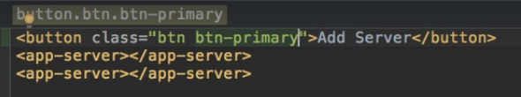

In server-cpmponent.ts file

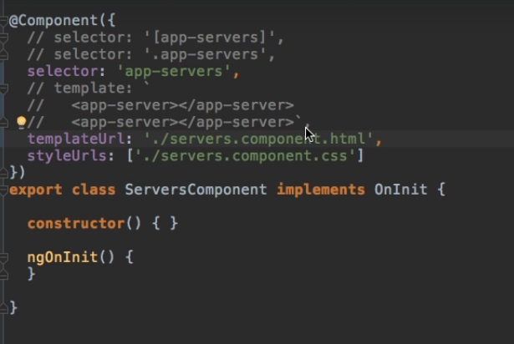

So I will add a new property in my TypeScript code here which I'll name allowNewServer and set it

to false.

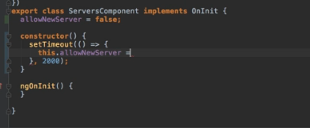

Here we're binding to this disabled property, this native element property,

we're binding this to our own TypeScript property here and the convenient thing is and this is what Angular isall about, that this will update dynamically.

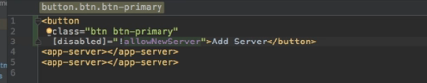

Property Binding vs String Binding

When to use Propety Binding and String Binding

Well basically if you want to output something in your template, print some text to it, use string interpolation.

if you want to change some property, be that of a HTML element or as you will later learn, of a directive or a component,typically use property binding.

Event Binding

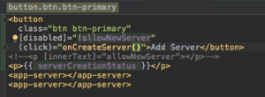

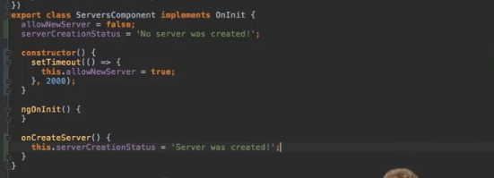

Two way Data Binding

we use it therefore by combining the syntaxes, square brackets and within these, parentheses.

Now here, we have to use a special directive and we will learn more about directives in a second, @NgModel.

Now we can set this equal to some property defined in our TypeScript code,

so of to the server name for example. This set up will do the following,

it will trigger on the input event and update the value of server name in our component automatically.

On the other hand, since it is two-way binding, it will also update the value of the input element

if we change server name somewhere else and I can demonstrate this by going back to the TypeScript code

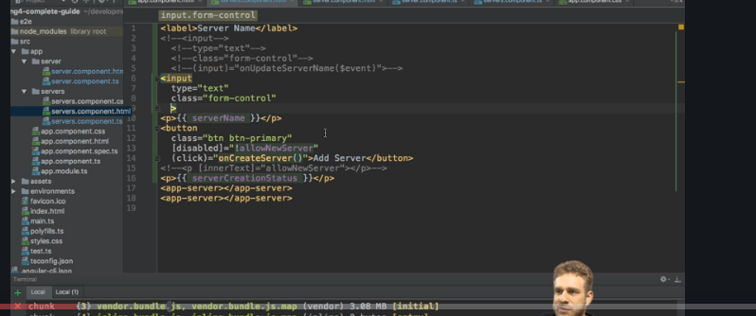

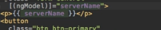

This set up will do the following,

it will trigger on the input event and update the value of server name in our component automatically.

On the other hand, since it is two-way binding, it will also update the value of the input element

if we change server name somewhere else and I can demonstrate this by going back to the TypeScript code

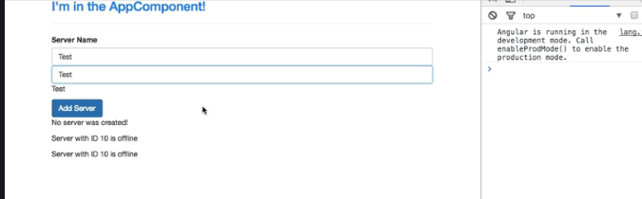

Directives

What are directives?

Directives are instructions in the DOM

and we actually already use directives without knowing it,components are kind of such instructions in the DOM.

Once we place the selector of our component somewhere in our templates,at this point of time we're instructing Angular to add the content of our component template and the

business logic in our TypeScript code in this place where we use the selector.

This was our instruction, Angular

please add our component in this place and indeed components are directives but directives with a template,

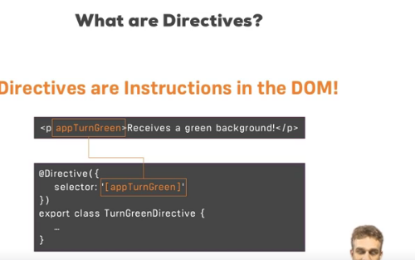

this directive might simply color the text green you could say. So Angular would

find this instruction, here we would have defined our directive with the directive decorator to inform

Angular that this class holds a directive

and there, we might have the logic to turn this green.

Using ngif to output data conditionally

Scenario-Now let's say one thing we want to do is we only want to show this server was created text here,

there is no need to have this

no server was created text to be displayed.

So it would be nice if we could conditionally show this message

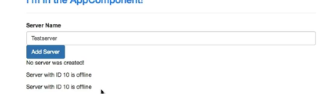

-ngIf. The star is required because ngIf is a structural directive which means it changes the structure of our DOM, it either adds this element or it doesn't add it.

- For ngIf,this has to beany expression returning true or false,deciding whether this should be added or not.

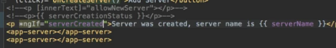

Now with this if we save this, what you see is that there is no text

but if I name this Testserver 2 and click the button, now the text is added here

and the interesting thing is if I reload the app and we inspect our DOM here, you'll see here that's our app server

component, above that is the button

but if I click this button, a new element was entered here,

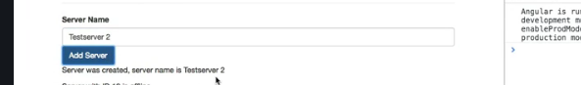

the paragraph and here you see kind of the hook which Angular created to know where this should be entered.

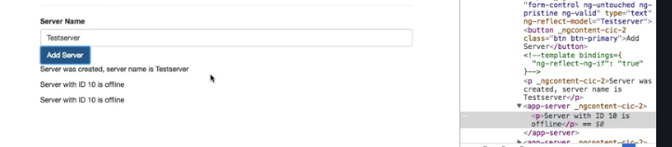

But the important thing is it's really added or removed to or from the DOM,

it's not there all the time, it's not hidden, it's just not there

which is super important to understand.

Enhancing ngif with a else condition-

-Sometimes you have not only the if condition but also an else condition,

so here we might want to say server was created, server name is something with ngIf but we could also add an else block where we then want to say no server was created.



Scenario:-

-but imagine that we do want to show that alternative,

so no server was created could be the text here and now we want to show this paragraph only if ngIf is

not true or this condition, server created, is not true.

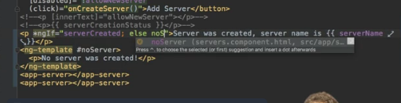

We can achieve this by placing a local reference on this element here and local reference is something

I will dive deeper into in the understanding components and data binding section of this course.

For now let's think of it as a marker,

so I will name this noserver,

any name you like,

noServer

with a capital s

and now we need to change the paragraph here to ng-template. That is a component, that directive shipping

with Angular which you can use to mark places in the DOM

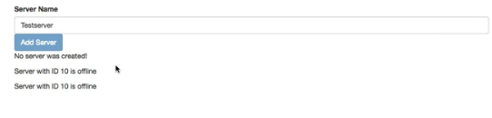

Styling Elements Dynamically with ngstyle



This ngStyle property expects to get a Javascript object

and here, we define key-value pairs of the style name as the key and the value of the style as the

value. So for example, we could bind background-color



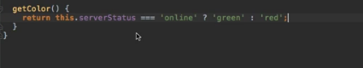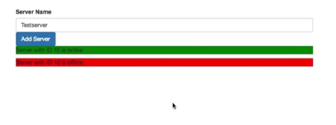

Applying css classes Dynamically

 -ngStyle allows us to dynamically assign a style,

now I will also add ngClass here and where ngStyle allowed us to change the CSS style itself,

ngClass allows us to dynamically add or remove CSS classes.

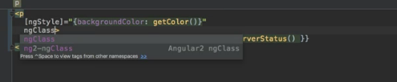

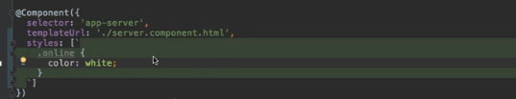

ngClass object works like this.We also have key-value pairs,

the keys are the CSS class names and the values are the conditions determining whether this class should be attached or not.

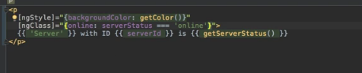

both are offline so none of the two should have the online CSS class added to it

and indeed, I can't find the class on any of the two.

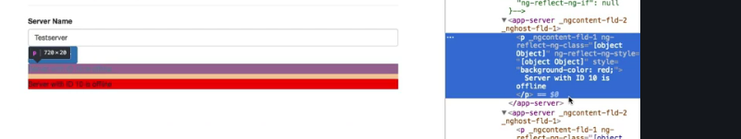

Outputting List with ngFor

Started with a scenario

Scenario-you are adding servers ,but you are not storing it in list?

ngFor

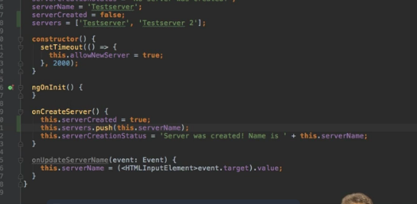

The ngFor base syntax looks like this,

we define a temporary variable for inside the loop with let, give it any name you like, like server for

example and then of servers. Servers here is the property we defined in the TypeScript file and this will

now loop through all elements in this array and assign the individual element to this dynamic server

variable.

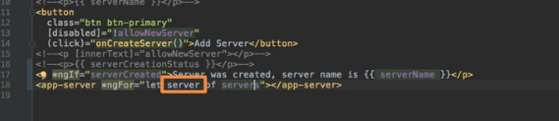

Of course the content of the individual server is still static because we can't pass the data like the

server name to that component but that is something we will learn in the next course section when we

dive deeper into components and we will learn how we can create our own properties on components

we can then set from outside the feature which would be great to have here.

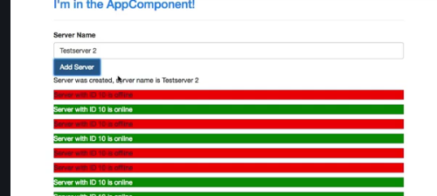

Project overview

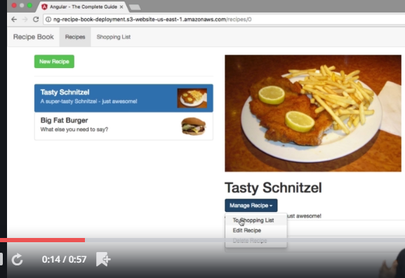

We are going to build a application with a list of Recipes, ShoppingList

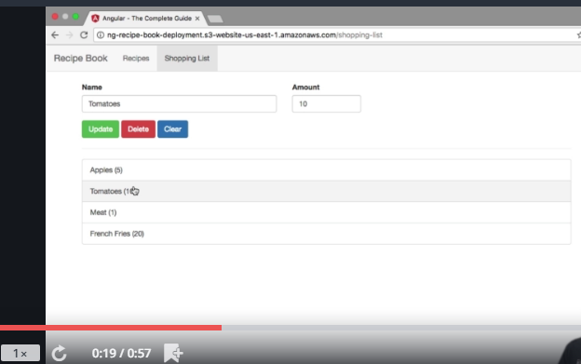

My goal in this project which we will build throughout the course, to which we will come back after the individual

sections of this course, is to build a recipe book and shopping list app,

you saw it in the intro video of the course.

Basically there, we're going to have two sections, shopping list and recipe book and we will be able to

manage our recipes, view them in detail and also to manage our shopping list and even push ingredients

from a recipe directly to the shopping list.

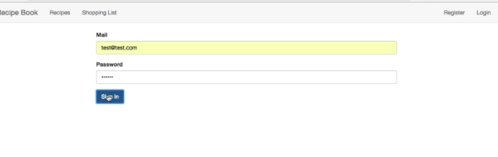

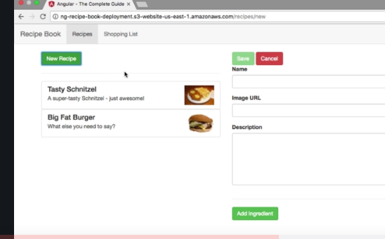

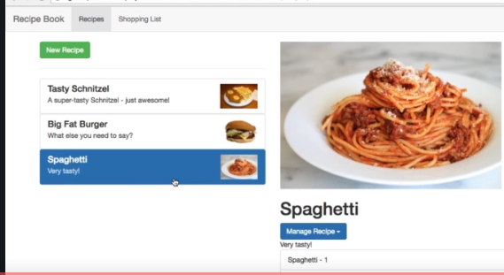



Planning the APP

Steps in planning a app

* a root component holding our overall application, the app component, every Angular app has this.
* hen since we have two sections, it probably makes sense
* to have some kind of header component where we can navigate between these two sections.
* 
* Of course you could also hardcode the headers simply into the app component but since it will contain its
* own business logic, in the end it will trigger a routing action later and we will also add a dropdown

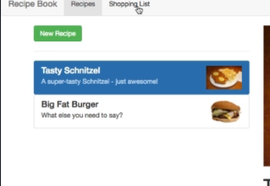

* there in the end which allows us to store our recipes on the server and fetch them from there.
* So since we will have that logic attached to the header, outsourcing it into its own component makes,sense so that we don't have to put all the logic into our root component which really mainly should only,be responsible for holding our overall app.
* 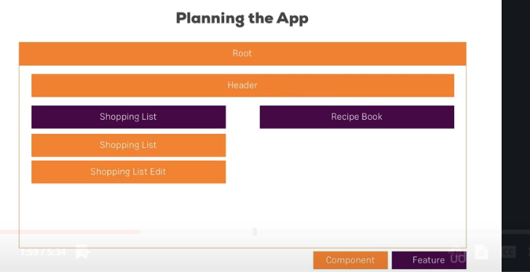

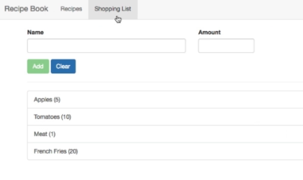

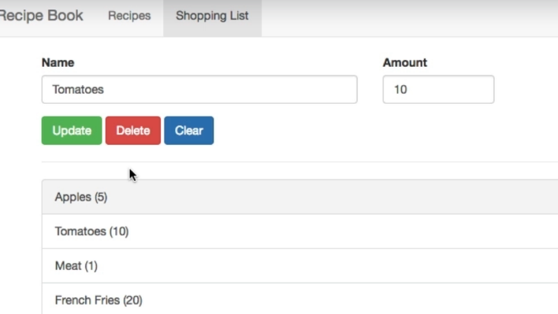

let's start with the shopping list. Here I guess it makes sense to have the overall shopping-list component,

remember the purple box is only the feature so we need a component holding our shopping list and maybe in this shopping-list component

- we also want to have a shopping list edit part which allows us to add new items, so an input field and a button because that again has its own logic,

- So if we have an overall list component, mainly holding the data of the list and the edit component

being responsible for managing this data kind of, though the edit component will be nested inside the list component.

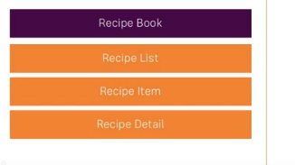

 a recipe-list component which

shows us a list of all our recipes. Here we might later also put each individual recipe into its own item



Here we might later also put each individual recipe into its own

item

-though since it holds a little bit more information than just one line of HTML code and a recipe-detail

area would be great too. So an area where once we select a recipe, we can see informations about that.

-So a list with items and then the details section which displays the details for the currently

selected item.

-sketch out here, we're really having each component focus on one main topic, displaying a list, displaying

information about a single item, displaying detail information about a selected item and so on.

which models will be use in this app?

mean which data. be clear about the data you're going to use and put it into its own class, so that you have your own

type you can use later on and that you have a clear interface or definition of what your data looks

like so that you can easily have your components talk with each other,

- So besides the ingredients which probably is a very simple model, only controlling the name and amount

maybe, we also will need a model for the recipe which contains things like title, the description, the ingredients

and so on.

Setting up the application

- now we also need to inform the CLI that Bootstrap should be included in our final bundle it creates

for us because of course, the CLI bundles all our script files and style files and by default, it would

not include Bootstrap. So to inform the CLI, we should go to the .angular-cli.json file and here

-  So to inform the CLI, we should go to the .angular-cli.json file and here

in styles, in this styles array, we can add any global stylesheets we want to add to our whole project.

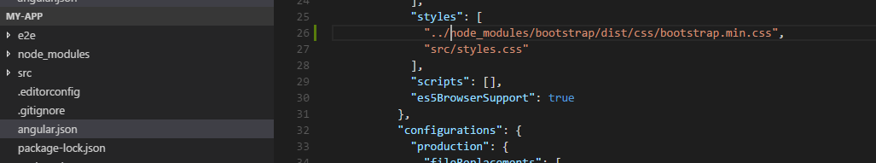

-To be precise, it would even be better to target the minified version which is a file also lying in that

folder,

so let's add .min between bootstrap and .css, so this will already give us the minified code

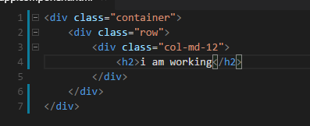

- plugin called emmet which allows me to just type dot claas name and hit tab to autocomplete it.

this looks like Bootstrap is working too, we can see those on the font size

and also if we inspect this here in the styles, all these styles here and down there

are coming from Bootstrap.

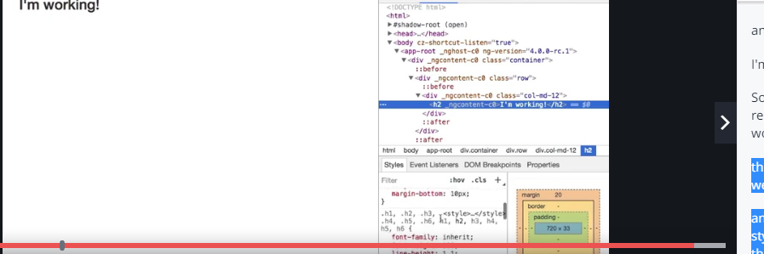

Creating the components

Now as you learned, a component is simply just a TypeScript class, so let's name it HeaderComponent here and right now, that would not be recognized as a component by Angular.

instead here we have to add the @component decorator.

-import from angular core from @angular/core,



Now with that, we need to pass a Javascript object to this decorator to configure this component,

specifically we need to add a template and I'll put this in external file, so templateUrl in this

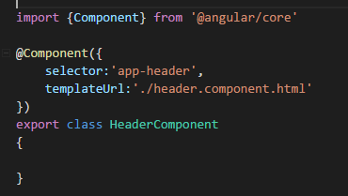

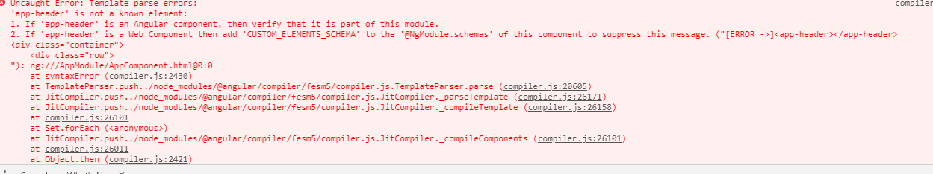

app-header is not a known element.

This is a common gotcha which is why I wanted to show it.

Why is it not known?

We added it here and we set up selector here, right?

Well remember, you have to register all the features you're going to use in the app module

and since we didn't use the CLI to create this component, it wasn't added there automatically.

So we have to add it manually to our declarations array

and that means we also have to add the import.

So we should import header component from and now pointing to the header folder and then in there,

the header.component file without the file extension.

So that now unlocks the header component in our app and if we save this, now we see the header.

-So we should import header component from and now pointing to the header folder and then in there,

the header.component file without the file extension.



So we had a couple of components we wanted to add and I will use the ng generate command or just ng g as

a shortcut and then we want to generate a component

or just c as a shortcut and the first component I want to add is the recipes component for this recipes

feature area.

I'll add spec false to prevent the creation of a testing file which I don't need.]



Using the components

as I said in my set up, I want to have a recipes list and detail next to each other.



col-xs-10 to create a very wide column here, I'll first

add my shopping edit component to have this editing area at the top where we can add new ingredients

or edit existing ones

and then I want to have a horizontal line here and somehow output my list below this.

So that's the rough setup I want to have in this component.



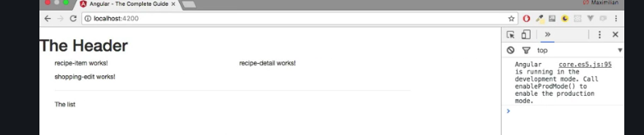

-here header is not pretty,lets bring it to the final stage in next video.

Adding a navigation bar

-instead I will use a couple of Bootstrap classes to create a nice looking header. So I'll create a wrapping

nav element and on this element, I'll add the navbar class and the navbar-default.

Again, these are just Bootstrap classes which will give me this default Bootstrap header.- I'll place a container-fluid div to have my own view container basically in there and the first thing

I want to have here is a header.

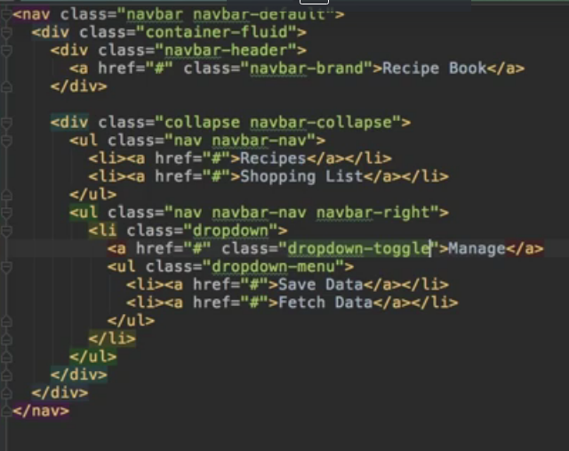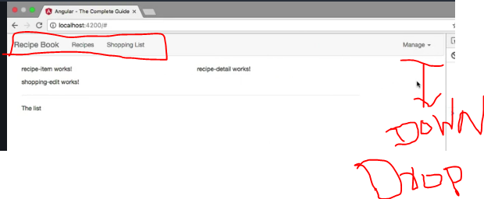

Again, these are just Bootstrap classes which will give me this default Bootstrap header. In there,

I'll place a container-fluid div to have my own view container basically in there and the first thing

I want to have here is a header.

For that, we get the navbar header class

we can add to a div and in this div, I want to have a clickable header,

so I'll add an anchor tag pointing to hash

for now, we'll later of course add a route there once we learned how to do this and this should have

the class navbar-brand, to give this this brand-like text style,

I'll say recipe book here since this is the name of our application. So that's the header part of our

header, so this main brand part,

now let's work on the actual links. For this,

I'll add a div which will receive the collaps class and then the navbar-collaps class.

Now, I won't really use the collapse feature,

I won't add a hamburger

icon here since we will not have many links on our header anyways but this gives us some nice styles

and of course, collaps here should have an e at the end, like that.

So in here, I now want to have a group of list items, so a group of links in the end, this will be an unordered

list with the CSS classes, nav and then navbar-nav.

So make sure to create this unordered list with these classes and in there, if we add some list items,

they will actually sit next to each other, so they will automatically be positioned correctly by Bootstrap.

Each list item should hold a link,

so here I'll add an anchor tag, also pointing to just hash for now, one for the recipes section and

the second one for the shopping list section.

Now with that added, I'll add another area in my header here,

this will be another unordered list which will receive the classes, nav and now also navbar-nav

like before but then also navbar-right to position these links at the right and actually, this will

only be one link here which will receive a class of dropdown, this list item

will, because later, we will add our own directive which will turn this into a working dropdown where we

will then choose some options to store our data on a server, something we'll also implement later

in this course or fetch it from there.

So in the dropdown, I simply want to have my dropdown menu which when using Bootstrap is added by adding

an unordered list with the class dropdown-menu,

so this will hold the items this dropdown and here, I'll add a couple of list items which all hold some

links pointing to just hash for now, one for saving data

and one for fetching data. Again this will be filled with working code later.

So that's my header,

let's save it and see how it looks.

Looks ok,

I don't see my dropdown though,

the brand looks off,

so I'm not entirely happy with that.

Let's see what is wrong.

The brand is not working because that should be navbar, not have a h in between, so if you fix this, the

brand looks all right.

Now what's wrong with the dropdown?

Well the dropdown simply misses the link we would see to open the dropdown because this unordered

class here simply is the content of the dropdown,

we of course also need a link to trigger it.

So let's add an anchor tag pointing to hashtag here

where I will say manage, just manage maybe, you could of course change that text and this should have

a class of dropdown-toggle because this will be the button toggling the dropdown in the end.

Therefore it will have a row of button to add some accessibility to this and also required for this to

work correctly though

and with this now if we save this, we see the dropdown. It would be nice to have a little arrow next

to it indicating that it is a dropdown.

So next to manage, I'll add a span with a class of caret which will give us this arrow pointing to the

bottom,

this arrow here and now we get a dropdown.

It won't work if we click it because we haven't added any code which would open the dropdown,

we will do this after the directives section though.

So the header is now working,

with that let's move on

and let's work on our recipes section.

Creating Recepies model

Final output of recepies model



-we get the recipes component which holds the recipe-list,

-for now what I want to do here is I want to add my recipes array, my array of recipes which for now is

an empty array

recepie-list-component.ts

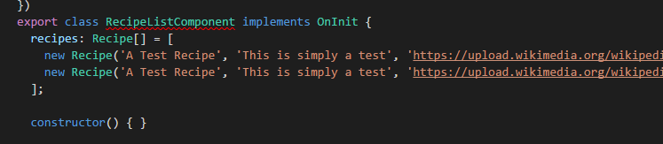

-want to define how a recipe should look like.

We're going to use a recipe a lot throughout this app and therefore we should definitely clearly define how

a recipe looks like, so that whenever we use it in any component, we're always talking about the same

structure, about the same kind of object.

So for this, I will create a model. What is a model then?

A model simply is a TypeScript file

**File:-Recepie.model.ts in recepies folder**

First of all, I'm going to export a ts class, a TypeScript class which is simply named recipe

because we define how a single recipe looks like here.

**-**@model here, now we're not going to do this,

there is no decorator like this,we can use vanilla TypeScript for this. A model



**Concept similar to class in java**

A class can be instantiated, so we can create new objects based on the setup we provide here in this

class. So we can define how a recipe should look like in this class,so let's do this.

-A recipe should have a name and I'll add an accessor to be really clear about that this is publicly available, so that this can be accessed from outside

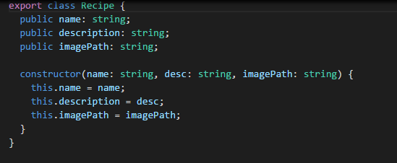

-So I'll add public in front of it and then name as the property name.

I'll also assign the type of this by adding a colon and the type will be string and that is just how you

assign types in TypeScript, you add a colon after the property name and then the type you want to assign,

so string

in this case

-I'll also add a constructor to it so that we can instantiate this with the new keyword and pass the arguments

right to the constructor,

-constructor is simply a built-in function

every class has and which will be executed once you create a new instance of this class,

-we get a recipe model we can use,

**Adding content to Recepies Component**

Back to recepie-list component

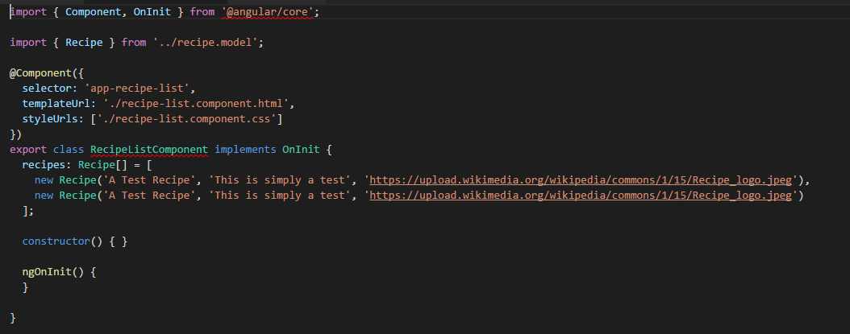

-I added my recipes array and now that we created the model, we can also define a type for this. So we

can add colon to inform TypeScript that now we will define the type for this property and the title

-will be recipe, so that will use our own model and not just a recipe but an array of recipes which is

indicated by adding square brackets after it.

-So now TypeScript knows

the only thing which will ever get stored in this recipes property is an array which holds a couple

of recipe object

-Now to inform TypeScript where this type is coming from, we need to add an import.

So I'll import recipe, that is what we named it in here, right,

that's our class name so that's what we have to specify between the curly braces here, from



So in this array, I will create a new recipe and I can use the new keyword to create a new object based

on this recipe blueprint, based on our class

and now when executing this like a method, we're actually calling the constructor,

so now here we need to pass the arguments we're expecting in this constructor, so name, description and image,path.



so to see that, we should actually do something in the template of the recipe-list component. Here I'm

right now only outputting my recipe-item and I want to loop through all these items and use them to

display my recipes. For now, what I will do is I will add a Bootstrap row

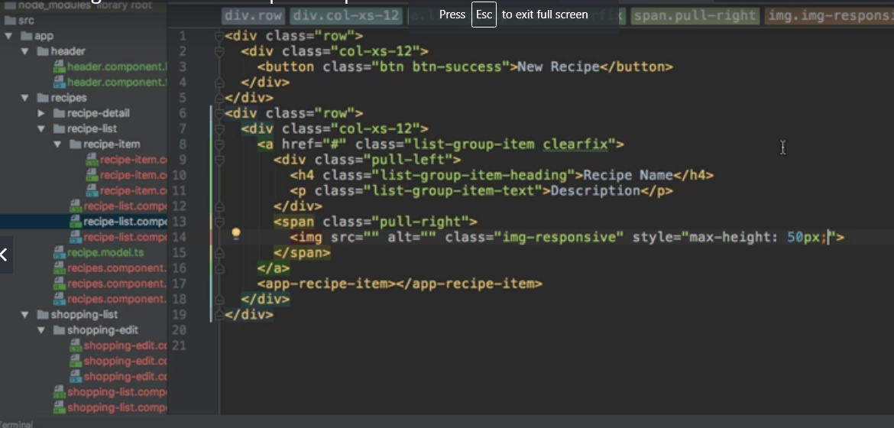

-So here, I'll simply set up a button with the classes btn and then btn-success where I say new

recipe, like this.

Now again, this will be hooked up later.

So I'll add another row below this which should now actually hold my list of recipes, here I'll

again use col-xs-12

to have this span over the full width and keep in mind, this will already be nested inside of this

md-5 columns,

so it's only that wide to begin with

but inside this column, I wanted to span over the full width

and now here, we will later output my recipe items. Now with that, the goal is to replicate this item, again we will later put it into its own component

and then fill these spaces here with dynamic data.

This is your challenge,

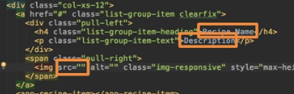

**and again all that content will go into the app-recipe-item component after the next course section.**

Outputting a list of Recepies with ngFOR

-So were you successful using our recipes array here and replicating this part in the code as often as

needed and fill it with the data for the recipe?

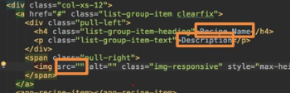

-So let's add ngFor, this is the directive which allows us to repeat code in our template

and here, I want to loop through all the recipes.

So I will actually create a local variable named recipe,

this name is totally up to you,

that will simply store the recipe of each iteration in our loop and I will loop through all the recipes,

so through this recipes property we created here in the TypeScript file.

-So let's use it to output the name,

we can use string interpolation for that.

String interpolation as we learned allows us to output some text anywhere in our template.

Now we got the single recipe but that's going to be an object looking like our model because remember,

the recipes array simply holds an array of our recipes,

-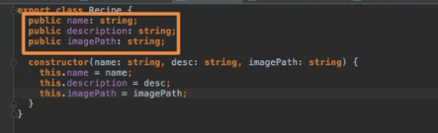

-

and for the description, we can replace this with recipe description.

So we're going to use the property names

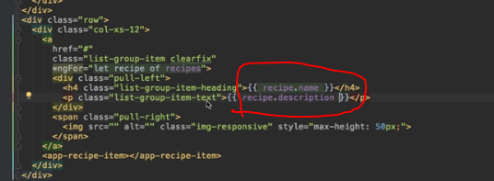

we set up here in the model and important, you have to use the ones here at the top of course because

down there, these are only the constructor argument names,

they are not available outside of this model.

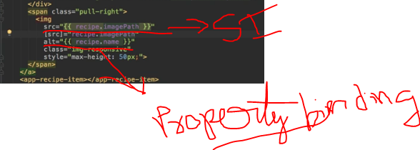

So here is a great example of where you may use both, string interpolation with the normal HTML attribute

or not using the attribute but directly binding to the source property of the image and then just putting

in a valid expression, returning what this property expects, in this case a string between the quotation marks.

-You can either use string interpolation here to output recipe imagePath here

and that should work fine

or as an alternative, you cannot use the attribute plus string interpolation but you could bind to the

source property itself

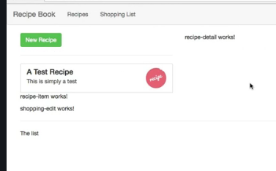

Displaying Recepie details

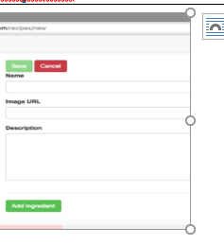So a button which allows us to add it to the shopping-list and then one which allows us to edit it orto delete it and actually, we could use a dropdown here. Such dropdown may be added here by adding a div,with the Bootstrap class btn-group

<**div class="row">**

**<div class="col-xs-12">**

**<img src="" alt="" class="img-responsive">**

**</div>**

**</div>**

**<div class="row">**

**<div class="col-xs-12">**

**<h1>Recipe Name</h1>**

**</div>**

**</div>**

**<div class="row">**

**<div class="col-xs-12">**

**<div class="btn-group">**

**<button**

**type="button"**

**class="btn btn-primary dropdown-toggle">**

**Manage Recipe <span class="caret"></span>**

**</button>**

**<ul class="dropdown-menu">**

**<li><a href="#">To Shopping List</a></li>**

**<li><a href="#">Edit Recipe</a></li>**

**<li><a href="#">Delete Recipe</a></li>**

**</ul>**

**</div>**

**</div>**

**</div>**

**<div class="row">**

**<div class="col-xs-12">**

**Description**

**</div>**

**</div>**

**<div class="row">**

**<div class="col-xs-12">**

**Ingredients**

**</div>**

**</div>**

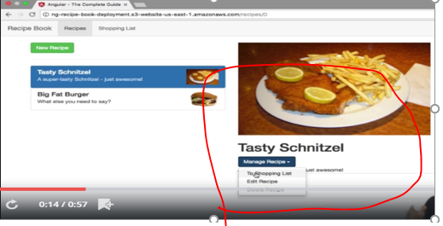

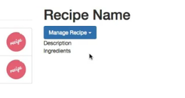

So that cross-component communication is a huge issue right now but no worries, that is something we're

going to dive deeper into in the next core section and thereafter, we'll come back to this and enable

all that communication which allows us to outsource this code into its own component and make these

links clickable so that we actually load the right recipe on the right. Before doing this,

Working on shopping list component

Understanding Angular error message

the developer tools and there, the Javascript console is a great idea.

you should find it right at the top and here it says that in app component,

that's the first important information piece, in the inline template,

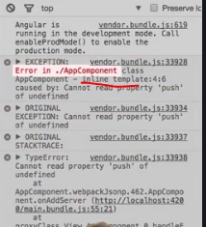

then this would be the line number and then the column where in the line, so line 4,

- so let's go to the app component then and let's have a look at it.

If we go there,well the line 4 argument is only kind of helpful because line 4 is neither the problematic code in ourtemplate nor in the TypeScript file. The report says line 4.

**-because in the end everything gets merged together and rebuilt, so that is where probably the code then is triggered in line 4 in the final code but not in our code.**

**-** Still, we get one important clue here, property push of undefined.

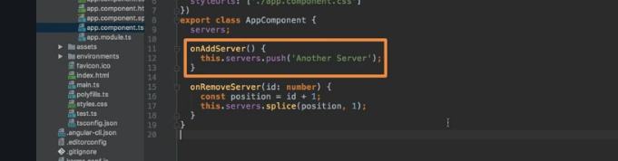

Still, we get one important clue here, property push of undefined.

So we try to call push on something which is not defined at the point of time we do call it.

So if we have a look at our code here, we see that there is only one place where we call push and

that is of course here in the

onAddServer method which makes sense because this is the method which gets triggered once we click the button.

So that would have been another way of finding where the problematic code has to be as this error occurred when we click the button,

onAddServer method which makes sense because this is the method which gets triggered once we click the button.remember it said push of undefined.So the thing we're calling push on is undefined, so that would be this servers.

-How can these servers be undefined,

we do declare it up here, right?

That's exactly the issue in this case.

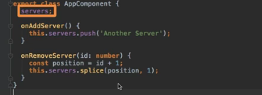

- here's going to be a property called servers but we don't initialize it.

It doesn't have any value assigned to it,

it's not an empty array, it's not a string, it's nothing.

So to fix our code, we simply have to make sure that before trying to push a new item on servers,

­ servers to an array because otherwise, it could be anything, it's undefined in the end,

so pushing is not supported here.

So what we can do is we can simply initialize an empty array at the beginning and with this little change

Debugging Code in the Browser Using SourceMaps

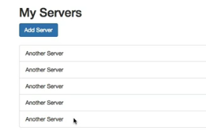-not at all deleting the last one,all the other all deleting

-lets see into code

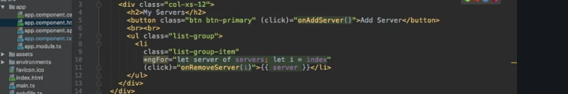

- Now if we have a look at our code, at the template

first, we see that on each list item, I call onRemoveServer and I do pass i, the index of the current

iteration to that method.

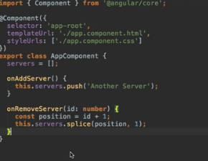

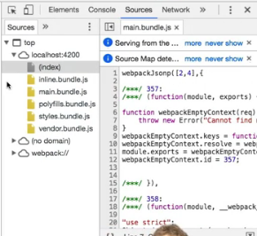

- you can simply go to sources and here, you will find all these sources imported on this page.

So in this case, all our script bundles and there are a couple of bundles as you'll see, the important one for

- us is of course the main bundle and if we have a look at the main bundle,

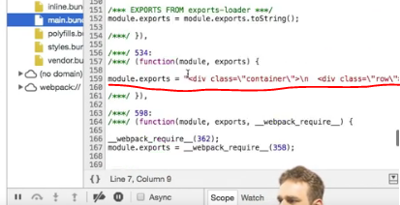

- of course, we can have a look at it and there, let's find, this seems to be our template here with container

and row and maybe we can find the line responsible for splicing, here and now maybe we want to debug here

and if you try to place a breakpoint here which you of course can do in your developer tools, you'll

see something changed,

- It jumped to the app.component.ts file.

Now remember, TypeScript is not what runs on the browser,

so there the Javascript, these bundles here are used,

how can we now access TypeScript? Because these Javascript files support source maps. **Source maps area little addition the CLI kind of adds to our bundles which allow the browser to translate our Javascript code to TypeScript**

or to simply map the Javascript code to our TypeScript files. In development-only,

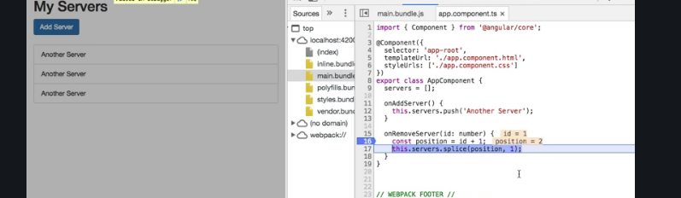

that's great but if I have to scan my main bundle to then click somewhere to open the TypeScript file,

that's not really a great tool because if that bundle grows bigger, it gets even harder to find

the right spot.

Therefore you can directly access your TypeScript files, under webpack

here, you should find a couple of subfolders and if you open up the dot folder here and then source, here

in the app folder and so on, you find all your TypeScript files,

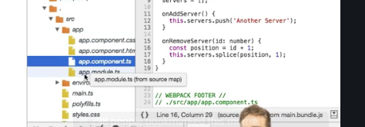

Using Augury to Dive into Angular apps

- it's called augury,

- should take you to the Chrome store since this is a Chrome extension

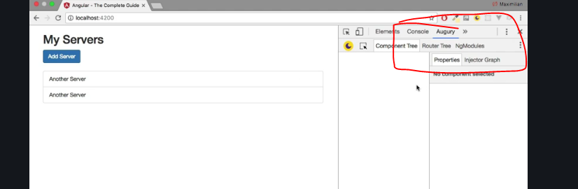

Augury is a nice little tool which allows you to analyze your Angular application.

So if we reload our app here, we see for example all our components

- on this component, you can jump into the state and see the properties of this component and also see the elements of that

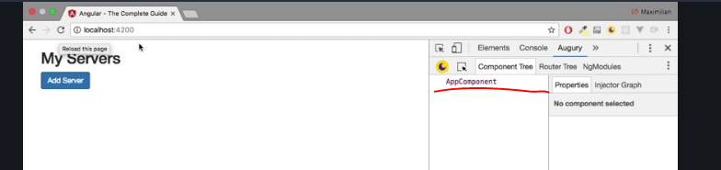

- you can have a look at the injector graph and injection is something

we will cover in one of the later modules but basically which will allow you to see dependencies between

your components and your services in your app,

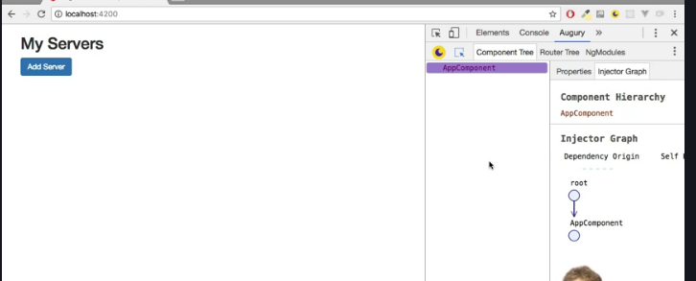

- When we come to routing, you can also have a look at your routes here and how they work together.

- You can check your NgModules like the app module, what it imports, what it declares, what it offers

you.So that is a nice little tool to understand your app at runtime, to see the app dependencies and jump

right into them and to be able to analyze them.

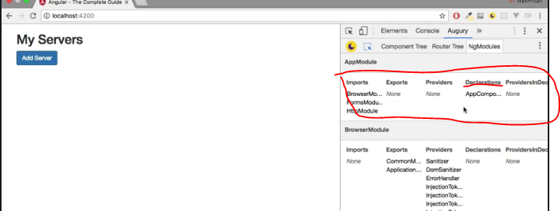

Course files used in this exercise’

//Main.ts

import { enableProdMode } from '@angular/core';

import { platformBrowserDynamic } from '@angular/platform-browser-dynamic';

import { AppModule } from './app/app.module';

import { environment } from './environments/environment';

if (environment.production) {

enableProdMode();

}

platformBrowserDynamic().bootstrapModule(AppModule)

.catch(err => console.log(err));

//index.html

<!doctype html>

<html lang="en">

<head>

<meta charset="utf-8">

<title>MyFirstApp</title>

<base href="/">

<meta name="viewport" content="width=device-width, initial-scale=1">

<link rel="icon" type="image/x-icon" href="favicon.ico">

</head>

<body>

<app-root></app-root>

</body>

</html>

//appcomponent.css

.container {

margin-top: 30px;

}

p {

color: blue;

}

//appcomponent.html

<div class="container">

<div class="row">

<div class="col-xs-12">

<p>Add new Servers or blueprints!</p>

<label>Server Name</label>

<input type="text" class="form-control" [(ngModel)]="newServerName">

<label>Server Content</label>

<input type="text" class="form-control" [(ngModel)]="newServerContent">

<br>

<button

class="btn btn-primary"

(click)="onAddServer()">Add Server</button>

<button

class="btn btn-primary"

(click)="onAddBlueprint()">Add Server Blueprint</button>

</div>

</div>

<hr>

<div class="row">

<div class="col-xs-12">

<div

class="panel panel-default"

*ngFor="let element of serverElements">

<div class="panel-heading">{{ element.name }}</div>

<div class="panel-body">

<p>

<strong *ngIf="element.type === 'server'" style="color: red">{{ element.content }}</strong>

<em *ngIf="element.type === 'blueprint'">{{ element.content }}</em>

</p>

</div>

</div>

</div>

</div>

</div>

//app.component.ts

import { Component } from '@angular/core';

@Component({

selector: 'app-root',

templateUrl: './app.component.html',

styleUrls: ['./app.component.css']

})

export class AppComponent {

serverElements = [];

newServerName = '';

newServerContent = '';

onAddServer() {

this.serverElements.push({

type: 'server',

name: this.newServerName,

content: this.newServerContent

});

}

onAddBlueprint() {

this.serverElements.push({

type: 'blueprint',

name: this.newServerName,

content: this.newServerContent

});

}

}

//appmodule.ts

import { BrowserModule } from '@angular/platform-browser';

import { NgModule } from '@angular/core';

import { FormsModule } from '@angular/forms';

import { HttpModule } from '@angular/http';

import { AppComponent } from './app.component';

@NgModule({

declarations: [

AppComponent

],

imports: [

BrowserModule,

FormsModule,

HttpModule

],

providers: [],

bootstrap: [AppComponent]

})

export class AppModule { }

//appcomponent.spec.ts

import { TestBed, async } from '@angular/core/testing';

import { AppComponent } from './app.component';

describe('AppComponent', () => {

beforeEach(() => {

TestBed.configureTestingModule({

declarations: [

AppComponent

],

});

TestBed.compileComponents();

});

it('should create the app', async(() => {

const fixture = TestBed.createComponent(AppComponent);

const app = fixture.debugElement.componentInstance;

expect(app).toBeTruthy();

}));

it(`should have as title 'app works!'`, async(() => {

const fixture = TestBed.createComponent(AppComponent);

const app = fixture.debugElement.componentInstance;

expect(app.title).toEqual('app works!');

}));

it('should render title in a h1 tag', async(() => {

const fixture = TestBed.createComponent(AppComponent);

fixture.detectChanges();

const compiled = fixture.debugElement.nativeElement;

expect(compiled.querySelector('h1').textContent).toContain('app works!');

}));

});

Understanding components and data Binding

Now I want to dive deeper into components and data binding and how you can connect both concepts even closer to now make the next big step in your application.

Splitting apps into components

-it allows us to define a server name here and then some content for the server and then we can either add a server or a blueprint.

-and as you can see, both look pretty similar but the server is bold and red or has some bold and red text,

the blueprint has some italic blue text.So that's the difference here.

-we got a lot of code and we can do better, we can

split this up because that's not ideal having all that logic in this component here, maybe splitting

it up makes sense because that would also allow us if we build a bigger app to reuse parts of that.

**-So how could we split this up?**

We could create a new component for this whole cockpit here where we enter

a name and content and click the buttons

and of course we could also create component, a component for an individual server

and with that, we should have a much leaner app.component.html file and we would bundle our business

logic better into individual components.

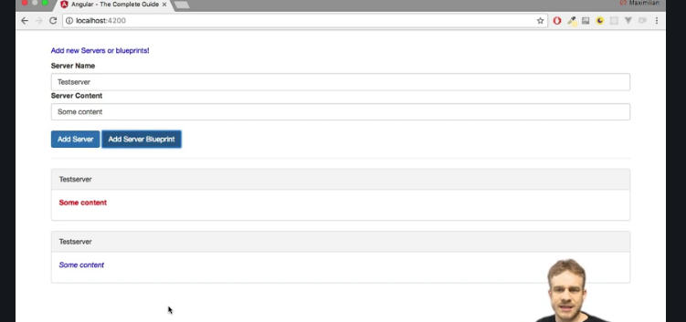

-the first component could be this cockpit here,so I will simply name it cockpit component.

-and then I will repeat the step for another new component which I will simply name server-element,

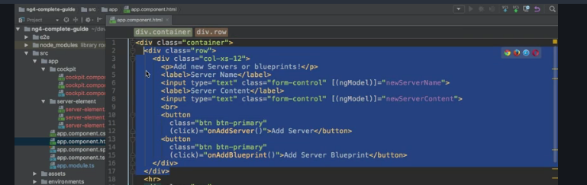

-get an error that a couple of properties are unknown.

So we somehow

and that is a key part,

need to get the new server

we add in the cockpit to this array of servers in our app component,

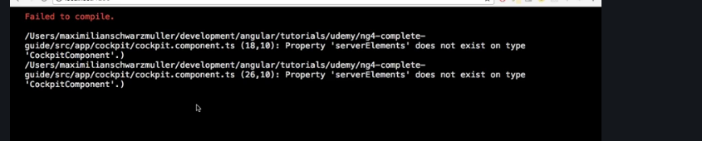

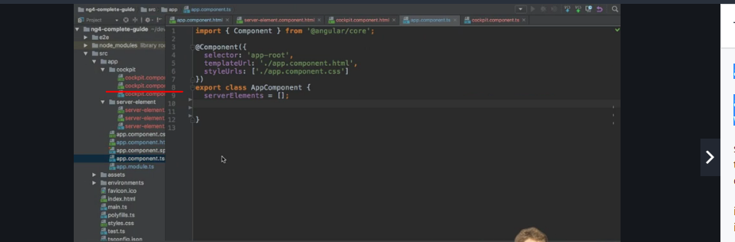

-so we kind of need to inform our app component that one of its child components, the app cockpit changed or that something changed there to which we should react,

a new server was added and then we also need to get the data we got from the cockpit,

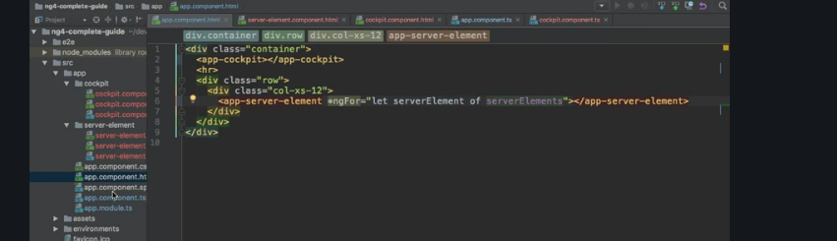

-and then we also need to get the data we got from the cockpit,

so this new server which is managed in this array of servers in the app component, we need to get to

individual server of a single loop iteration here down to the app-server-element.

So we need to pass data between components and that of course is a super important task

we haven't touched yet but we will dive deeper into right now.

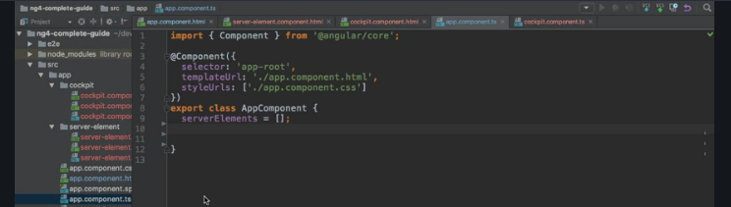

Property and event binding overview

we split up our app into multiple components which is great, that is why we use components

but one issue is that we need to pass data between these components.

-Now in the basics section, we learned about property and event binding and there we used it to, for example bind the disabled property of a HTML element.

-with event binding, when we click this HTML button,something happened,this button emitted an event to which we were able to listen,so it sent us some data. The same for the inputwhere we even used that data with $event if you remember this.

we need to be able to send data into a component or receive data, receive an event and Angular of course

-we need to be able to send data into a component or receive data, receive an event and Angular of course

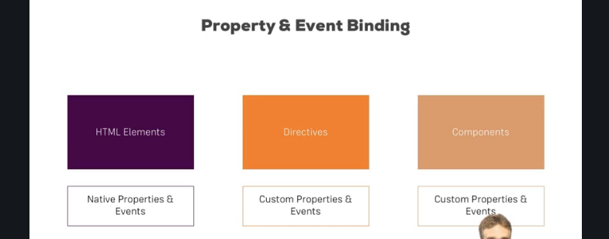

Used files

Used files

Cockpit.component.html

<div class="row">

<div class="col-xs-12">

<p>Add new Servers or blueprints!</p>

<label>Server Name</label>

<!--<input type="text" class="form-control" [(ngModel)]="newServerName">-->

<input

type="text"

class="form-control"

#serverNameInput>

<label>Server Content</label>

<!--<input type="text" class="form-control" [(ngModel)]="newServerContent">-->

<input

type="text"

class="form-control"

#serverContentInput>

<br>

<button

class="btn btn-primary"

(click)="onAddServer(serverNameInput)">Add Server</button>

<button

class="btn btn-primary"

(click)="onAddBlueprint(serverNameInput)">Add Server Blueprint</button>

</div>

</div>

Cockpit.component.ts

import { Component, OnInit, EventEmitter, Output, ViewChild, ElementRef } from '@angular/core';

@Component({

selector: 'app-cockpit',

templateUrl: './cockpit.component.html',

styleUrls: ['./cockpit.component.css']

})

export class CockpitComponent implements OnInit {

@Output() serverCreated = new EventEmitter<{serverName: string, serverContent: string}>();

@Output('bpCreated') blueprintCreated = new EventEmitter<{serverName: string, serverContent: string}>();

// newServerName = '';

// newServerContent = '';

@ViewChild('serverContentInput') serverContentInput: ElementRef;

constructor() { }

ngOnInit() {

}

onAddServer(nameInput: HTMLInputElement) {

this.serverCreated.emit({

serverName: nameInput.value,

serverContent: this.serverContentInput.nativeElement.value

});

}

onAddBlueprint(nameInput: HTMLInputElement) {

this.blueprintCreated.emit({

serverName: nameInput.value,

serverContent: this.serverContentInput.nativeElement.value

});

}

}

Server-element-component.html

lass="panel panel-default">

<!--<div class="panel-heading">{{ element.name }}</div>-->

<div class="panel-heading" #heading>{{ name }}</div>

<div class="panel-body">

<ng-content></ng-content>

</div>

</div>

Server element.component.ts

import {

Component,

OnInit,

Input,

ViewEncapsulation,

OnChanges,

SimpleChanges,

DoCheck,

AfterContentInit,

AfterContentChecked,

AfterViewInit,

AfterViewChecked,

OnDestroy,

ViewChild,

ElementRef,

ContentChild

} from '@angular/core';

@Component({

selector: 'app-server-element',

templateUrl: './server-element.component.html',

styleUrls: ['./server-element.component.css'],

encapsulation: ViewEncapsulation.Emulated // None, Native

})

export class ServerElementComponent implements

OnInit,

OnChanges,

DoCheck,

AfterContentInit,

AfterContentChecked,

AfterViewInit,

AfterViewChecked,

OnDestroy {

@Input('srvElement') element: {type: string, name: string, content: string};

@Input() name: string;

@ViewChild('heading') header: ElementRef;

@ContentChild('contentParagraph') paragraph: ElementRef;

constructor() {

console.log('constructor called!');

}

ngOnChanges(changes: SimpleChanges) {

console.log('ngOnChanges called!');

console.log(changes);

}

ngOnInit() {

console.log('ngOnInit called!');

console.log('Text Content: ' + this.header.nativeElement.textContent);

console.log('Text Content of paragraph: ' + this.paragraph.nativeElement.textContent);

}

ngDoCheck() {

console.log('ngDoCheck called!');

}

ngAfterContentInit() {

console.log('ngAfterContentInit called!');

console.log('Text Content of paragraph: ' + this.paragraph.nativeElement.textContent);

}

ngAfterContentChecked() {

console.log('ngAfterContentChecked called!');

}

ngAfterViewInit() {

console.log('ngAfterViewInit called!');

console.log('Text Content: ' + this.header.nativeElement.textContent);

}

ngAfterViewChecked() {

console.log('ngAfterViewChecked called!');

}

ngOnDestroy() {

console.log('ngOnDestroy called!');

}

}

App component.html

<div class="container">

<app-cockpit

(serverCreated)="onServerAdded($event)"

(bpCreated)="onBlueprintAdded($event)"

></app-cockpit>

<hr>

<div class="row">

<div class="col-xs-12">

<button class="btn btn-primary" (click)="onChangeFirst()">Change first Element</button>

<button class="btn btn-danger" (click)="onDestroyFirst()">Destroy first Component</button>

<app-server-element

*ngFor="let serverElement of serverElements"

[srvElement]="serverElement"

[name]="serverElement.name">

<p #contentParagraph>

<strong *ngIf="serverElement.type === 'server'" style="color: red">{{ serverElement.content }}</strong>

<em *ngIf="serverElement.type === 'blueprint'">{{ serverElement.content }}</em>

</p>

</app-server-element>

</div>

</div>

</div>

App.component.ts

import { Component } from '@angular/core';

@Component({

selector: 'app-root',

templateUrl: './app.component.html',

styleUrls: ['./app.component.css']

})

export class AppComponent {

serverElements = [{type: 'server', name: 'Testserver', content: 'Just a test!'}];

onServerAdded(serverData: {serverName: string, serverContent: string}) {

this.serverElements.push({

type: 'server',

name: serverData.serverName,

content: serverData.serverContent

});

}

onBlueprintAdded(blueprintData: {serverName: string, serverContent: string}) {

this.serverElements.push({

type: 'blueprint',

name: blueprintData.serverName,

content: blueprintData.serverContent

});

}

onChangeFirst() {

this.serverElements[0].name = 'Changed!';

}

onDestroyFirst() {

this.serverElements.splice(0, 1);

}

}

App.module.ts

import { BrowserModule } from '@angular/platform-browser';

import { NgModule } from '@angular/core';

import { FormsModule } from '@angular/forms';

import { HttpModule } from '@angular/http';

import { AppComponent } from './app.component';

import { CockpitComponent } from './cockpit/cockpit.component';

import { ServerElementComponent } from './server-element/server-element.component';

@NgModule({

declarations: [

AppComponent,

CockpitComponent,

ServerElementComponent

],

imports: [

BrowserModule,

FormsModule,

HttpModule

],

providers: [],

bootstrap: [AppComponent]

})

export class AppModule { }

Binding to custom properties

-we can use property binding to bind to our own properties,now we will start with Binding properties our own components

 -we should create a property in this TypeScript file, element which represents our server.

We can even assign a type by adding a colon and then simply defining the type which will be a Javascript

object hence the curly braces

and just because it's important, this is not the value, this is TypeScript syntax for defining the type

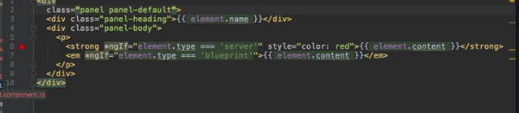

-we're trying to access here,a type, a name and a content. So we'll have a type and type on its own will be of type string,we will then have a name which will be a string and we'll have a content which will be a string.

So that is all now our type definition for a property we want to use in our HTML code

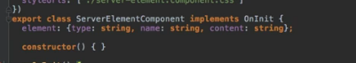

This everything is declared in the server-element component only.so we can add use in this component any where

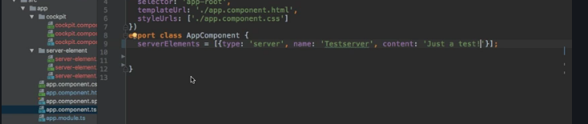

- Now it would be great if in our app component where we manage our server or our array of serverElements

I should say, if we could somehow access this property because let's say just so that we can see something,

we start with one server here which is of type server, has a name of test server and a content of just

a test

and just to be super clear, these colons here are not type definitions,

we're on the right side of the equals sign,

**so here we are assigning a value and the value here simply is a Javascript object and in Javascript**

**objects, we simply assign key-value pairs or we create key-value pairs by having the key, then the colon and then the value,so normal Javascript syntax here.**

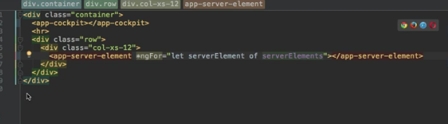

- we're looping through this array here on the app-server-element in the app-server-element,

we have our element property,

so a property in that component.

Now we want to access this component from outside,

so it would be great if we could bind to it, just like we were able to bind to disabled.

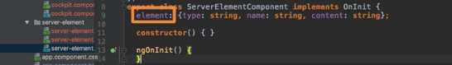

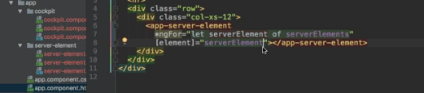- so the name of the property in the component, here this name and then assign the server element, so simply

the element we store for each iteration in this variable here. It would be great if we could do this

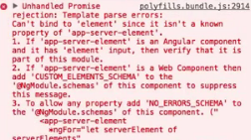

so why can't we access it?

because by default, all properties of components are only accessibleinside these components, not from outside and that generally is a good thing.

-You don't want to make all your properties bindable from outside.

So you have to be explicit about which properties you want to expose to the world so to say.

**So if you want to allow parent components to be able to bind to this property,**

**you need to add something to that element property,you need to add a decorator.**

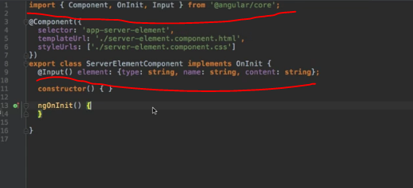

- Remember, I said that decorators are not only available for classes,

here we're going to add onto this property, the decorator we need to add is @input and here important, you

need to execute it,

it's like a function in the end,

so add parentheses and input now needs to be imported from @angular/core.

- With this in place, now we are successfully exposing this property to the world,

so now any parent component, any component hosting our server element component, so implementing it through

its selector like we do here, is now able to bind to element

Assigning an alias to custom properties

we learned how to bind to our own properties with @input parentheses in front of it,

- Now you can even configure this a bit more,

sometimes you don't want to use the same property outside of the component as you use inside of it.

So inside this component, you might say element is exactly the property name I want to use because it

makes the most sense but outside, so here, you maybe don't want to bind to element,

maybe you want to bind to srvElement to make it clear it's a server element, anything like that.

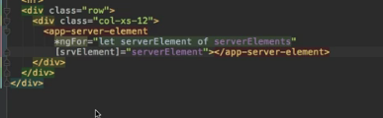

- Angular doesn't know

that it would be bindable

because there is no server element property in this component with @input in front of it.

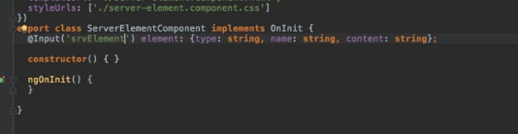

you can pass an argument to @input with the property name as you want to have it

outside of this component,

so srvElement could be added here and now from the outside,

so from the component where you implement this component, you now have to target srvElement if you

want to bind to this property.

- So that's a little bonus, a little alternative in case you want to bind to some other property name outside

of the component,

this is how you assign an alias.



Binding to Custom events

**Previous lecture we know how to pass data from a component down to another component which**

**was implemented there.**

**-** Now about the other direction, what if we have a component and something changes in there and we want

to inform our parent component, so the component which implements the other component?

**-** For example here in app component, we're implementing app cockpit

and in this child component, in app cockpit, something can change because here we got two buttons and

when we click the buttons, we want to do something

**-** and right now the code which would normally get executed was simply commented out.

- So here, we want to inform our parent component, the app component

in this case, that a new server or a new blueprint was created.

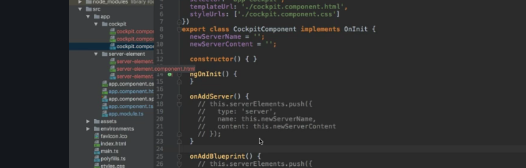

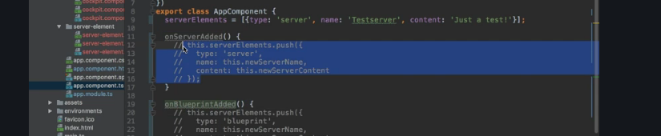

However I will adjust the names and say onServerAdded because these methods will kind of only be executed

after this button has been clicked, so not once the button is clicked but thereafter, once we really already

are done creating the server so to say. So onServerAdded and onBlueprintAdded sounds like more appropriate

- pp component is the central place in our app for now which manages this array of servers.

So how can we emit an event, our own event,

how can we inform our app component?

It would be great if it would look something like this, on the app cockpit,

so in the app.component.html file where we implement app cockpit,

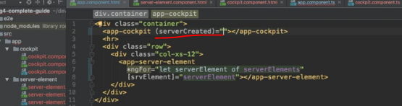

- t would be great if we could listen to serverCreated, any name you like but that would be a fitting

name for the kind of event we want to listen to.

Of course this event doesn't exist by default,

so just like we listen to click, now we want to listen to some event like this, serverCreated and once

a server was created, we execute some code,

so just like in any other built_in event like click here, on the right side of the equal side between the

quotation marks,

we want to call onServerAdded, the method we've prepared for this.

And we even expect to get some data with $event,

this is how you could catch this data, that could be some object which gives us the required information

about that server, like the name and the content.

So in onServerAdded now here, we would expect to get event data

or let's say we would actually expect to get the server data and that could be of type, let's say a Javascript

object which has a name field with a string

or let's be more explicit,

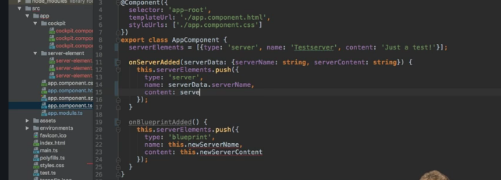

let's name it serverName which is of type string and serverContent which is of type string.

So that would be the type of object we expect to get in this method

and with that, we could use it here and use server data, serverName to assign it as a name for our

newly created server, the one we push onto our array here

and the same of course down here for the content,

so that is how it should work.

We get this data in onServerAdded and we call onServerAdded once our custom event occurs on the cockpit

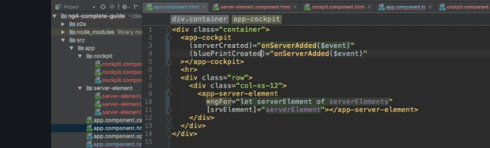

We are waiting for events named serverCreated and blueprintCreated, maybe with a lowercase p.

So in the cockpit component, I kind of want to create two new properties here, properties, that's important,

serverCreated and blueprintCreated.

Now before, we placed @input in front of them to mark them as properties you can set from outside,

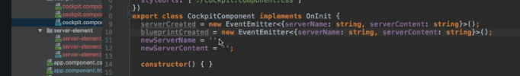

- we want to make sure that both properties kind of are events we can emit and to make them events,

we first of all have to assign a new value, new eventEmitter and eventEmitter needs to be imported

from @angular/core,

so you should add this import here at the top. eventEmitter is a generic type which is indicated in TypeScript

by using this smaller than and greater than sign and in-between, you simply define the type of event data you're

going to emit

and here,

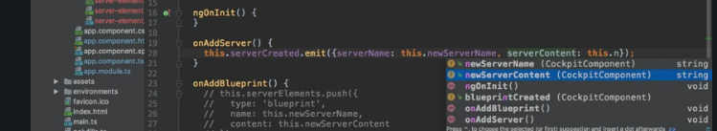

Now we get two event emitters and that's the first step, eventEmitter is an object in the Angular framework

which allows you to emit your own events.

What we can do with that is in onAddServer, we can now call serverCreated

and here we can call the emit method.

This will, well like the name implies, emit a new event of this type, so of the server created

here using this eventEmitter. Well and here, we simply want to create the object or pass the object

Asigning an alias to coustom event

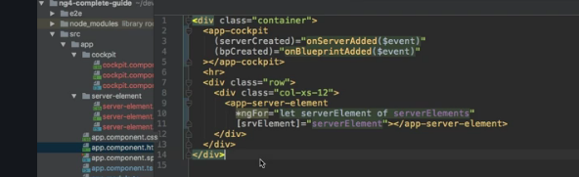

- Now just like on @input, on @output you also can assign an alias but here for blueprintCreated,

maybe you want to name this bpCreated. Now with this,

this is the event you can listen to from outside.

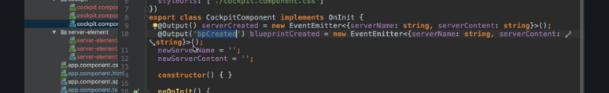

So in the app component where we try to listen, we now need to rename it here to and listen to be bpCreated,

which is now just like on @imput,

the one and only event you can listen to when it comes to this blueprintCreated event.

The other name, blueprintCreated here will not be exposed to the outside anymore, so it has to be

bpCreated now.

All the rest stays in touch and works just like before.



Understanding View Encapsulation

Concept- behavior enforced by Angular which is not the default behavior of the browser.

So whilst of course this CSS files have the goal of encapsulating styles for the component they belong to,

this again is not a default behavior, Angular gives us this behavior and it's a great behavior because with that, we can make sure that whichever styles we define in a CSS file will only get applied to the component they belong to.

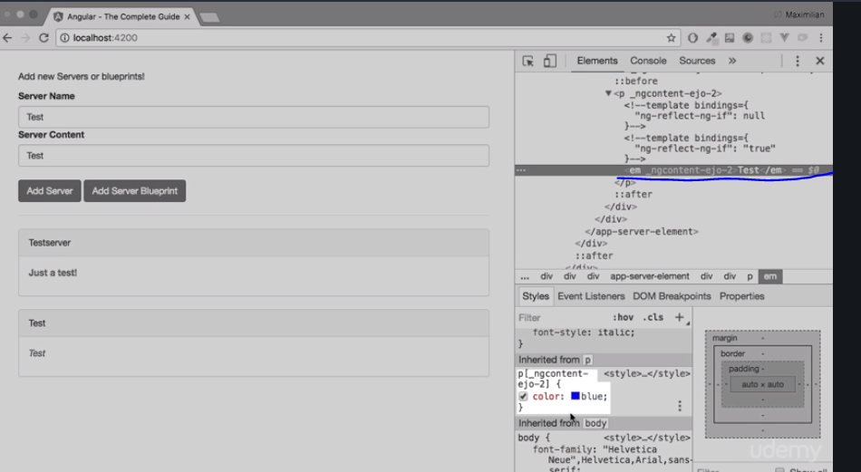

You can see this attribute here on the paragraph, that is why this style gets applied here because this style definition says make every text blue which is in a paragraph where the paragraph has this attribute, something which is true for the paragraph holding this specific text.

-Now the other paragraph we have in app cockpit here in the div,this paragraph does have a different attribute, _ng-content-ejo-1,down here we have ejo-2.That is why the styling gets not applied to this paragraph and all these strange attributes which you can see all over the place here,all these strange attributes are applied to their specific elements by Angular

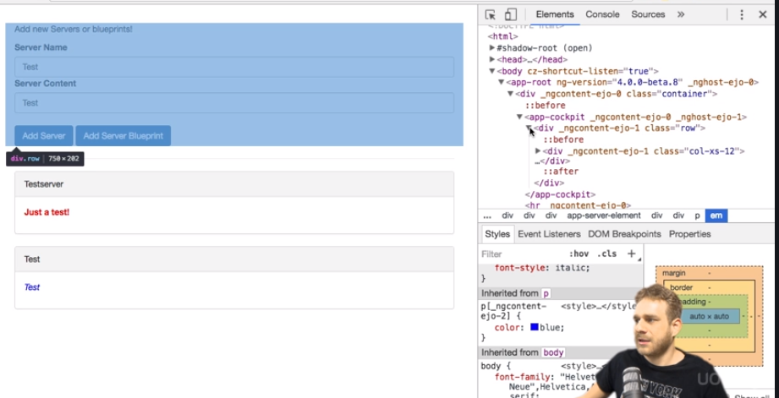

Angular as I told you enforces this style encapsulation and it can't do that magically,

so the way it does it is it simply gives the same attribute to all elements in a component.So all elements in this cockpit component have ng-content-ejo-1 attached to it as you can see and it does this for each component with different unique attribute names, ejo-1 and ejo-0 and ejo-2 .and with that, it can make sure that once it changed your style selector, it automatically adds this attribute selector to all your styles defined for a component, that these styles get only applied to elements of that component.This is how it enforces this behavior.

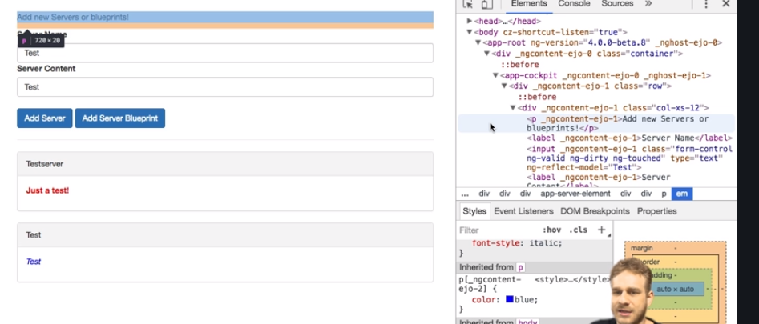

It kind of emulates the shadow DOM, the shadow DOM is a technology not supported by all browsers where each element has its kind of own shadow DOM behind it, where you then could assign styles to each element but as this technology is not supported by all browsers, this is how Angular emulates it and that is the default behaviour of view encapsulation in Angular.

More on View Encapsulation

Concept-

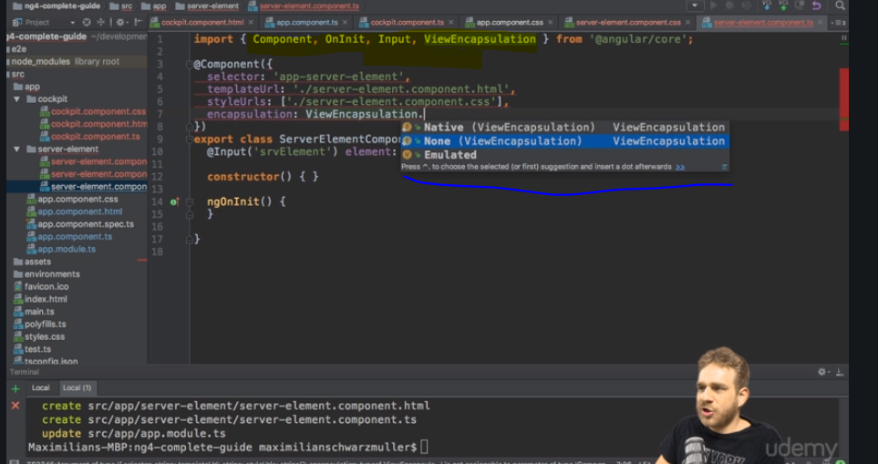

-now you can override this encapsulation though. If you go back to your code, to the server element

component, you can add something to the @component decorator,

-it's called encapsulation, this property and there as a value, you can access ViewEncapsulation which

needs to be imported from @angular/core

-choose between three modes.

1)Emulated is the default,

2) none if you add this would make sure that if we have a look at our component

again and we inspect our server element, that now in here, we don't see these strange attributes being, Therefore, this component now does not use view encapsulation.

3) Now besides none, you also could choose native and native uses the shadow DOM technology. This should give you the same result as before with emulated but only in browsers which support it which is why for most cases, you want to choose emulated but be aware that you could switch to none or native here too.

Using local reference in Templates

Concept-

 -with using output and input to pass data around our own custom property and event

binding.

- Now in the cockpit, right now I'm using two-way data binding to get the serverName and content.

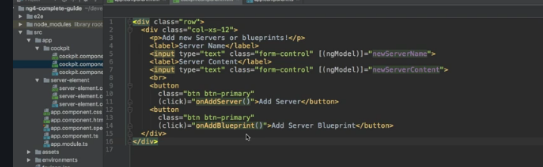

Now there is nothing wrong with that but maybe we don't need to use two-way data binding.

- Since I only want to save or use the data at the point of time I click the button, the add server or the add server blueprint button, it would be enough to get the value of the input at this point of time and there is a nice way we can achieve just that.

- a local reference on that element. A local reference can be placed on any HTML element, so not only on an input element, on anything you see here in the template and you add with a hashtag and then a name of your choice, like for example server name since this is what this reference will hold, a reference to this element, so maybe serverNameInput..

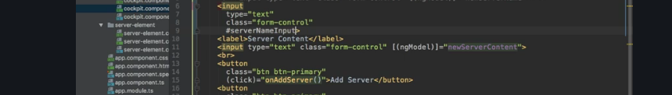

- Now important, this reference as I just said will hold a reference to this element,

so not to the value we entered there, to the whole HTML element with all its properties.

We can see this if we pass this now as an argument once we click add server, onAddServer.

- Here, I can pass serverNameInput because the other important thing you need to know about references besides how to create them is that you can use them everywhere in your template but important, only there, not inside your TypeScript code, only in the template. But we do call the method here inside the template of course, so here we can use serverNameInput and that is a way how we can pass it to the TypeScript code because

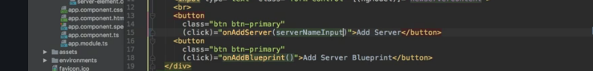

in onAddServer, we now know that we will receive the name input,

you could also name it serverNameInput and if we log this, we can analyze what this actually means, what we actually got here.

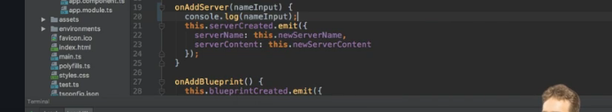\

**you see we actually get the input element itself. So this is the element we got here,**

**that is what the local reference gives us, the element with all its properties. So here we could also output value, the value of this input since we know that an input element has a value and of course this will depend on which kind of element you placed your local reference on,**

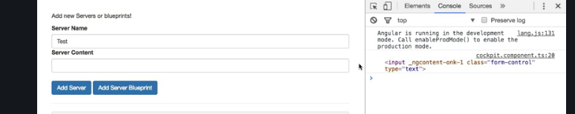

So local references, a very nice feature to get access to some elements in your template and then use

that either directly in the template, you could also output serverNameInput value here or you can pass it on, like we do to use it in the TypeScript code, a nice and handy feature.

Getting Access to Template and Dom with @view Child

Concept-In the last lecture we learned about local references.

**Now there is also another way of getting access to local references or to any element actually directly from within our typescript code.**

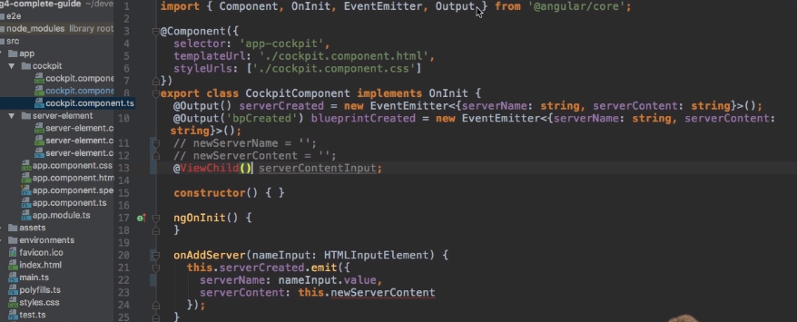

**-**a new property which I'll name server content input now server content input like this is just a property

but we can add at view child in front of it.This decorator with parentheses and we need to import view child from at angular core.

Now view child like this won't work.We need to pass an argument here and this argument actually is.

**=**We need to pass an argument here and this argument actually is.

Lecture or off to element how we want to select the element and select or now not like a CSX selector.

But for example we can simply pass as a string the name of a local reference so server content input

could now be passed as a string.



**-**If you don't want to pass a string but want to select a component you could simply pass to component

type here.So in the cockpit we don't use any other components but in the app component we could pass cockpit component so to type like this not like a string to get access to the first occurrence of this cockpit component

**-**So unlike the local reference we pass directly from the template why the method which was the element

itself.This is of type element ref so we can set this type here. Element ref a reference to that element element ref needs to be imported from at the angular core it's

the angular type.



**=**This server content input here and then native element to get access to the underlying element which

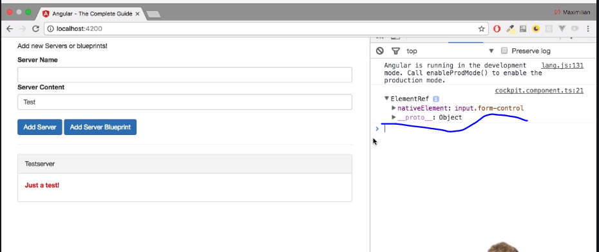

now has a value because this will now be the input element.

Now we can do the same of course for the on app blueprint method.

And with this we get direct access to elements in our Dom in our template through at view child.

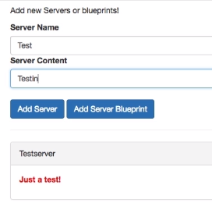

-And if we actually do this like this and I click ads or a blueprint you see something was now added

here.

I strongly recommend not doing this.

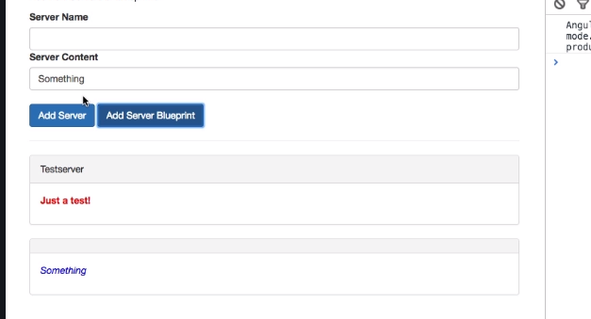

**-**You should not access to DRM like this angler offers you a better way of accessing the Dom and you will

learn about this in the directives section.

Generally you should use the other tools like string interpolation and property binding if you want

to output something in the DOM and not directly mess with any element.

You can get even though if you have gotten them through angular.

**-Projecting contents in the components with ngcontent**

Everything you place between the opening and closing tag of your own component is lost by default, is

simply removed from the DOM, Angular will not take care about it

but you can change this.

There is a special directive and it is a directive, even though it looks like a component but

it doesn't have its own template,

**-**Now without two way binding but with local references past two methods or local references fetched through

view child.

Now one important thing to watch out for is you should not change the element fruit is because of course

you could use our server content input the native element and then set value to something right.

You can't do this.

a special directive you can add in the server-element components template here, in the place where I

want to render the content, I can add ng-content, opening and closing again.

It still is a directive, just using this element like selector and this serves as a hook you can place

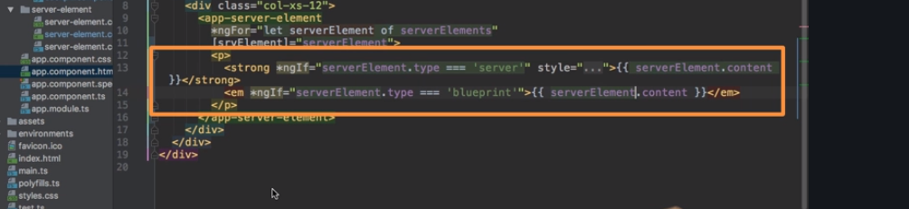 -in your component to mark the place for Angular where it should add any content it finds between the

opening and closing tag here,

so this content in this case. With this tiny addition, you should see that once you save this and let it

reload,

-but if it's more complex HTML code, property binding really is not the best solution because Angular

will escape HTML tags there to prevent cross-site scripting attacks from happening and you could

kind of work around that

but really, ng-content then is how you want to display this and that is a great tool to have at your

disposal.

Understanding the component Life Cycle

there is one thing you might have recognized before where you

weren't sure what it does.

What's up with this ngOnInit method we have in new components created through the CLI,

what's it doing?

**is a lifecycle hook and Angular supports a couple of lifecycle hooks**

If a new component is created in Angular

and of course Angular is responsible for creating these components when it finds one of our selectors

for example, it will instantiate a new version of that component and add it into the DOM.

So once a new component is instantiated, Angular goes through a couple of different phases in this creation

process and it will actually give us a chance to hook into these phases and execute some code.

We can hook into these phases by implementing some methods Angular will call if they are present.

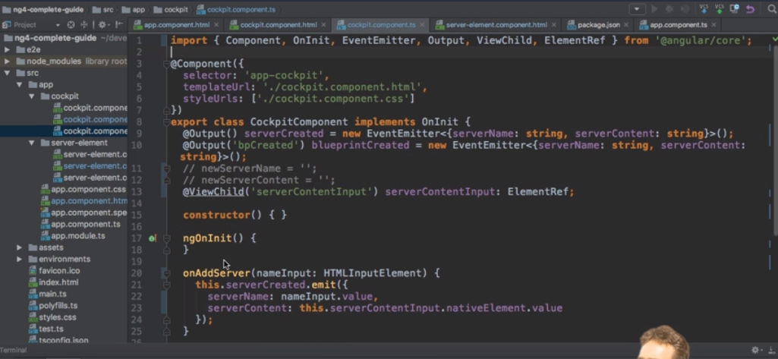

-The first phase, the **first hook** we can hook into is ngOnChanges and this may actually be executed

multiple times, it's executed right at the start when a new component is created but thereafter, it's

also always called whenever one of our bound input properties changes

and with that, I mean properties decorated with @input,

so whenever these properties received new values.

-Now the second hook is **ngOnInit,**

this method gets executed once the component has been initialized.This does not mean that we can see it,it has not been added to the DOM yet so to say, it has not been displayed yet but Angular finished the basic initialization, our properties can now be accessed and initialized for example,so the object was created you could say and if you're interested, ngOnInit will run after the constructor

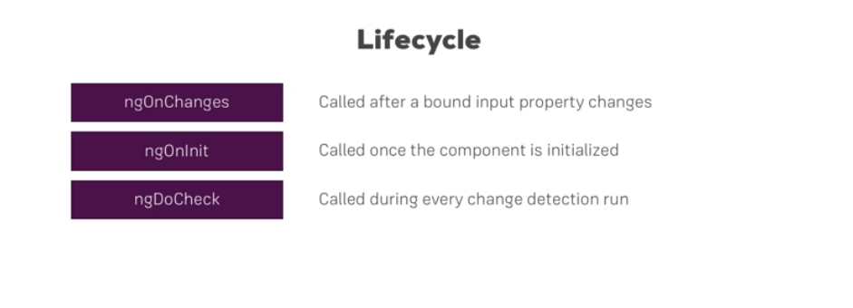

-Then we have **ngDoCheck,**   
that will also run multiple times,actually this method will be executed a lot because this will run whenever change detection runs.Now change detection simply is the system by which Angular determines whether something changed on the template of a component or inside of a component I should say,so whether it needs to change something in the template. So whether some property value changed from 1 to 2 let's sayand that property is output in the template.

well of course Angular needs to re-render that part of the template and ngDoCheck is a hook executed

on every check Angular makes. Now important, on every check, so not just if something changed,

a lot of times ngDoCheck will run because you clicked some button which doesn't change anything

but still it's an event and on events, Angular has to check if something changed because how else would

it know?You don't tell it,right,

so it has to check on certain triggering events like you clicked somewhere or a timer fired or an

observable was resolved and on these occasions, it will check your code and ngDoCheck will be executed.

-so change detection on Angular works pretty great and doesn't cost a lot of performance. ngDoCheck

is a great method to use if you want to do something on every change detection cycle, like maybe manually

inform Angular about some change it would not be able to detect otherwise, though that is a very advanced

use case.

-Well then, we reach **ngAfterContentInit**,

this is called whenever the content which is projected via ng-content has been initialized.

So not the view of the component itself but instead you could say the view of the parent component,

especially the part which will get added to our component through ng-content.

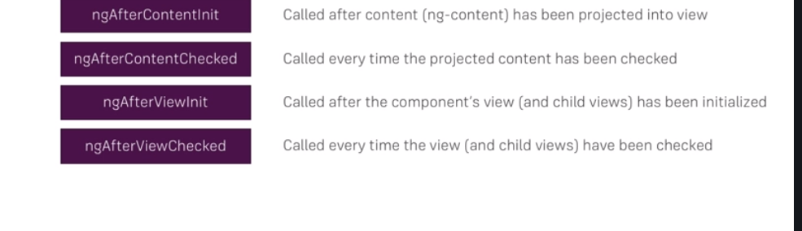

**-ngAfterContentCheck**

is executed whenever change detection checked this content we're projecting into our component.

-**ngAfterViewInit** is then reached once the view of our own component has been finished initializing,

so once our view has been rendered you could say.

- **ngAfterViewChecked,** well that is called

whenever our view has been checked,

so once we are sure that either all changes which had to be done were displayed in the view or

no changes were detected by Angular.

-if you destroy a component, for example if you placed ngIf on it and this gets then set to

false and therefore it removes it from the DOM, **ngOnDestroy** is called

and here's a great place to do some clean up work because this is called right before the object itself

will be destroyed by Angular.

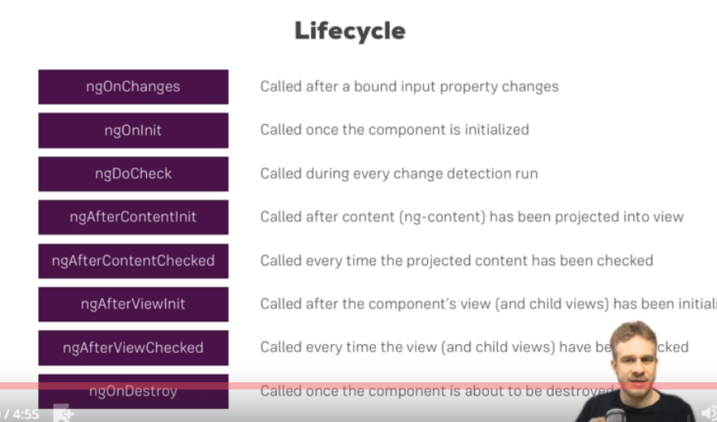

Seeing Life Cycle Hooks in Action

-now let's see what they actually do. In the server element component,



this is the component I will choose for demo purposes,

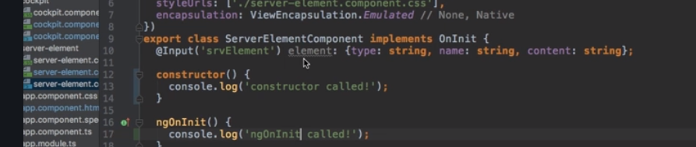

and if we reload the application here, we see right at the top, constructor called ngOnInit called

and for every new server we add, we see this again of course because a new instance of this component

was created and therefore all these hooks are executed again because it's a brand new instance, doesn't

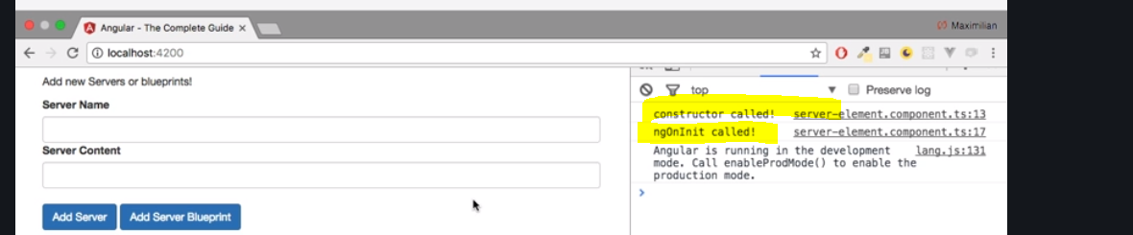



though it is a good practice to implement the onChanges interface too and that

is true for all hooks. Implementing the method alone will do the trick but it is a good practice to be

very explicit about which interfaces your component users or which methods your components will have.

So therefore implementing these interfaces is a really good practice,

it's very clear then which methods may be called in your component and which methods you won't have.

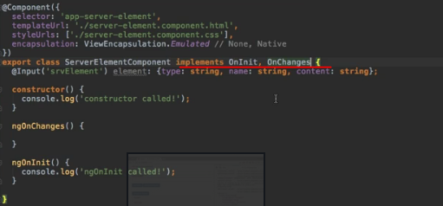

- So ngOnChanges runs first as I told you,- here we receive a changes argument which is of type SimpleChanges which also needs to be imported

from @Angular/core.

So I will simply log changes here, so that we can have a look at it and see what's inside.

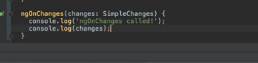

- we see constructor called ngOnChanges called

as mentioned before, ngOnInit and then we see the SimpleChanges.

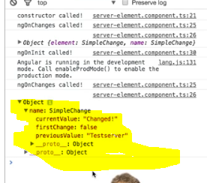

- to you if you want to react to any changes and then do something with the old values, store it

before it gets dumped or something like that,

that's ngOnChanges.



his will give us a method which is executed on every change detection run.

So ngDoCheck is the method we need for this

and here we can simply console log

ngDoCheck called,

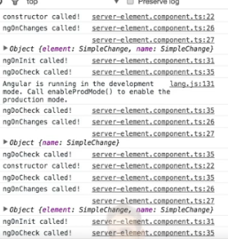

So ngDoCheck as I told you gets called whenever Angular checks for any changes and there are a couple

of triggers which trigger this method and event was called by clicking or a promise gave us back

some data, so a lot of triggers for ngDoCheck.



afterContentInit, this needs to be imported from @angular/core too, this

interface

and with that we need to implement ngAfterContentInit.

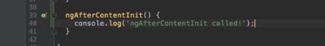

ou will see that here it is, there it is called after do check and it is called only

once because it doesn't get initialized again. Remember, content is the thing we projected into this through ng-content,

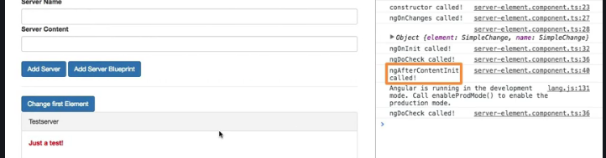

Remember, content is the thing we projected into this through

ng-content,

so this here will be our content in the end.

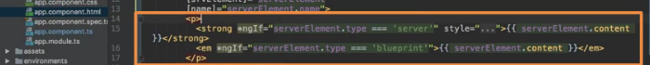

AfterContentChecked,



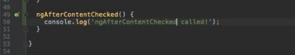

you see here it is called and here it is called again after do check, which makes sense because it is

called after each change detection cycle.

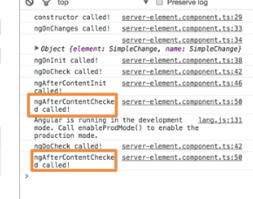



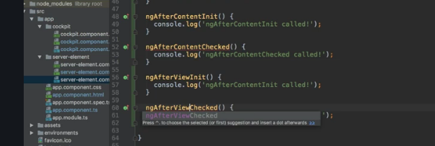

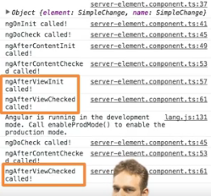

So if we log this, you see it happens after the content has been checked.





ngOnDestroy and onDestroy is called, well right before this gets destroyed,

this component gets destroyed.

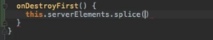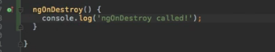

 We'll add it here to my TypeScript code and there I will something call server elements, the splice

method splicing at the first element and then just one element therefore removing it.

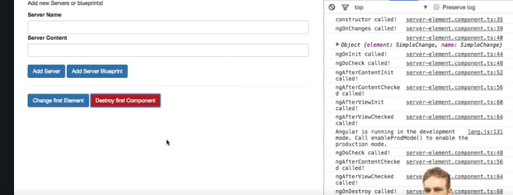

- and if I destroy the component, you see ngOnDestroy was called because we removed it from the

array,

therefore ngFor reran and didn't render this first element because it was removed,

therefore it was removed from the DOM,hence this component hook was called.

Life Cycle hooks and template Access

Concept- So that is the difference between Wilder points of time where these hooks run after view and it gives

you access to the Template elements.

You can then access them and use their values and so on before does Hook has been reached.

- We learned about at Vue child which we can use here in the cockpit to get access to element from our

while Dom from our template.

- So with that we get access to it and now we would expect that we can't use stairs before we reached

after view in it.

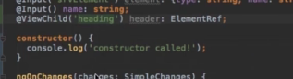

So let's try it and energy on in it.

Let me actually console log this

header and there the native element.

And now let's access something which is definitely a whale on a div and that is the text content if

we do this and I save this.

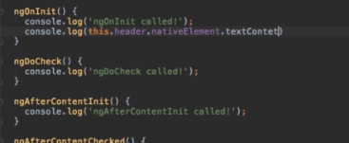

- This is where I would have expected text content can make this even clearer by outputting text content

and then while rendering the text content if there were any there is no text content in here as you

can see an empty space.

If I copy the exact same code and placed as an after view in it here.

So after the view should have initialized now you will see that here when it's called the second time

after viewing it we see test server.

So that is the difference between Wilder points of time where these hooks run after view and it gives

you access to the Template elements.

You can then access them and use their values and so on before does Hook has been reached.

You can't do that you can't check the value of some element in your dorm because it hasn't been rendered

yet.



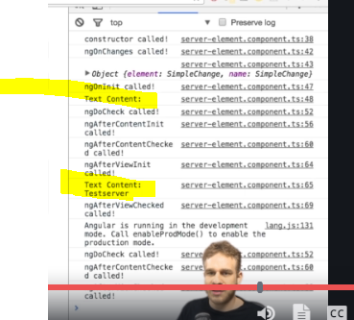

Getting access to ng content with @contentchild

Concept-if you want to use a local reference in ts file by local reference in template

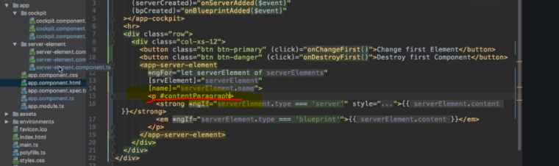

App component local reference going to be used in server.component.ts

- Now in the app component which is where we currently placed us in the template we could use at The View

child because it's in the template of the app component even though it will be kind of passed on to

the server element component later.

- But at the view child won't work because it's not part of the view.

It's part of the content which is why we also have separate hooks your content in it and view in it.

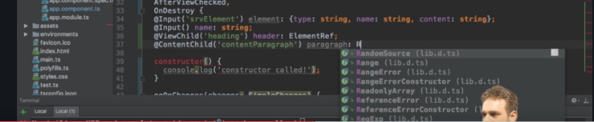

- with view ref we of course can't access to value or anything before we reached content in it.

So that's something I just wanted to add at content child to get access to content which is stored in

another component but then passed on via energy content.

Course Project- Component and Data Binding

Introduction

So in this section, what we're going to do is we're going to fine tune this, we're going to make sure

that we can navigate between recipes and shopping lists,

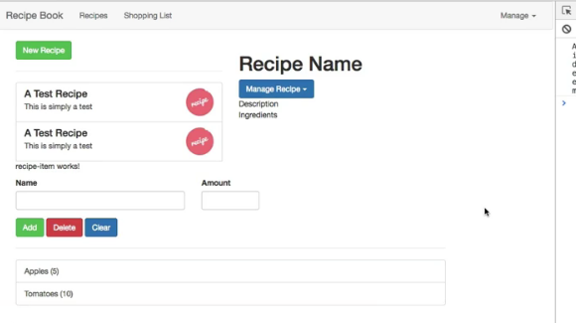

-can select recipes here and load them in the detail section

and generally, that we have a working communication between our components.

Adding Navigation with event binding and ngif

Concept-here how information should be passed between two components

-header component has option to navigatre between two components

-in header we will set one property to feature selected, to eventlistener

-on appheader html getting that property and assigning to on navigate method

- loaded feature to check which feature is loaded

-using in appcomponent by using ngif.

-I will use ngIf to only load one of the two sections at a time, so somehow in my app component probably because that is where I include both, here I will need to manage which one should be displayed and I should determine which one is displayed in the header component,

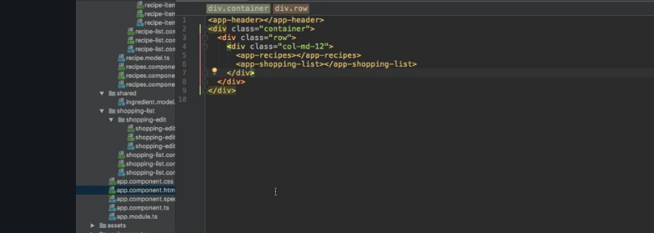

-so somehow in my app component probably because that is where I include both, here

I will need to manage which one should be displayed and I should determine which one is displayed in the

header component,

-so I should kind of pass the information which link was clicked there to my app component, so that

I can then switch a property there to only display one of these two components.

-emitting some event in the header which allows us to determine which component should be displayed here

in the app component.

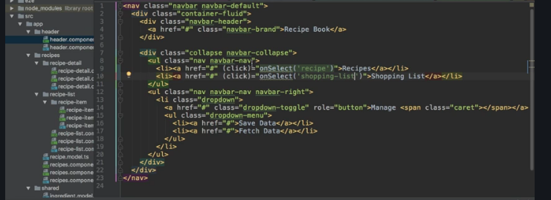

-I'll start in the header component template, here we got these two links and I want to attach some click listeners to these links.

-Here I will say onSelect and I will pass a string

here, recipe maybe, we can of course pass our own data to the methods we execute here and here,

I will select another one or add another click listener and I will say onSelect shopping list.

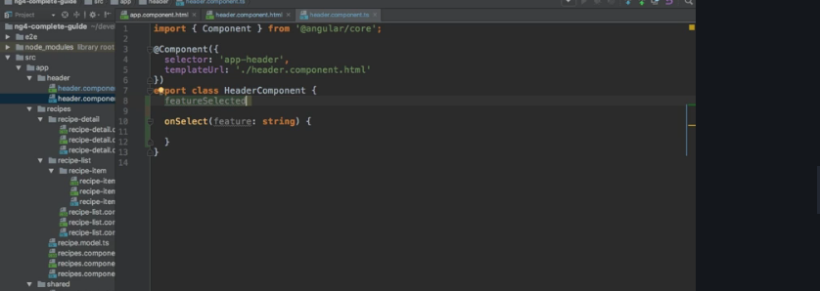

-now in the header component, I of course need to implement onSelect and we get an argument here,

we pass it here right,we get a string on what to select.So maybe let's name it feature and that will be a string,so let's assign the type string here by adding a colon and string thereafter and now as I said, I want

to emit my own event.

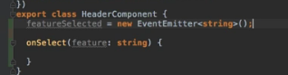

-first of all I'll need to add a new property which I'll name feature selected,

-This should be a new event emitter and now remember, event emitter is imported from @angular/core,

that's a generic type and we will pass string here, the feature which was selected in the end and we have to add parentheses to instantiate this, so to create an object based on the event emitter class. That is our feature selected event,

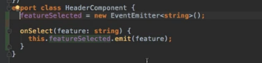

That is our feature selected event,now I want to use this property which now holds this event emitter as a value to emit an event whenever we click one of the buttons and I will then emit feature,

-so this string we receive from these method calls here in our template.

-missing piece is to enable this event to be listened to from outside of this component.

**So we have to attach something to this property to make it listenable from the parent component,**

**the app component in this case, that something is the @output decorator, don't forget the parentheses**

**-@output enables us to use this event or to listen to it from the parent component.**



-So in the app component which is the parent component which adds app header here, I will listen

to the feature selected event and then here, I will execute onNavigate let's say and of course,

**-interested in the data I'm receiving from feature selected, so I can get access to it with $event,**

**this protected name we could use in the template to get access to any data an event passes to us.**



So let's turn this back to $event to get access to the data we actually pass in our own event

-I will add onNavigate and here, I will receive

the where should we navigate to information. So you may choose any name you want,

I'll go with feature again, this is the feature we want to navigate to and now we should make sure that we

actually store this feature.

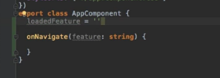

and then in onNavigate, I will set this loaded feature equal to the feature we receive here as an argument.

And you could even omit this method and directly set loaded feature equal $event here

but I will go for the longer approach to be very explicit about what's happening here.

So with that, we're getting this loaded feature,

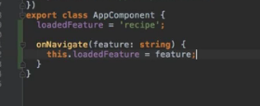

-now we can use ngIf to determine which of the two components should be displayed.

App recipes should be displayed if loaded feature equals recipe and shopping list should be displayed

whenever loaded feature let's say does not equal recipe,

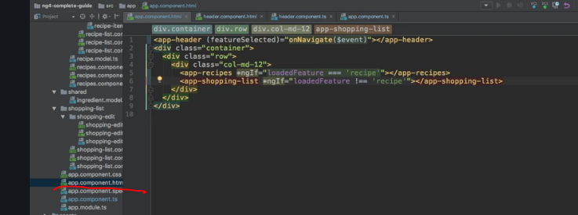

so that will also catch cases where it somehow is set to something else.

So with that, we're using ngIf,

now let's see if that works.We only see the recipe now and if I click on a shopping list, we see the shopping list and the other way around.So now navigation is kind of working, again

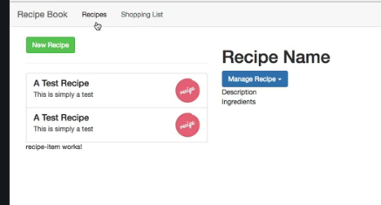

-Now let's move on to making the list items here real list items living in their own component.

Passing Recipe Data with property binding-

Concept-took the code from recepie list component and add it in recepie-item-component

-and take this ngfor out from recepie-item-component and add it to recepie list component.

-do the iteration

ow I want to work on this list of recipe. Right now if we have a look at its component here,

we see that the code for a single list item is this one here.

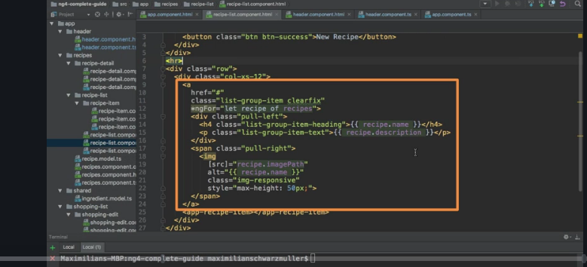

We do have a separate recipe item component

- now the goal of course is to remove this ngFor loop **from recepie-item component-html** and move to to recepie-list- component.html and then pass down the individual item, the individual recipe of each iteration

to that component so that we can still output recipe name and so on here.

so get ngFor out of this component and then pass down the selected recipe or the recipe of the current

loop iteration, in a few seconds you'll see my solution.

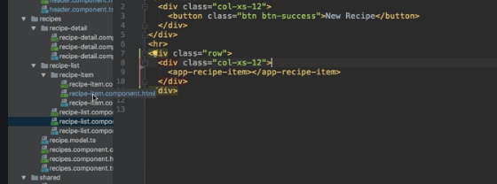

First of all, I'll cut the ngFor loop here and I'll go back to the recipe list component and add it to the

app recipe item selector,

so that now the whole component is replicated for each recipe.

- Now the issue of course is that we don't have the recipe which we access inside the recipe item component anymore.

So we should probably add a recipe here, the recipe of that single recipe item component.

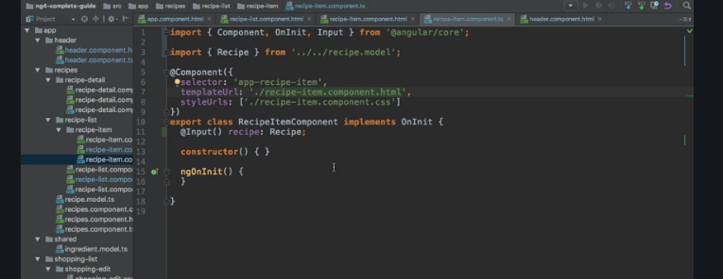

It will be of type recipe of course,so we have to import this from our own recipe model,

- there won't be a value assigned to it because I want to get this recipe from outside.So to get a recipe from outside or any data from outside,

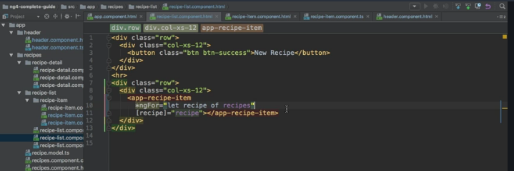

- we need to add something, a decorator, @input with parentheses which needs to be imported from @angular/core.

@input allows us to bind this component property from outside

and of course I want to bind it from my recipe list component here,

- Now here we can now bind to our recipe, referring to the property in the single recipe item and bind the

recipe of the current loop iteration.Now I'm not happy with the naming here because that can be very confusing,

- so to make super clear what each name here refers to, I'll rename the recipe here in our loop to recipeEl

for element and that also has to be replaced here then because we're passing the single recipe element

as a value,

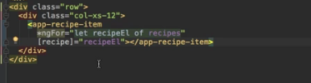

And keep in mind, the recipe here between the square brackets simply is the recipe property in the component we're placing this on.So in the recipe item component, this recipe here, that is what that r

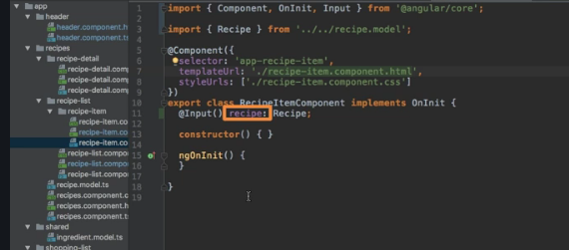

- the recipe item component and the sending one, here template of the sending one, the recipe list component above each other,so that is what we're binding to here.So let me close this.

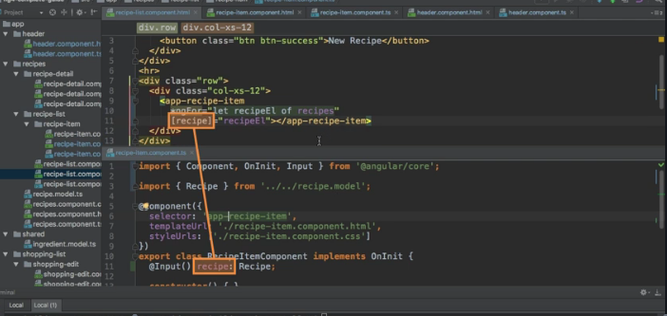

Now let's work on a feature that once we click an item here, we actually select it and then we load it

in the recipe detail component.So that is what we'll work on next.

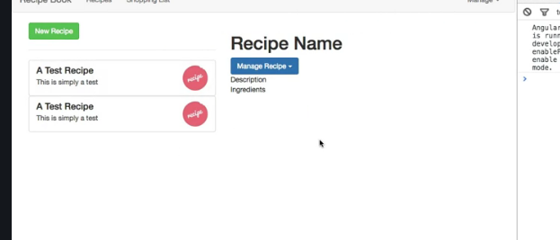

Passing data with event and property binding

Concept-

Exercise- So with all these features added, let's make sure that we can click on a single item here and load it in the recipe details section.

-Again this is the challenge for you, it only uses tools we learned thus far,you somehow need to emit an event on the single recipe item component.

- that it was clicked and then get this event somehow to the recipes component which then also holds the recipe detail to pass down the event data, which recipe was selected to that component.

-Now you're going to have to work with property and event binding for this,again only things you learned thus far and if you're getting stuck or something like this, of course we will solve it together in a couple

of seconds,here's your chance to pause.

Allowing the user to add ingredients to the shopping list

Concept- local references and at view child. excercise

- For now I want to make this shopping list input fields here are working so that we can add new items

to our shopping list.

- We will overwrite this later when we learned about forums but it's a great exercise to work with local

references and at view child.

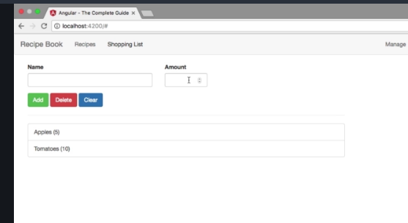

what I want to do is I want to work on this shopping list added component here.

Here we got a couple of input fields and we get the Add button which submits our form later delete and

clear.

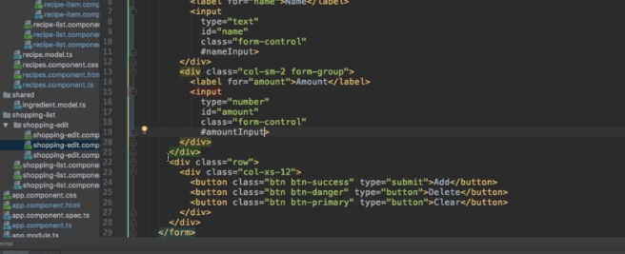

-Now I want to allow the user to add new items.So what I'll do is I will restructure both inputs to use multiple lines simply to make it easy to read and understand.

And on the first input for the name I will add a local reference named name input on the second one

I'll add one named amount input.

Now with that setup your challenge would be to get this Add button to kind of use these local references

preferably by either passing them as an argument or more advanced by selecting them with at view child

so that once you click the button you use the values of these inputs to create a new ingredient and

add it to your array of ingredients.

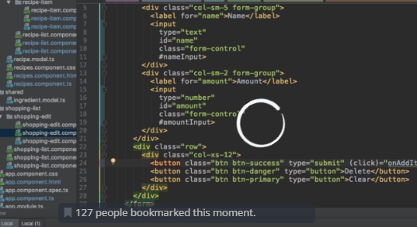

Directives Deep Dive

Concept-

-learn how to build our own directives and really dive into the

-difference between attribute and structural directives

-ngfor and ngif

-ngstyle and ngclass

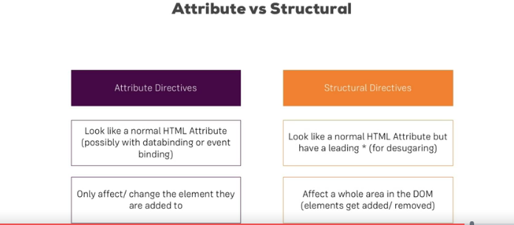

-Attribute directives are called like this because they sit on elements, just like attributes and whereas on the attribute directive, you never destroy an element from the DOM,you only change properties of that element,for example the backgroundColor.So that is why we have attribute directives only affecting the element they sit on and structural directives

-structural directives basically do the same but they also change the structure of the DOM around this element. If you have ngIf on a paragraph, if that condition is false, this paragraph is removed from the DOM,

Creating a basic Attribute Directive

Concept- creating a Directive folder and a file.

-mentioning @directive on the top and importing from angular/core

-

Scenario- So I want to build a directive which simply highlights an element I hover over, let's say.

-  just like with a component where we added @component, here we have to add @directive and directive

needs to be imported from @angular/core,

**Now how do we configure a directive?**

The one thing our directive absolutely needs is a selector because remember, we do place directives in

our template to attach them to elements, so we need to have some way to give Angular that instruction and that is the selector. Here that should also be a unique selector.

So typically, here you use a camel case notation to give it appHighlight as a selector or here maybe

appBasicHighlight, like this.

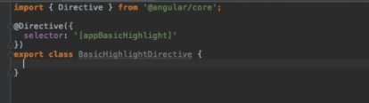

Now that would select it by element. Now I want to have this attribute style, so I'm going to wrap this in square brackets which means this will now be recognised whenever I add appBasicHighlight without square brackets to an element.

**- So the basic thing is, the most basic use case is we change let's say the background colour of the element where we attach this directive.**

For this we need to get access to the element the directive sits on and

the cool thing is Angular gives us this access. We can inject the element

the directive sits on into this directive and **injection is something we'll take a closer look at in**

the next course module, in the big next course module which is about services, I can say that much.

**It basically is an easy way to get access to some other classes without having them to instantiate**

**on our own.**

**-** We do inject by adding the constructor which every TypeScript class has,

we don't need to write anything in the constructor body for now but here on the list of arguments, we

list a couple of arguments we want to get whenever an instance of this class here is created

and of course Angular is responsible for creating these instances.

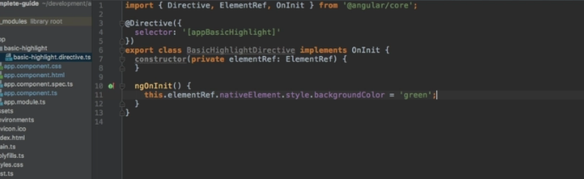

Well this thing we need in this case simply is a reference to the element the directive was placed on. So

an element ref and this name is totally up to you but the type is important, the type has to be element ref,

you might recognize this from @ViewChild,

there it also was a reference to some element, here it is too. Now to be able to use this data in our class

**-** will make this both a property of this class, so property element ref and automatically assign this value,

so this instance we're getting to this property. Now with that, we got access to the element,

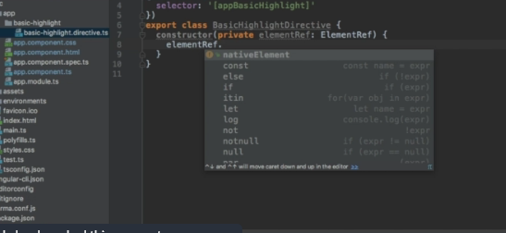**-** now we can use it here in our constructor for example, access the native element and then do something

with it. Though a better place than the constructor is onInit

and just like the component, the directive also has the ngOnInit lifecycle hook.

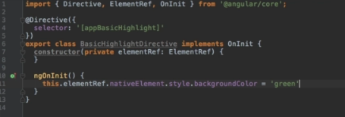

So here, I can therefore add ngOnInit and in there, we could access element ref,

that's the shortcut which automatically gave me this property, access the native element and there access

the style and maybe the background color and set this equal to green so that we can see something changed.

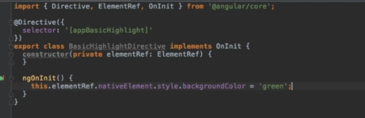

**-So what we're doing here is we're getting access to the element the directive was placed on,**

**- getting access to that exact element and then we're overriding the style of this element,**

**-** now let's use this directive. To use it,we have to do two things.

First of all like for a component, we have to inform Angular that we have a new directive.

Just like with components, it doesn't scan all our files, so it doesn't know

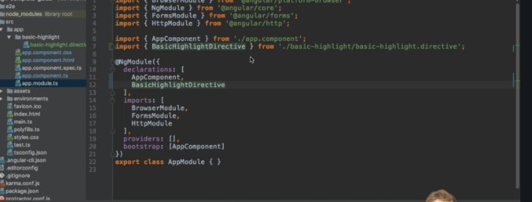

**-** So we have to go to app module and here in declarations, we have to add our BasicHighlightDirective

and also add the import pointing to the basic-highlight folder and there to the BasicHighlightDirective

file.

-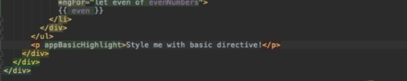

We don't need to set any value

and importantly, we don't use square brackets because as I already emphasized, the directive name is just

a selector

we set up here and the square brackets here are not part of that name,

it's part of this selector style telling Angular please

**What happens Behind the scenes on structural directive**

**Concept-** star is actually required.

- This star indicates to Angular that this is a structural directive,

-ng template helps in achiving the same.

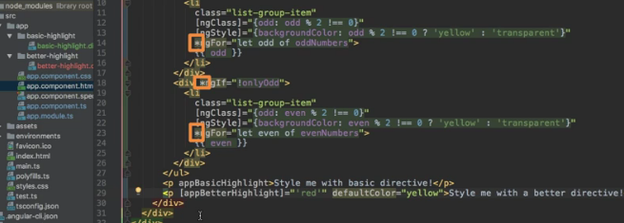

I would have an ng-template element, that is provided by Angular as the ng indicates

and inside this element, we have the content we conditionally want to render.

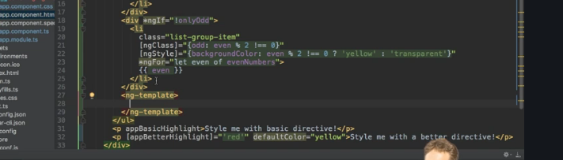

So in this case here, we would have a div inside of this and in this div, our list item.

Now you probably see that it's basically the same but that it's wrapped in ng-template,

**the reason for this is that ng-template is an element which itself is not rendered but which allows**

**us to define a template in the end**

**for Angular to use once it determines that this template, some element needs to be rendered because this**

**condition is true in this case.**

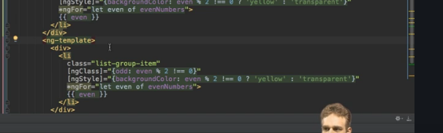

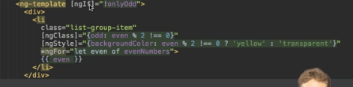

**Building a Structural directive**

**Concept-**

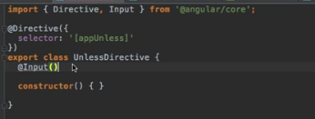

**-** Now here, I need to get the condition as an input, so I'll add @input and remember in the end, we will use property binding with the square brackets because Angular transforms it for us,

**-** we need to of course import input from @angular/core

and then here, I want to bind to a property named unless, which kind of simply is the condition we get

but whenever this condition changes so whenever some input parameter here changes, I want to execute a method and therefore, I can implement a setter with the set keyword.

This now turns this into a method, though technically and that's important to understand, this still is

a property, it's just a setter of the property which is a method which gets executed whenever the property changes and it of course changes whenever it changes outside of this directive,

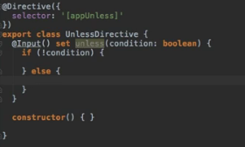

so we could also name this condition. Then we can check if the condition is not true, which is the case

in which I want to display something because unless is the opposite of ngIf and if the condition is true,

well then I want to display nothing.

So that is how we get the condition, how we use it, how do we display something?



Keep in mind that our unless directive here in the end will sit on such an ng-template component because

that is what it gets transformed to by Angular if we use the star.

So we can get access to this template and we also need to get access to the place in the document where

we want to render it, both can be injected.

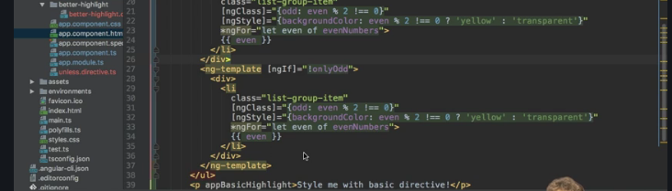

**-** The template can be injected by adding template ref, any name you like but the type is of type template

ref, so just like element ref gave us access to the element the directive was on, template ref does the same for a template and this is a generic type, you can simply pass any here and we need to import template ref from @angular/core.

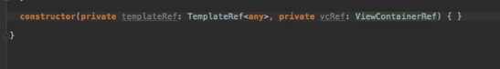

The second information piece we need is the view container,

so where should we render it?

The template is the what, now the question is where.

So I'll name it vcRef for view container reference and the type is view container reference or view

container ref which is also imported from @angular/core.

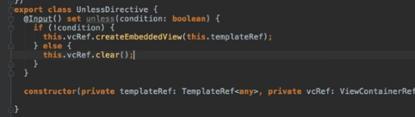

createEmbeddedView method which does just what the name implies, it creates a view in this view container

and the view simply is our template ref.

So this template we created there is exactly this reference to the template there, is exactly what we

need.

Well and if the condition is true in this case, so if its not what we were looking for, then we will

simply call the clear method to remove everything from this place in the DOM.

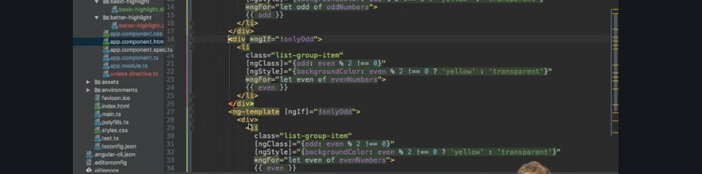

**-** we can use our own directive, maybe to replace ngIf here, so I'll comment out all this stuff here

**-** So here instead of using ngIf, I'll use appUnless and the star is important because it still is a structural

directive,

**-** So here instead of using ngIf, I'll use appUnless and the star is important because it still is a structural

directive,

otherwise we would have to manually write it with this ng-template syntax you learned before.

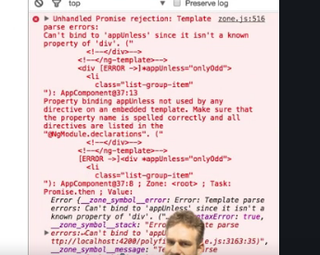

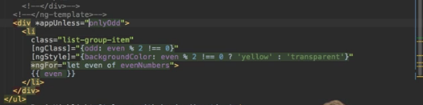And with this in place, we get that we can't bind to appUnless because it's not a known property. Why do

we get this? Can be really hard to track,

we get this error because what we're trying to do is we have property binding here, custom property binding

with @input and we're binding a property named unless.

Now keep in mind, the star

automatically transforms this in this ng-template syntax where we then try to property bind to the

directive name which is appUnless. So we have to make sure that our property here shares the name of the

directive,

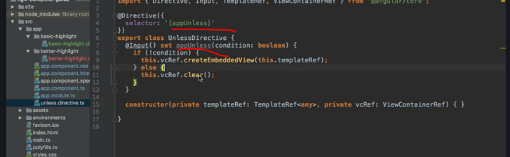

**Understanding NGSWITCH**

**CONCEPT-**

I want to conclude the section with one other built-in structural directive which might be handy from time

to time, ngSwitch. Imagine the case that we have a value like this which is simply 10,

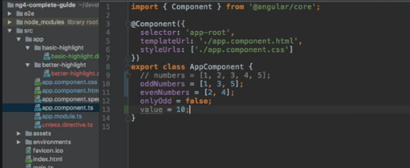

Now we got a place in our app where this value changes and we get a couple of different messages

we want to display for each of these values. For this, we can use ngSwitch,

so let's add a new div

below our paragraphs with our own attribute directives and ngSwitch is used like this.

We are bind to ngSwitch with property binding,

so no star at this point and we bind to value.

So this is our condition

basically, what we want to check and then you might be aware that switch has a couple of cases we can now cover.

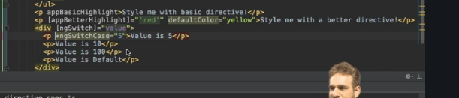

**-** Now here, we also need to add the star of course. With this in place, if we save this, we only see 10 here

and if I go to my component and I change this to 5, like this, then of course we see five.

So this is ngSwitch, super easy to use, might be useful in some cases where you find yourself creating

a lot of ngIf conditions, ngSwitch might be the better solution in such cases.

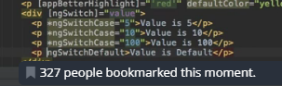

**Course project directives-**

**Building and using a dropdown directive**

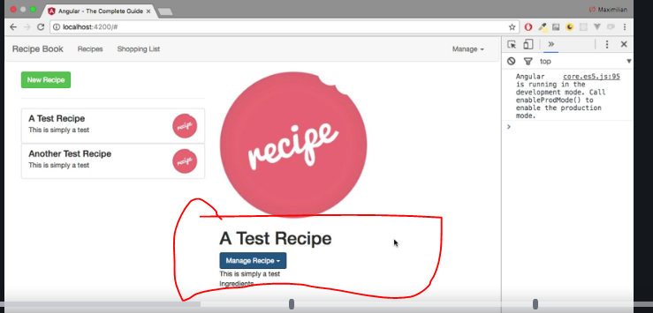

but now I want to enhance this project by adding our own directive which allows us to open the drop

downs which don't work as of now if you click them.

**-** They don't work because we didn't import Bootstrap's Javascript code and I don't want to import

this because Angular should be the only thing interacting with my DOM

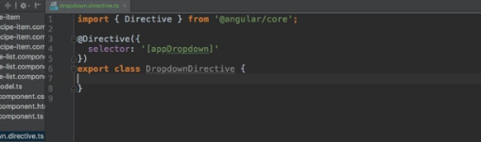

**-** name which doesn't accidentally interfere with an officially existing attribute name or anything like

that.

Now what should this directive do?

I want to add some functionality to it which allows us to add a certain CSS class to the element it

sits on once it is clicked, so once this element the directive sits on is clicked and removes the class

once we click again let's say.

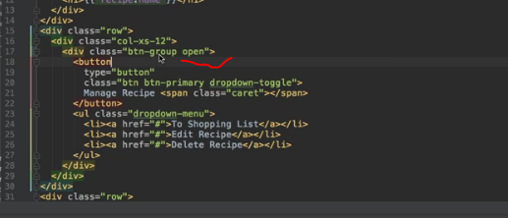

mplementing such a method which basically listens to clicks and then toggles some property which

determines whether some class is attached or not and also try implementing some code which dynamically

attaches a CSS class or not. Before you actually start though,

let's find out which class we need to attach.

**-** So it's this open CSS class, the same for the usage in the header

we need to attach. So that's your challenge, build a dropdown directive

which attaches this class whenever we click on it or removes it once we click a second time.

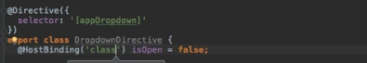

**-** a fitting name because that is what I want to do,

I want to toggle whether this should be opened or not.

Well then, I will add an isOpen directive which I'll set to false initially and in my @HostListener, I'll

simply set open or isOpen to what it is currently not. So if isOpen was true,

it will now be set to false and the other way around.

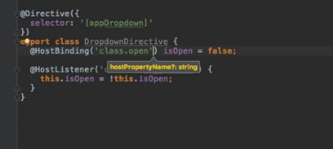

So with that, I'm toggling that property. Now to dynamically attach or detach a CSS class depending

on this,all I have to do is, I'll add @HostBinding which needs to be imported from @angular/core and allows us to bind to properties of the element the directive is placed on

I want to bind to the class property of that component, of that element, class simply is an array of

all the classes and here, it's all about this open class. As you learned, that's the CSS class we need to attach dynamically or detach and now the rest will be handled by Angular since I bind to isOpen,

this will not be attached initially, whenever isOpen switches to true, it will be attached and whenever it switches to false, it will be removed

and that's our entire directive.

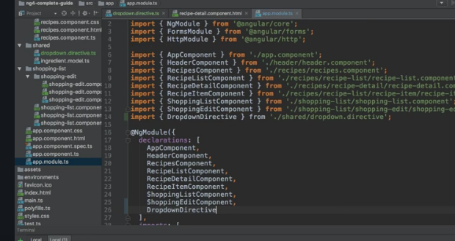

Now to be able to use it, I need to go to app module and add it here, add the dropdown directive and add

the import pointing to the shared folder and with that imported now, I can use it.

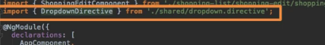

I can use it in the

detail component,

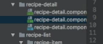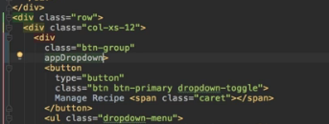

on this directive and now in the header, here the place where I need to add it is this list item with

the class of dropdown, here this is what will actually need the open class to show something. With that

in place and and ng serve still running,

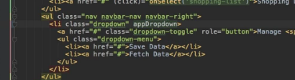

**Using Services and dependency injection**

**Module introduction-**

**Concept-** reusability of code, We also communicate between these components,

that's another area where services can be really helpful

**-**what are services? Let's consider this application, we get an AppComponent, an AboutComponent, a UserComponent and a UserDetailComponent.

**-**Now we might have some methods in those components, let's say we want to log some data to the console in the AboutComponent and in the UserDetailComponent and somehow this log statement is pretty similar,so pretty much the same text, so we're basically repeating ourselves here, we're duplicating code in two different components.

**-**Let's say in the UserComponent, we also want to access some data, some array of users maybe and maybe we also don't know if we will later use that in some other part of our application.

Both use cases, duplication of code and data storage, providing data are typical use cases for a service

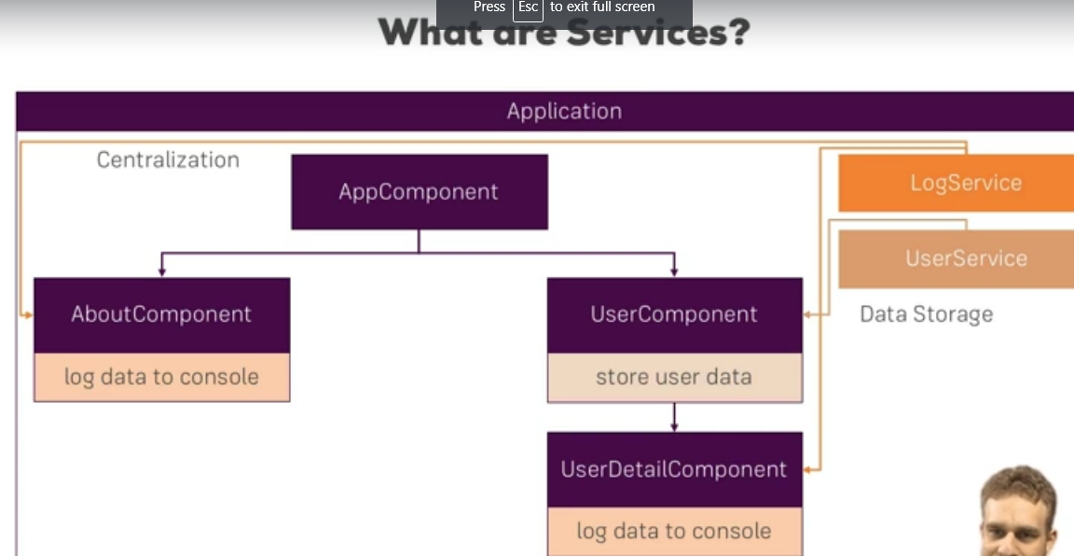

**-**because a service is basically just another piece in your Angular app, another class you can add which

acts as a central repository, as a central business unit you could say, something where you can store, where you can centralize your code in. So we could create a log service for example to centralize our log

statement, we could create a user service to manage the data storage here.

**Why would you need the service**

**Concept-**how services will make the data binding easier.

we started with three accounts here at the bottom,

-we can switch these status of these accounts and you can see that whenever I switch it or log something

to the console,

**-**if I create a new account here and overall, what we get here is the logging and the data storage,

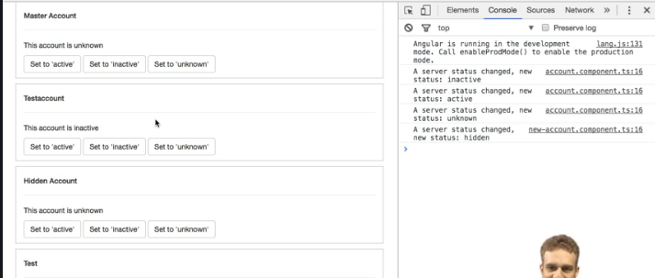

**-**We also communicate between these components,that's another area where services can be really helpful

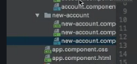

**-**I got three components, the app component, then the account and the new account component.

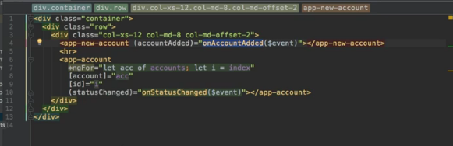

**-**The app component is where it all comes together,

there in the template, I embed the app new account and the app account component and I use property

and event binding to pass data around,

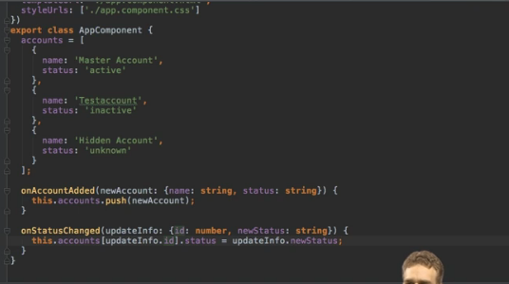

for example I loop through all accounts which are right now stored in the app component here and I pass them via property binding to the app account component here and there on the other hand, I have an event which gets fired when I click one of the three change status buttons,

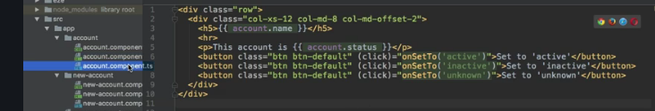

on the other hand, I have an event which gets fired when I click one of the three change status buttons,

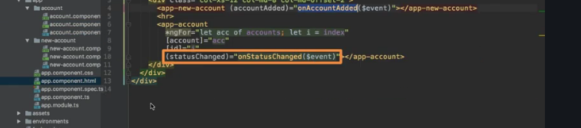

which is submitted here which will be cached by my app component where I then handle it again.

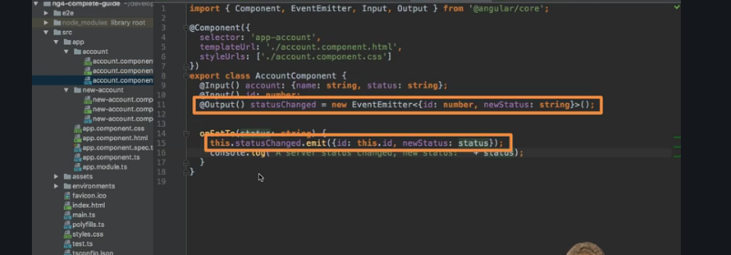

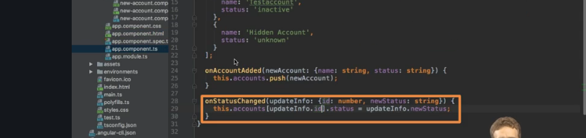

**-**So I do have event binding to be informed in my app component whenever something changes in the account component, pretty much the same happens in there new account component.

There, I can also listen to a click when I create a new account and on such a click, I emit some data

to the app component.So this is all fine but we already got quite a complex set up here to pass data around and that even though that it's still relatively simple, it's not a complex app here afterall.

Now in this lecture, we're going to see how services can help us with that and what we have to watch out for. So let's dive into it and build our first service in the next lecture.

**Creating a logging service**

**Concept-how to create a logger service**

-finding where it fits

-create a service

-adding a helper class

-how u should not use a service

First we have to choose a fitting place now since this service will do some generic task, I will place it in the app folder, you could also create a shared subfolder there,I will again place it right in the app main folder and I will simply name it logging and the file name should be logging.service.ts to follow this convention of being pretty clear about what's in a file.

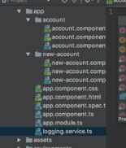

Now a component becomes a component because we attached this @component decorator,

a directive becomes a directive because we attach @directive,

you could think that we now simply add @service right. but we don't do that. A service is just the normal TypeScript class

- So here, we could create a helper method, logToConsole and simply pass the message

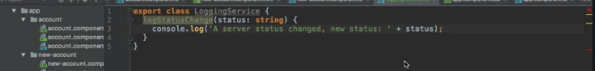

**-** but since we know that we simply want to log the change of account status here, I will simply say log

status change like this and take the new status which will be a string as an argument.

**-** with that I centralized this code, now we need to use the service in our other components,

so everywhere where we console log.

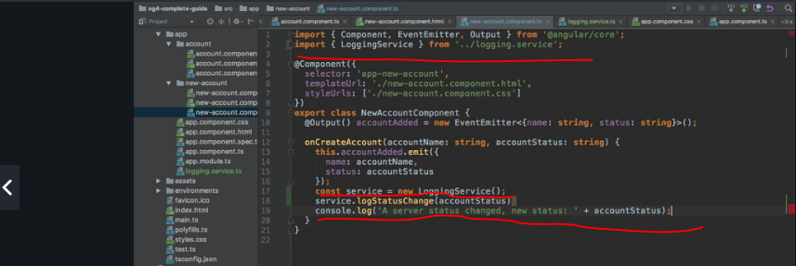

**How not to use service**

now we need to use the service in our other components, so everywhere where we console log.

Now you could think that we simply use it by importing it at the top of our file,

so here we could import the loggingService from and now let's move up to the main folder

and then here from the logging.service.ts file and then we could simply create our service like this,

new logging service and on our service here, we could call log status change and pass the new account status. And actually, if I get rid of this code here, this will work, let it recompile

and if I now create a new service here, you see I do log it to the console.

So this would work and still, this is wrong, this is not and this is super important, this is not how you

use a service in Angular.

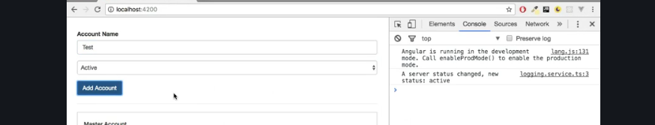

**-** Angular provides a much better way of getting access to your services and therefore, you

should not create the instances manually.

**-** So let's get rid of that import and of that instantiation and let's learn in the next video which tool

**Injecting the logging services into component**

**Concept-**

In the last lecture, we created our service and I told you to not instantiate it on your own.

I told you that Angular offers some great tool which will give us access to our services,

it's Angular's dependency injector.

- **What is a dependency injector?**

**Well a dependency is something a class of ours will depend on,**

**for example the new account component depends on the loggingService because we want to call a method in that service and the dependency injector simply injects this dependency, injects an instance of this class into our component automatically. All we need to do is we need to inform Angular that we require such an instance.**

**So how do we inform Angular that we require such an instance?**

We add a constructor to the class, to the component, in this case where we want to use our service.

So there, I can bind it to a property by using this TypeScript shortcut of adding an accessor in front

**-** So there, I can bind it to a property by using this TypeScript shortcut of adding an accessor in front

of the name, of the argument to instantly create a property with the same name and bind the value to

it.

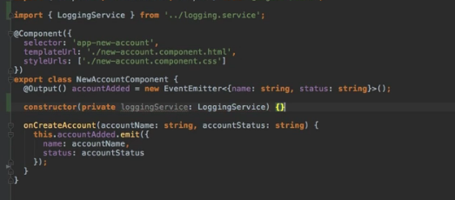

So here, I will name this loggingService,this name is totally up to you.

Now this is the important part here though, add a type assignment here,this is not optional.

You need to set the type and the type has to be the class you want to get injected, loggingService in this case, make sure to also add the import at the top.

-  this simple task here informs Angular that we will need an instance of this loggingService. Correctly

**You might ask, well how do we inform Angular, why does this matter if we write this in the constructor?**

- Think about who gives us the instance of this account component, this new account component here.

This is a TypeScript class

in the end so somewhere, this needs to get instantiated so that something happens in our app.

**Well who is responsible for creating our components?**

* Angular is of course because we are placing selectors in our templates and when Angular comes across
* these selectors, it gives us instances of our components.

Now since Angular is responsible for instantiating our components, Angular will need to construct them correctly.

* So if we define in the constructor that we require some argument, Angular will recognize this and now it tries to give us that argument, it tries to give us this type in this case. So it knows we want an instance of the loggingService class because we defined a type, this is why this is important.

**Doesn't know how to give us such an instance ?**

* We need to do one additional step, we need to provide a service. Provide simply means we tell Angular how to create it and that sounds very complicated and it is very simple, all we have to do is add one extra property to the @component decorator,
* the providers property here. This also takes an array like other properties we added before

and here we again just have to specify the type of what we want to be able to get provided you could say, so loggingService again.

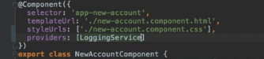

* and now we can simply in our component, anywhere in this component, access our loggingService property which is created automatically since I use this TypeScript shortcut here and call log status change.So now I'm not creating that instance manually, Angular does it for us

**And why is this better than creating it manually?**

* You will see some other advantages later but this basically let's you stay in the Angular ecosystem and Angular knows how your app works.Again, some other advantages will come up later.

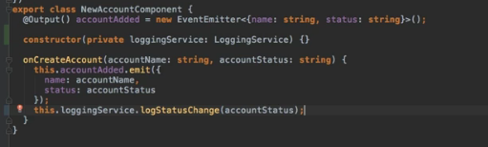

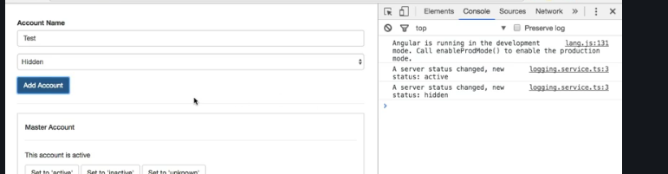

- Now let's also do the same by copying that in the account component here.

So here, I'll also add the constructor and of course here we also need to add the import because

TypeScript needs to know where this loggingService comes from, not Angular, TypeScript and I will also add a provider of course because for this component too, I need to inform Angular how to create this loggingService.

So if we do this and then go back to the application here, reload, create a new service again,

this works, now let's change the status and this also still works.

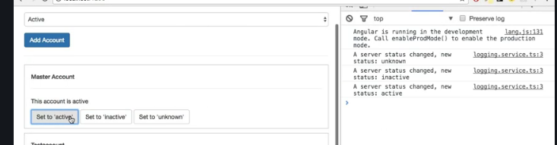

Creating a data service

Concept-

- typical use case for a service, to store and manage our data. 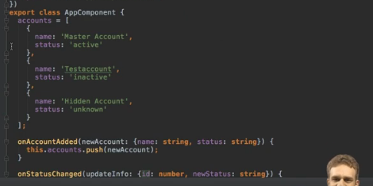

**-** So for example our accounts, right now I store them here in the app component and then we have this chain of property and event binding to get data to the app component so that we there can update our accounts.

**-** and here I will now copy in my accounts, so I will remove them from my app component and paste them into

my accounts service and I will add an addAccount method here where I simply expect to get an account name and status and I will add an updateStatus method where I expect to get the ID of the account I want

to update and then the new status here.

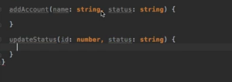

**­** I simply want to push a new account onto my array of accounts and here, I will simply quickly create a new object where I assign the name and the status, so the data we get passed into this method and for the status changed,

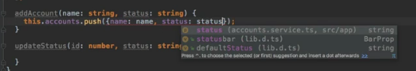

well here I basically want to also just access my account with that ID here and set the status to

the new status we get passed as an argument too.

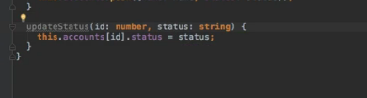

If we have a look at the app component template, we still loop through all the accounts here,

so I should still have my accounts here in the app component but we remove them from here,

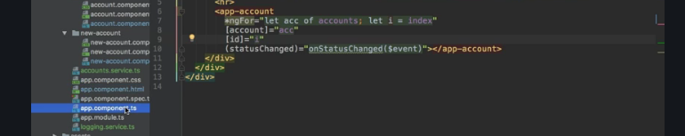

So we should maybe re-add them here but now, this should simply be an array of accounts,

so each account object has a name which is a string and a status which is a string, so

I'm just defining the type here and we want to have an array of such objects, initially it should be an empty array,this is what I'm saying here.





- Now since we have our account service, we should inject it here as we learned it.

So let's add our accounts service here, of type accounts service, the type is super important to inform Angular about what we need here.

- We also need to add a provider. So here at the providers array, we should add accounts service so that Angular knows how to create such an account service.

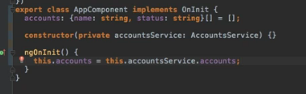

With that, we can now add for example onInit, this onInit lifecycle hook as most initialization should

not be done in the constructor but instead here and simply set this accounts, accounts equal to this

account service which is available as a property because I use this shortcut with the accessor in front

of the argument name and here, I can access my accounts field.

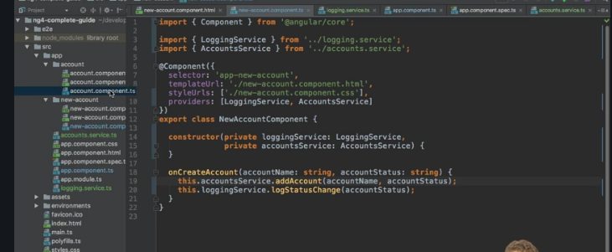

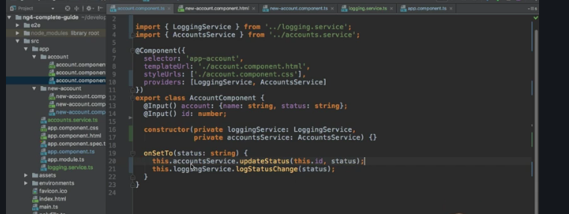

Understanding the hierarchical injector

Concept- hierarchical injection

Level of injection

-app module,app component and any other component

-

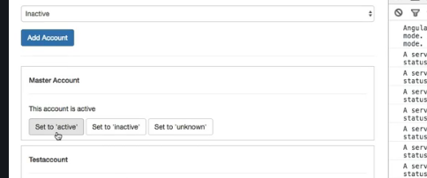

In the last lecture, we set up our account service and hooked it up on our app and still, our app seems

to be broken.

If I click these buttons, the status has not changed,so somehow our code is not working. actually it's working correctly, we're just using services wrong here, in this specific case,we're not using the service in the way we should use it in our app.

**What's going wrong?**

**-** The Angular dependency injector actually is a hierarchical injector, that means that if we provide a

service in some place of our app,

**-** let's say on one component, the Angular framework knows how to create

an instance of that service for this component and important, all its child components

**-** and actually this component and all its child components and the child components of the child components will receive the same instance of the service.

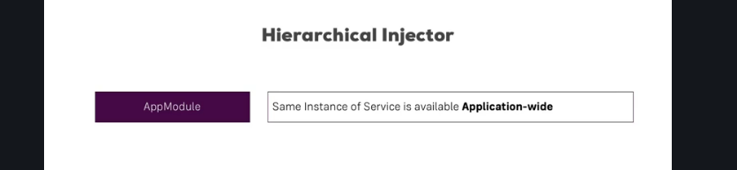

**There are other places where we can provide a service too, the highest possible level.If we provide a service there, the app module does have a providers array, the same instance and that's important, the same instance of the class, of the service is available in our whole app, in all components, in all directives, in all other services where we maybe inject the service.**



**The next level for example would be the app component, there the app component and all its child components do have the same instance of the service and this is true for any component,so even if we have a child of the app component, if we provide it on that child, all the children of this**

**child will have the same instance and the child itself but not the app component. The instances don't propagate up,they only go down that tree of components.**



**The lowest level therefore is a single component with no child components.If we provide a service there, this component will have its own instance of this service and well it doesn't have any child components, so this instance will only be available for this component and this will actually even overwrite if**

**we were to provide the same service on a higher level and that's exactly what we're doing. So let's take a closer look in the next lecture.**

**How many instances of a service should it be**

**Concept-**

In the last lecture, we learned about that hierarchical injector and actually, this injection behavior leads to the behavior we see here. Now that's not a bug, it's intended,

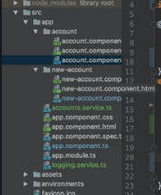

Scenario- you might have an application where you want to have many different instances of the same service, where you absolutely don't want to have the same instance but sometimes, you want to have the same instance and we definitely do because right now for our account service, we have three instances.

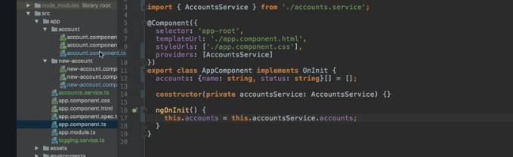

Now you might say fine because new account and account are child components, right but there we provide it again and hence we overwrite the instance we would get from the app component.

-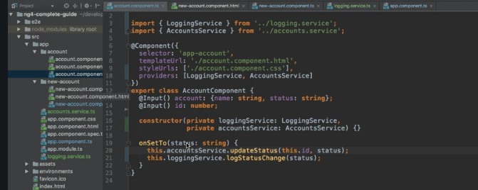

Now new account and accounts component have their own instances,so these are the other two instances of this service class. And therefore if we add a new service, we call add account, there we push it on this array of accounts and this actually works but it's a totally different instance of the service than the one

- **How can we fix it then here for our app?**

Simple, we just remove it from the providers array. Don't remove it from the constructor,

we of course do need it here because that tells Angular that we want an instance, the providers array

basically tells which instance so there we need it to remove it and the same for account component.

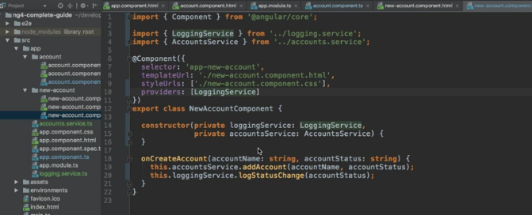

Leave it in the constructor, leave the import at the top but remove it from the providers array. With

that little change.

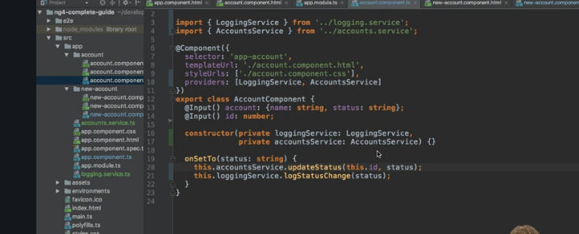

- different instances of the service. Now we're using one and the same, before we weren't. Both

may be the behavior you want in your app but make sure that you get the correct one.

Injecting Services into services

Concept-

I mentioned that the highest possible level is actually not the app component,

so let's remove it here, this providers array, leave it in the constructor and leave the import

but the highest possible level is in the app module.

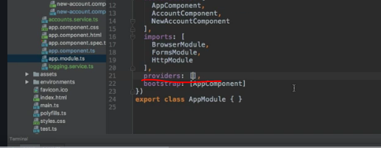

if you don't have it and here, we can also provide the accounts service,

make sure to also add the import at the top here then.

- With that little addition here, we're making surethat our whole application, everything in our application receives the same instance of the service unless it overwrites it as we did before.

- Now with that, we can now even inject a service into another service because that's not possible by providing it on a component level, for that we need to provide it in the app module.

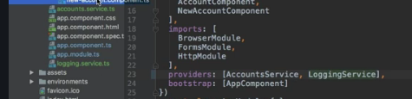

So let's say we want to log something if we call an action in the accounts service. So I would have to provide the loggingService in my app module now and therefore, I will simply comment out providers here in my @component decorators and I don't want to call loggingService here anymore, so I will comment this out and I will actually leave the injection

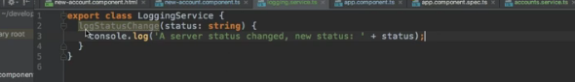

Instead let's say I want to use this loggingService in the account service and now I want to call the log status change method there because this is in the end the place where the status changes, either because we added a new account or because we called update status.

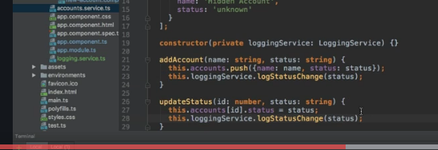

So to use the service there, generally we start in the same way, we add a constructor and we inject our

loggingService in this case, set the type, import this type at the top, make sure to add the import and we provided it in app module. So you could think that we are set to go, that we can now go to add account, call loggingService, log the status change, pass the status here and do the same here for update status, you could think this is how we do it

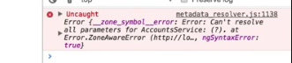

**The reason is if you inject a service into something, this something needs to have some metadata attached to it.**

**Now a component has some metadata because we have @component,**

**a directive has some metadata because we have @directive, a service doesn't have any metadata.**

**It's just how Angular works that we need to attach some metadata and of course not any metadata, you shouldn't attach @component here. There is a specific metadata you should attach in such cases, it's @injectable which needs to be imported from @angular/core. This tells Angular that**

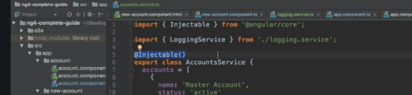

You don't add @injectable to the service you want to inject but to the service variant you want to inject something, so the receiving service you could say, the to be injected in service and you don't need to add it to any other service.

If you don't want to inject anything in a service, like here for the loggingService, you don't need to add @injectable, only addit if you expect to get something injected. With this if

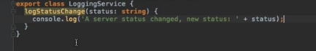

Using services for cross component communication

Concept-

Advantages of services-

**-We talked a lot about services in this module and I hope you saw how services can clean our app up, make the code a bit leaner, more centralized, easier to maintain,**

- **you don't have to build these complex output input chains where you pass events and properties to getdata from component A to component B,**

Scenario- Let's say that if we click on the button here in the account component, for some reason, we want to output something in the new account component.

* Normally without services, we would have to emit an event in the code component, that something was clicked or something happened so that we change the status for example,
* we would have to catch the event here in app account.
* So we would have to catch these events here and then we would have to pass the new data down via property binding to the component where we wanted to handle it,

pretty complicated and building these chains of property and event binding is not the most convenient way of writing code, it's so much easier with services.

Let's say in our accounts service here, we want to provide some event which we can trigger in one component and listen to in another.

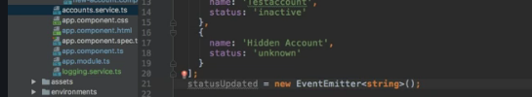

- So we could simply add the status updated event which could be a new event emitter which we import from @angular/core,

so make sure to add this import at the top which will pass on the new event, excuse me, the new status,

so a string and yes we could trigger it now here in the update status method but we can also since we inject the account service here

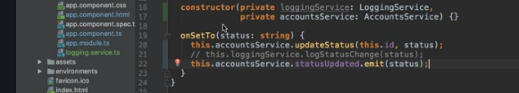

where we set a new status, call account service, status updated and emit this with the new status.

- I set up in the service and as a side note later in the observable section, you will learn about another

construct you can use to submit or to emit events and subscribe to it instead of

using the event emitter but for now, it's absolutely fine. So here we are emitting an event, again the event emitter lives in our service and in the new account,

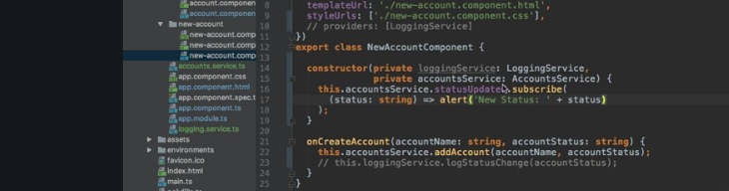

I now want to listen to it. So here, let's say I want to throw an alert. So I will do this in the constructor for now, access my account service and now for the status updated event here, I will subscribe to it because event emitter in the end just kind of wraps an observable.

So here, I could then receive the new status which I know will be a string and then it will simply throwan alert where I say new status, status, something like that.

- So now, I'm not building any chain of property and event binding,

I do have cross-component communication through a service with the event emitter. And you can see this if I click a button here, it actually got opened on another window but you see this alert was thrown,

with the new status unknown, same here in active, active. So now we're communicating between components through a service which really can save you a lot of time and with that, I hope you saw a lot of reasons why services can be very helpful and how you can use them to your advantages.

Routing

Concept-

-if you looked at the URL at the top, it was always localhost:4200.

Now what if you wanted to have a page where you actually display several pages, like you have a

/users or a /accounts page? Now you might think that for this, you indeed need multiple pages, multiple index.html files or something like this

-if you want to go to different url.

-angular do need different index.html pages.no it will have only one index.html page.

- **Angular ships with its own router which allows you to change the**

**URL in the URL bar and still only use one page but then exchange major parts or a lot of parts of**

**that page, so that to the user, it really looks like a new page was loaded because maybe only the header is the same but behind the scenes, it is still Javascript changing a lot of parts in your DOM, in your page, making it look like a new page was rendered but you're still in the Angular world in your single page application.**

Why do we need a router

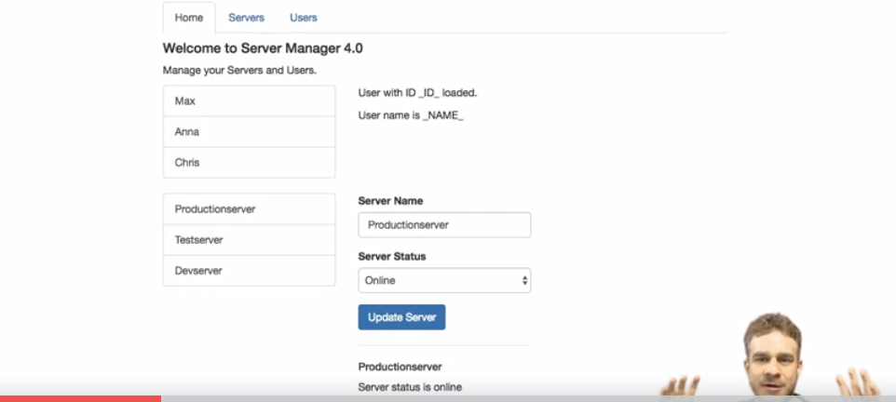

-Now on the first look, it might look nice but it has one fundamental issue,

we can't switch the pages here. We get some tabs at the top but these tabs are not working and therefore what we see on this home page are actually all the components I later want to split up over multiple pages or multiple pages in quotation marks I should say in this module. We do have a home, a servers and a users page and as you can see here, we got users, servers and the home page on the same page.

-So that is something we can improve but it would be nice to have separate pages as I said,so a /users page or a /servers page and so on. So this is what we're going to work in this module and for this, we need routes, we need the Angularrouter and the Angular router needs to know which routes our front-end application has. So you might know this pattern from a full-stack application where you also register some routes the user can then visit, we can do the same in Angular and we will do this in the next lecture.

Setting up and loading Routes

So here I am in the source code responsible for the app you saw in the last lecture

and as you can see, here I got three major components and then some subcomponents

of these components. In the app component, I'm loading them all, my home component, my users component and

servers component.

But for now, I'm going to ignore my subcomponents here, edit server and a single server,

so we will later nest this even more

but for now it would be nice if of these three components,

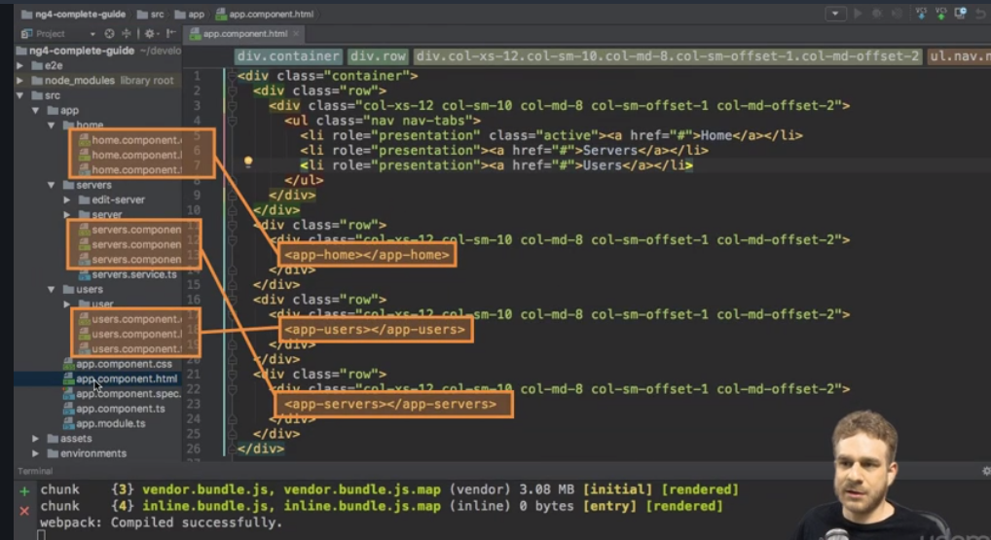

These routes are responsible for our whole app. Everywhere in our application,

if we enter /users, we want to load the users component as our main page let's say.

So since this is really a core part of our app,

where should we register it?

Well, the app module sounds like a good place because here is where we configure our app, where we add all these components and so on, so this might be a good place to also inform Angular about the routes our application has and it is.

So here above this @NgModule decorator here, I will add a new constant and I will name it appRoutes

because it should hold all the routes of my application.

Now these routes constant should be of a specific type, the routes type, which needs to be imported from

@Angular/router.

So make sure to add this import at th

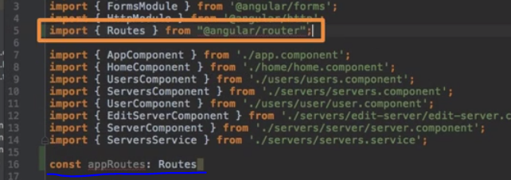

Now with this import added and the constant set up, what should this constant actually hold? It should hold an

array because we will have multiple routes.

So we add all the routes we want to set up to this array for now

and each route now is just a Javascript object in this array.

Now the question is, how should such a route be configured in an Angular app?

It has to follow a specific pattern, a specific structure for Angular to be able to use it

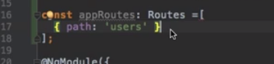

 structure always needs a path,this is what gets entered in the URL after your domain.

This should be a string.

So this is now the path and this will later allow Angular to determine which route in our array of routes here should be selected if we enter something in the URL or click some link because it clearly defines well which path this route should be.

I also want to have a certain page I display once we have just localhost:4200,

so an empty path after it, you could say.

So we should also create a route for this with just an empty path

and here I want to load my home component,

this is the starting page you could say. You of course don't need to have such an empty path but then you

somehow need to handle this,

well the user accesses an empty path differently and I will come back to this later.

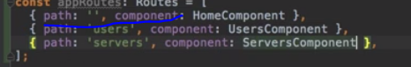

How would Angular know that you want to use this constant?

-You could have added any constant here and the name appRoutes,

well that is totally up to you. So right now, these routes will be ignored by Angular and the type routes here doesn't do anything when it comes to this.

-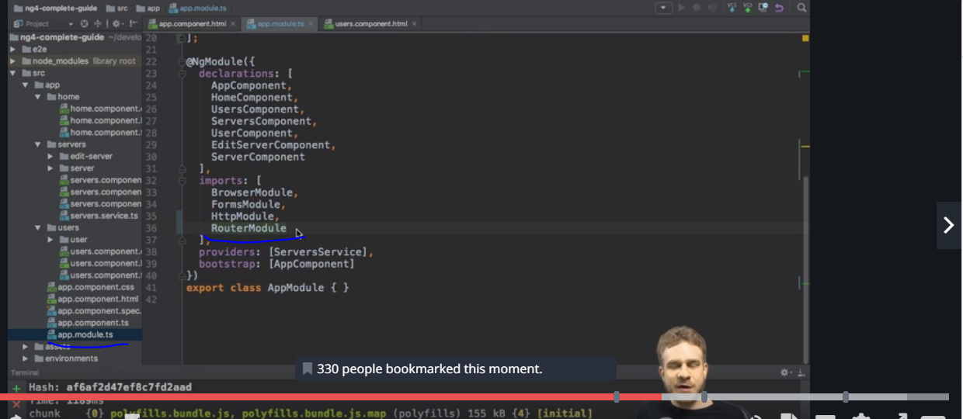

So we somehow need to register these routes in our app and we do this by adding a new import here to

this imports array,we need to add the RouterModule here and this RouterModule should be imported from our @angular/routerpackage here. So with this added, we're adding the routing functionality to app but still, our routes are not registered.That is why this RouterModule has a special method we can call, forRoot, which allows us to register

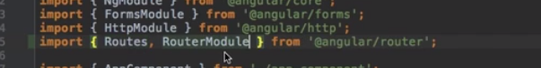

some routes for our main application here.

So forRoot will now receive our appRoutes constant here as an argument and with that, our routes

are now registered in our Angular app on this RouterModule which gives us this routing functionality

and now Angular knows our routes.

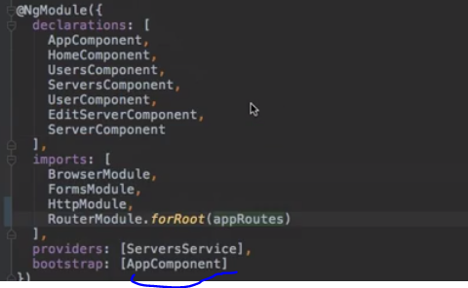

OK we visit /users, so Angular knows we want to load the users page but how does it know

where to display it?

How does it know if you want to display it here or here or maybe here in the header, it doesn't know.

So the right place to inform where to load it is to get rid of all these rows here but one, so only have

the place where you actually want to render your route

and now you don't add your component with its selector but you add a special directive shipping with

Angular, the router-outlet.

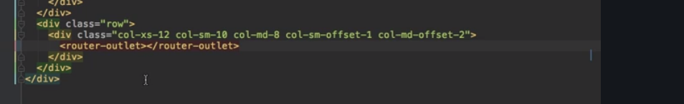

Now this looks like a component but it still only is a directive,

keep in mind directives may have any selector including this component or this elements style selector.

And with this, this now simply marks the place in our document where we want the Angular router to load

the component of the currently selected route.

Navigating with router link

Scenario-we need to click on link,it should navigate accordingly.

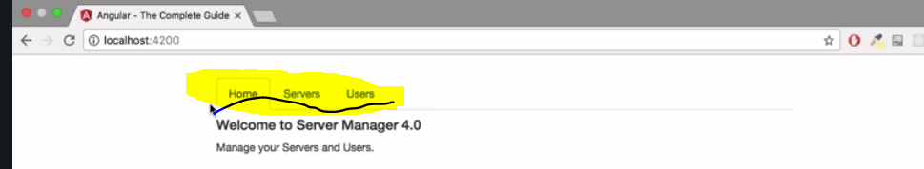

-nice to have some working links here in our navigation to have these tabs work.

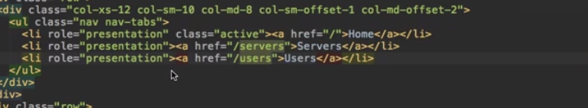

Wrong assumption

-The first thing you might think about is, hey we can or we already have this ref attribute here to be

precise,

so here we could have ref, well just slash to load our root route,

here we could have /servers and here we could have /users

and if we now save this, we added all the routes, the paths we set up in our routes configuration to our

navigation here

and hence if this reloads and we click the tabs, hey this is indeed working,

but it is reloading -new page but wrong

So the same thing happens as if we enter this manually here.

That however is not the best behavior because it means it restarts our app on every navigation,

that of course means our whole application state will be lost and it might not really be the behavior

we want to offer to the user.

-There is a special directive Angular gives us, let's get rid of all these ref attributes here,

so this is not how we will navigate around.

Instead let's use this special directive

it's called routerLink.

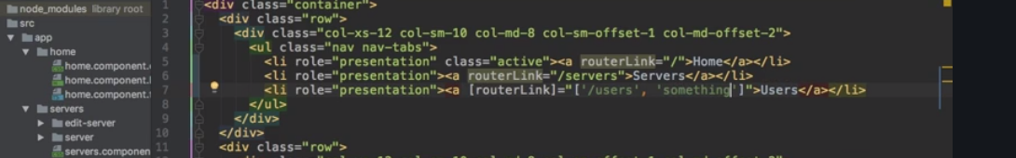

Now this will tell Angular that this element on which routerLink is placed here, this anchor tag here

will serve as a link in the end but it will handle a click differently as you will see in a second.

Need to see more about router link

routerLink catches the click on the element, prevents the default

which would be to send a request and instead analyzes what we passed here to the routerLink directive,

so this path or this array of path elements and then parses it and checks if it finds a fitting

route in our configuration which it of course does because we defined all the paths we're using here.

And this is how we can navigate around with a routerLink

Understanding Navigation paths

**Concept-** difference between absolute path and relative path,and how it effects the navigation.

**Scenario**-

So on the servers component, I now added this routerLink where I basically want to make sure that I stay

on the servers page which I'm already on.

So if we go to servers here, we see the reload page here and if I click it, you'll see we got an error. This

error here occurs because it doesn't find a route which is servers/servers.

Now this error won't occur if on the servers component, I turn this to /servers,

so to an absolute path, it was a relative path. Here

Styling Active Routes

Concept-if you want to highlight what you click.routerlink active,and routerlinkactive options.

-explained how we want to set the visual indication that we clicked that.

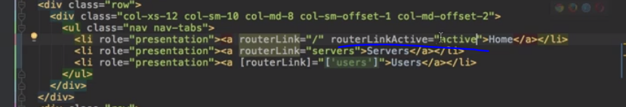

-So now theoretically, all my links should receive this active CSS class once they are clicked or when

they are active.

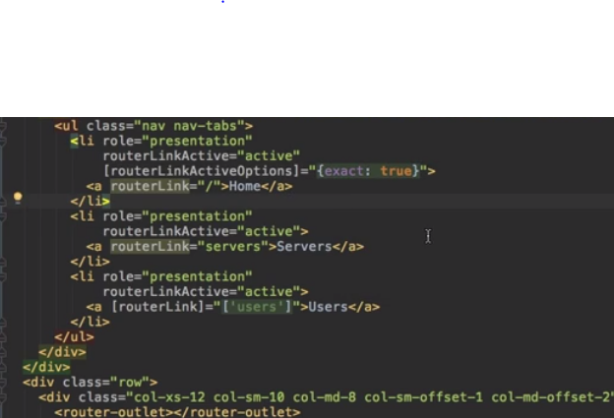

Navigating progrmatically

Concept-going to a router after some operation.like after getting data go to that route.

How to call a router inside a method.

How to use .navigate() method.

Scenario-we don’t have a link that user clicks,if user finishes one operation,he clicks a button then we have to navigate.

Using RELATIVE PATH IN PROGRAMATIC NAVIGATION

CONCEPT-Activated route,relative to->property

Absolute path- \server

Relative path -server

Localhost:4200\server\server

We should get an error but we don’t.reason is due to navigate method.

-configure relative to

-default it is root domain

Activated Route-simply injects the current active route that angular knows what our current active route is.

Passing Parameters to routes

Concept-adding parameters to route :->use of this

-dynamically loading some route.

-encode some data into our path

-next video- we can see how we can get access to the data in the loaded component though.

Scenario-let us think we show users but now we want to show the user by danamically passing the id in the router.

Adding parameter to the router

Users/id -you can load by using the parameters you defined by id.

Fetching Route Parameters

**Concept**-Activate route ->getting loaded route

-defaining in ngoninit()

**Scenario**-now we should get the data based on given id in url.

We will know that some data will be in theurl and how you can get the access to it.

By using Activated Route we will get access to the currently loaded route.-->0.45

Explain hoe to getin ngonINIT()->to data

Using Relative path in programmatic navigation

Concept: activated roots

>Relative to properties

>absolute path\ services

>relative path\ service

Now it trys to add

Local hot:4200\service\service

But this page we don’t have

* We should get an row but we don’t

Relation is due to navigate method

* Configure related to def out its root domine
* Activated root
* Simply injects the correct active root
* Angular knows what our current active roots

Retrieving Query parameters and Fragment

Practicing and some common Gotchas

**Review**-So now that we learned a lot about navigating passing parameters,

**Concept**-

Dynamically construct a link.

The issue is if we parse a parameter from our URL, it will always be a string because our whole URL

is simply just text, so ID here will actually not be one in the case of /1,

**Scenario**-

-let's improve our app a little bit by going to the users component where we have a list of links in

the end to single users and let's add the routerLink here, pass an array as an argument

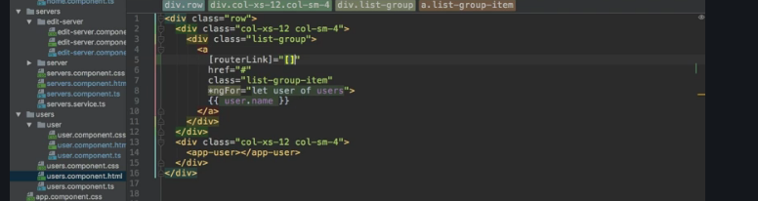

and here, we want to target /users and we already created our route, right?

We have /users, /ID and /name, so we can use that information here in users component,

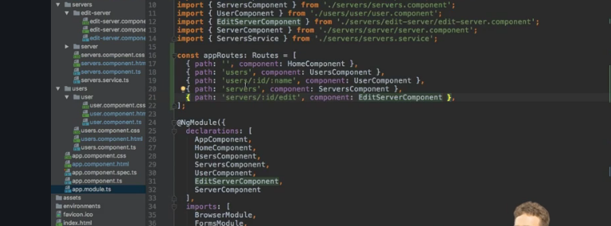

-the second element here in this array there should be the ID and since we have a for loop where we loop through all our users, we can easily dynamically add the ID here by accessing user ID and the same for the name, the third element, the third segment in this path, the user name, we can access username.

This is how we can dynamically construct such a link

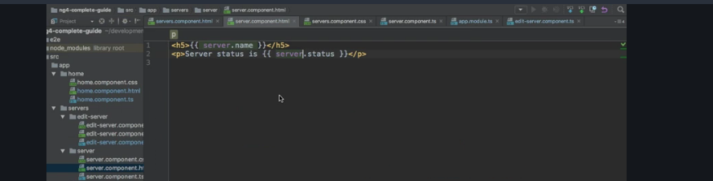

-And of course now, in this single server component, this one here where we want to output our server data, we need to get that data we pass in the route path in the URL

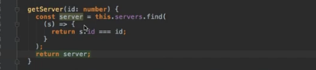

we do have the ServersService where we are able to get a server by ID and we already do this in our server component here in ngOnInit, right now always for the server with the ID one.

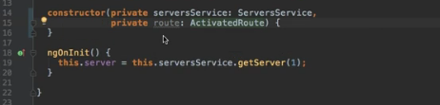

Step1-

Of course to get access to the router parameter, we need to inject our activated route.

So we learned how to do this, add this route property and make it of type ActivatedRoute which you need to import from @angular/router

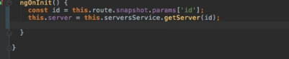

Step2-

and now in ngOnInit, you can get your ID from this ActivatedRoute from the snapshot, the params object here and then the ID which is encoded in the URL and now you can use this ID here to get that server.

Step3-

Now if you also want to react to any changes thereafter, you need to subscribe to your params observable

here and basically do the same. You get the params here which is of type params, make sure to import that from @angular/router

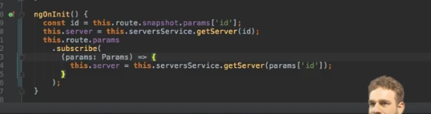

and once you get this, you can get a new server whenever your params should change. So here, you could

then access params ID like this to update the server whenever change is triggered on this page.

So with this in place, if we reload our app and go to servers, you'll see we get an error here which makes sense because keep in mind on our servers component here, we still are always loading our single server component and therefore, we are also loading it if we don't have this ID available.

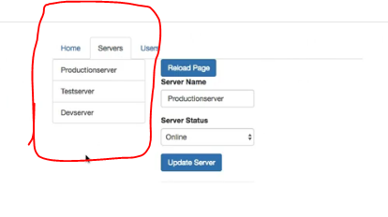

will soon learn how we can nest

another router in there to have some kind of child routing, to load this route dynamically next to our

menu here. If I now click on a server here, we still get an error and now this can be a tricky one to spot, what's going wrong here?

The issue is if we parse a parameter from our URL, it will always be a string because our whole URL

is simply just text, so ID here will actually not be one in the case of /1,

it will be a string of one.

So if we try to get a server by this ID, it will actually search a server which has an ID of one but a

string one,

however we use numbers here.

So we simply have to make sure to convert our ID to a number and we can do this by adding a plus in

front of it and this is perfectly fine to do.

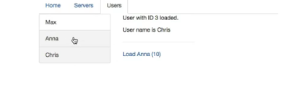

-it would be nice if we don't load a new page with the user or the server here but load it next to our

menu in both cases. So we somehow need some nested routing, some child routes kind of, to have a router

inside a router.

Setting up child Routes-

Concept-how to implement nested routing

-all start with servers and all start with user should combine

-implimenting of children property

-router outlet tag in html

Scenario-

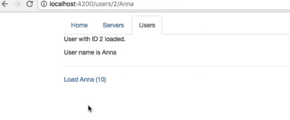-Reloading route next to component without navigating to page

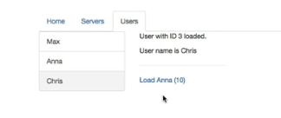  
-We improved our app quite a bit

but the issue we have is that if we click on a server or a user, we load a brand new page.

It would be nicer if we would load it next to this menu,

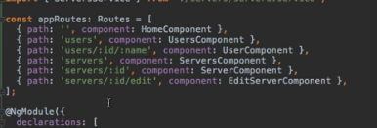

- We can also see that in the app module, we kind of have some duplication here,

all these routes here start with servers and all these routes with users,

so it would be nice to nest them and to have some child routes which all start with servers

then here in this case for example, let's add such child routes.

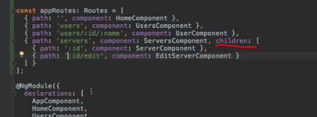

- I'll go to my servers component route, to the /servers route and I'll add another property,

children. Children takes another array of routes, so now I can simply take my two other servers routes here and add them inside of this array as children.

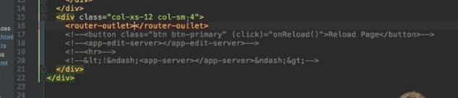

- router outlet here.

This now adds a new hook which will be used on all child routes of the route being loaded on the servers

component which of course is our /servers route here,

so all these child routes will be loaded in this router at the place now.

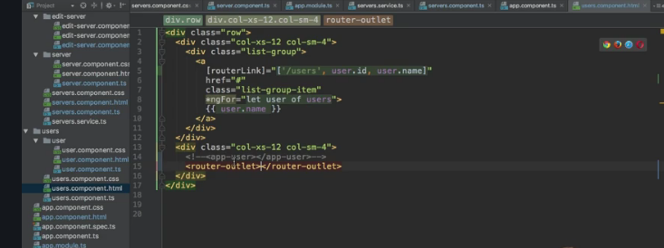

- and now in my users.component.html file, I'll replace my app user here with another router outlet

where all the user related child routes or the one user related child route we have will be loaded.

- super important to dynamically update the ID and so on because the component wasn't exchanged,

we were able to switch the loaded user while this old component, the user component, the single user component was already loaded. And this is how you can implement child routing nested routes with these children property which then holds all the nested routes.

Using Query Parameters- not clear

Concept-

Scenario-

- In our servers component, we have our links loading to individual servers,

- so the single server component, this component here with this allowEdit query parameter.

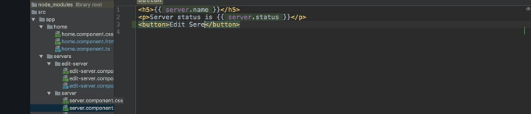

So now in the

server component, we should add some button where we say edit server because right now, we get no way of reaching the edit-server.component besides manually typing this route here, this path here into our URL.

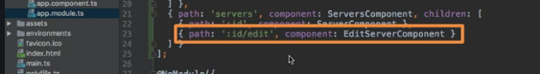

I say onEdit. Now again, this is on a single server component.

So here I'll add the onEdit method and in here, I now want to navigate to the edit-server.component.

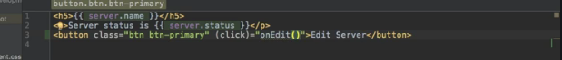

and in here, I now want to navigate to the edit-server.component. We learned how to do this, we need to get access to the router so that we are able to call the navigate method, so let's inject it,

make sure to also add the import from @angular/router and with that injected in onEdit, we can  navigate

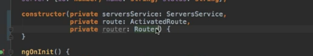

I would call my router,

then of course we have the navigate method and here we need to pass an array and we simply want to append edit to the end of the currently loaded route. So you could of course also use /servers, the relative path, then use the ID of the currently

loaded server again, server ID and then append edit

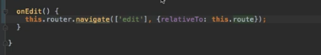

but since we already are on this path, why not just use a relative route and just use edit?

Now you learned if you want to use a relative path here, when using the navigate method,

you need to set up the relativeTo property here on the second argument, on this object you can pass

to navigate and reference the currently loaded route, so that the @angular/router knows to which route

you want to navigate relatively.

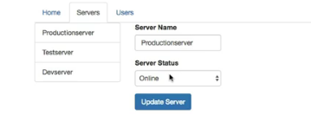

we load the edit server page

and now here, we want to control on where the user is allowed to update, to edit the server or not.

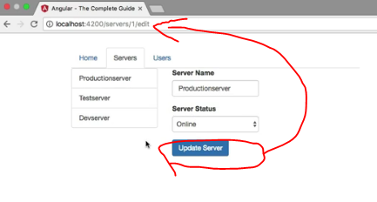

The issue is, you see we theoretically have our query params here, allowEdit always set to one in

this case but we lose this information as soon as we click edit server,

so that is something we need to fix before we can use the information there.

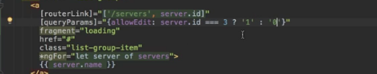

So only if the server ID equals three let's say, only in this case we want to allow edit, so we want to set

it to 1, otherwise we will set it to zero.

So that's just a ternary expression,

checking the server ID and if it's not equal to 3, we will set it to zero,

so we will set the allowEdit parameter to zero.

That's the first step.

Now in edit server of course, we w

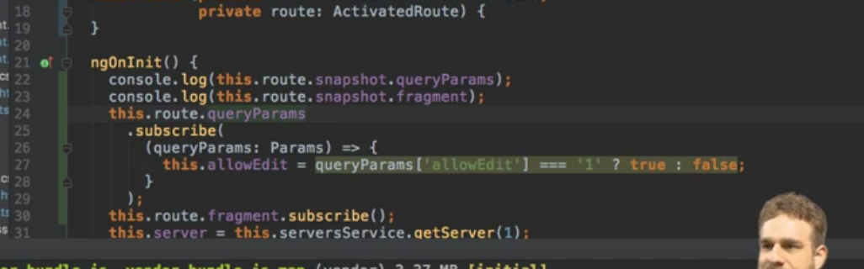

now here I want to determine on whether we are allowed to edit or not.

So I will add a new allowEdit property here and set it to false initially but whenever this

changes here in the query parameters, I want to get my query params which are also of type params to

be imported from @angular/router

and then here in the method body, I will set this allowEdit equal to my query params here equal

to the allowEdit ID or property we set there

and now this either is one, string of one, of course you could also pass true as a string here, in which

- let's see how we can actually preserve our query params once we navigate again.

Configuring the handling of Query Parameter

but the issue is our query parameters are gone whenever we navigate away from our single

server component, to the edit server component for example. So we want to preserve them because we already set

this information at the point of time we visit a single server,

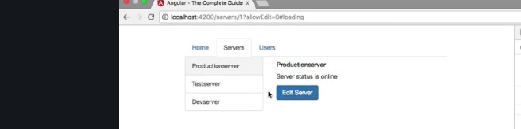

now we want to preserve this information once we navigate one step further to the edit server component.

To preserve that information,

we get a simple way of doing so. In the server component where we navigate, we can pass another property

or add another property to this Javascript object we use to configure our navigation

and here, we get the query params handling property.

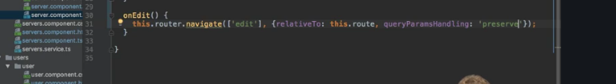

Now query params handling takes a string as a value and this could be merge, to merge our old query params

with any new we might add here. Now we don't add any new ones,

so we can simply choose preserve instead and preserve which will overwrite the default behavior which

is to simply drop them and make sure that the old ones are kept.

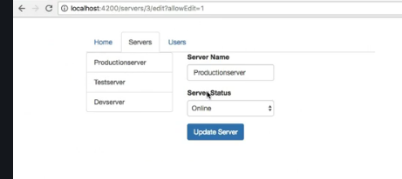

So now if we click on this again and click edit server, now you'll see allowEdit equal to zero is

still set and therefore on the dev server where it is set to 1 if we click edit server, we do see the edit

menu again.

So query params handling here, super important, super useful to know to make sure you don't lose the

information you had before.



Redirecting and wild card Routes

Concept-

Scenario- Here the concept is lets think if you enter something which is not mentioned in route



- You already learned a lot about routing. We're nearing the end but did you ever wonder what happens if we enter something here which we don't cover, like let's say just slash something.

We get an error because clearly, we don't have a route with slash something here.

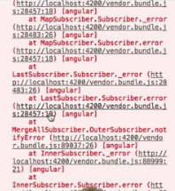

So that is something we probably want to improve, we want to do some 404 error handling,

-we maybe want to redirect the user to a specific page whenever he tries to visit a page we don't have.

These are the topics I'll focus on next,

- setting up a router which handles all routes

we don't have set up and redirecting requests, not necessarily to topics you use together but also not

that uncommon.

**So let's start with redirecting.**

**-** So with this in place, if we now save this, go back to our application and visit slash something, we of

course see this page was not found.

**-** Now let's change something to not found and let's make sure that once we add another new route which

then is something let's say, we don't also have to add component here but we redirect to another route,

**-** to the not found route maybe. For this,

we get another property we can add to any route config here,

so of course to any of the other routes. If you don't want to specify a component to load, you can say

redirectTo.

**143-152-routing**

**168-177-observables**

**Handling forms in Angular apps-180-213**

**Using Pipes to transform output**

**Introduction why pipes are useful-**

**Old class review-**

**Concept-** Now that is the main purpose of pipes, transforming values, - Now for this, you could use a pipe, namely the uppercase pipe, this actually would be a built-in. .

**Scenario-** A basic example would be the following, you have a username, that's a property in your component, for example here it holds a string, Max. Now you want to output that username in your template and for this you probably use string interpolation

**-** Now that's all right but then you decide it would be nice if the output which is Max uppercase

what are pipes?

Pipes are a feature built into Angular 2 which basically allows you to transform output in your template.

**-** there are pipes for different types of output and also for synchronous and asynchronous data,

**-** A basic example would be the following, you have a username, that's a property in your component, for example here it holds a string, Max. Now you want to output that username in your template and for this you probably use string interpolation

**-** Now that's all right but then you decide it would be nice if the output which is Max uppercase

**-** So you don't want to change the property itself to uppercase

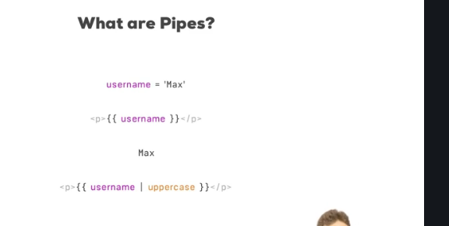

**-** but you want to transform the way it is displayed once you render it to the screen.

- Now for this, you could use a pipe, namely the uppercase pipe, this actually would be a built-in pipe and we will have a look at the built-in pipes in a second.

- Now that is the main purpose of pipes, transforming values,

**Using Pipes**

**Old class review-**

**Concept-**

->pipe is only responsible for transforming the output, so the right place to use it logically is the template.

**->** I would like this server instance type to be uppercase.Now that's easy to achieve, we just add the pipe symbol, hence the name, pipes and then the name of the pipe.

**Scenario-** Now for example, we get a server name which looks all right to me but then we get this instance type here, medium, large, small and we get the state.

Example project-

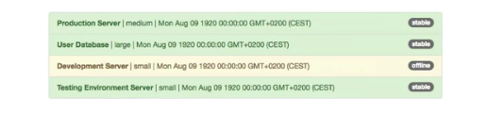

Now the code responsible for what you saw here on the screen is basically this app component template

where I output a list of servers and the servers are stored here in my app.component.ts file,

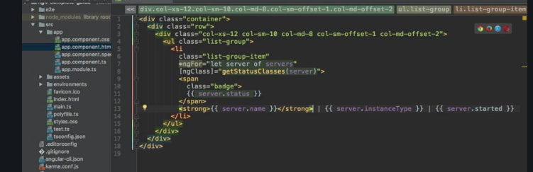

I got the servers array which simply holds a couple of Javascript object, each representing a server and then at the bottom here, I got a little helper class which simply retrieves the right CSS classes which should be attached to that list group item depending on the state of the server, if it's stable or offline.

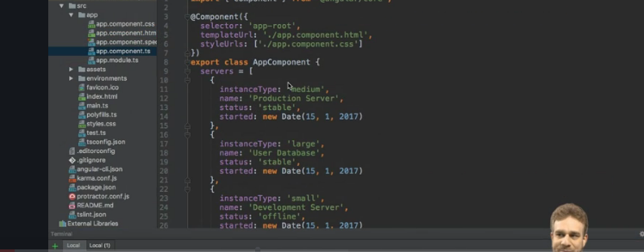

-**-** Now for example, we get a server name which looks all right to me but then we get this instance type here, medium, large, small and we get the state.



-Now you could for example put this instance type to be all uppercase and the date,

I'd like to change something about the state too

-but let's start with the instance type, medium, large, small here to see how to use pipes and you will

see it's actually pretty simple. To change it,

-we have to go to the template, to the HTML file because remember, a pipe is only responsible for transformingthe output, so the right place to use it logically is the template.

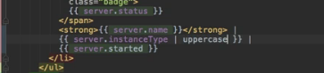

I would like this server instance type to be uppercase.

Now that's easy to achieve,

we just add the pipe symbol, hence the name, pipes and then the name of the pipe

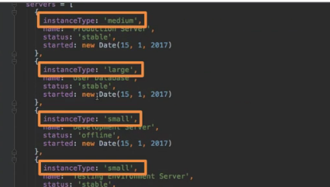So without changing anything else, without and that's important, changing the property itself, herethe instance types are still lowercase, without changing anything here, we change the way users can view it simply by adding a pipe here.

**-**well if we add the pipe symbol here too, we could add the date pipe, another built-in type and I willcome back to where you find those built-in pipes in a second. Now with this added, let's save this and now you see out of the box,

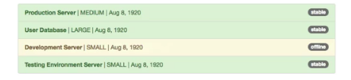

**Parameterizing pipes**

Old class review- In the last video, we added a couple of pipes, the uppercase pipe to transform the instance type and the date type to transform the type

Concept- configure a pipe

Scenario- I want to display data in a nice formatted way as shown below



-this layout here, this way of displaying the date might not be the layout, the format of the data you

want to output. So it would be nice if we could parameterize a pipe and we can.

-and this is the case for any pipe, you configure it, you pass a parameter to it by adding a colon,

**-** Now the date pipe expects to receive a string parameter, so let's pass a string and there, you basically set up the date.

- now for the moment let's just enter fullDate, camel case, so a capital D.

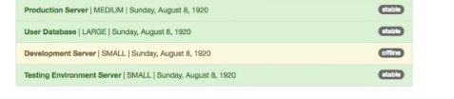

**-** by simply adding a colon and then the parameter. As a side note, if you would have multiple parameters

here, you simply separate them with additional colons. So the date pipe doesn't take an additional parameter but if it would, you could pass it by adding another

colon and then the second parameter.

**Where to learn more about pipes**

**Old class review-** In the last lecture, we parameterised our first pipe here, the date pipe.

**Concept-** Now let's learn more about all the built-in pipes and how we can configure them

**Scenario-**

so you can just head to angular.io and there under docs,

click on API reference.

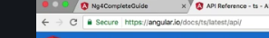

So here, you can enter pipe as a filter and then you view all the pipes which are built into Angular

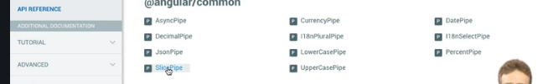

-we already use the date pipe and the uppercase pipe but

there also is a slice pipe which allows you to take a slice of the input and there you would see that

the slice pipe actually takes multiple arguments, the start and the end, so where it should start slicing

out a piece of the word and where it should end.



 I want to have a look at the date pipe. Here you can see how you can configure it, you can see a couple of different shortcuts for getting a specific date format or you can format it from scratch with the typical symbols like a lowercase D for a day and so on.

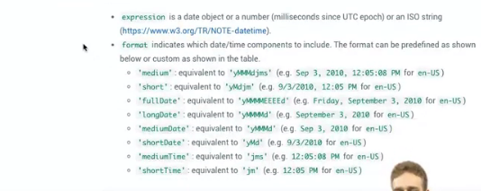

Chaining multiple pipes

Old class review-

Concept- chaning pipes

->Now you can simply chain pipes by adding a pipe symbol after a pipe

-> order of pipes execution, generally it will be parsed from left to right.

Scenario- Now what if we wanted to yes, format the date like this

but then for some reason, also make it all uppercase?

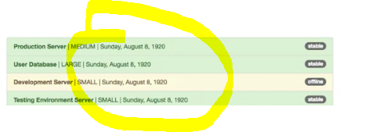

Now you can simply chain pipes by adding a pipe symbol after a pipe, so we could add uppercase here.

Now the order might be important,

generally it will be parsed from left to right.

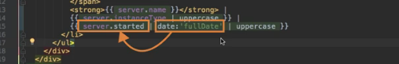

generally it will be parsed from left to right.

So server started gets into this pipe here,

so the date pipe gets applied to our server started property output here, to the string interpolation.

The uppercase pipe then gets applied to the result of this operation

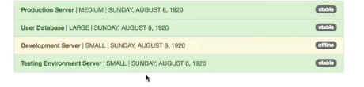

Now if I switch positions here and put the uppercase pipe first and then parse the date, you see we get

an error



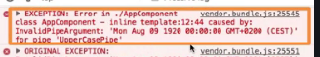

it doesn't know how to parse it because it is a date and not a string and there are elements which can't be turned into uppercase.So this is why it's important to watch the order,

Creating a Custom pipe

Old class review- Thus far, we already learned a lot about the built-in pipes or on pipes in general. You learned how to use them, where to find out more about them, how to pass parameters or possibly multiple parameters and also how to chain pipes.

Concept-creating your own pipe

-> needs to have one special method transform method.

-> interface is called PipeTransform and you need to import it from @angular/core.

-> transform needs to receive the value which should get transformed.

-> transform always needs to return something because a pipe is just you put something in,you get something out,

-> So just like components and directives, you also need to add pipes to declarations in appmodule.ts file.

->  @Pipe decorator which is also imported from @angular/core. On top of the transform method ,the name of our pipe to use in template

-> you can now go to your template

Scenario- for example here I want to create a pipe which shortens my words, the input because let's say I want to shorten this name of my server, so the testing environment server somehow gets cut off.

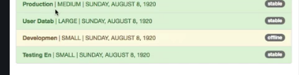

you need some functionality which just isn't built-in, in this case you need to create your own pipe

for example here I want to create a pipe which shortens my words, the input because let's say I want

to shorten this name of my server,

so the testing environment server somehow gets cut off.

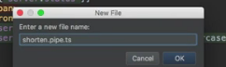 this naming convention of being descriptive about what's in a file.

 this class needs to have one special method to be usable

as a pipe and whilst not strictly necessary,

it's a good practice to implement a certain interface which requires you to implement the method,

the interface is called PipeTransform and you need to import it from @angular/core.

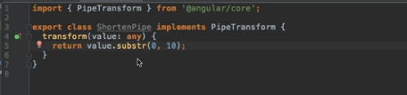

- need to apply or we need to provide the transform method.Now adding the transform method like this still is not 100% correct, transform needs to receive the value which should get transformed.

- and then we would receive a list of arguments. Now for now our pipe here doesn't take any arguments, so I will omit any other arguments here in the transform method, so we only received the value.

- transform always needs to return something because a pipe is just you put something in,

you get something out,

-> value but somehow shortened and we could simply use the substring method, substr,

this is a built-in method Javascript offers, where you can define how long this string, the substring we

want to extract should be.

So you want to start at index 0, at the start of the value and then let's say we want to have it 10 characters

long, this would only give us back the first 10 characters.

- Now to use this pipe, we need to go to app module and add it to declarations here, the ShortenPipe.

- So just like components and directives, you also need to add pipes to declarations.

Make sure to also add the import pointing to the shorten.pipe.ts TS file, of course as always without

the .ts at the end here.

- Now with this added, we make this pipe available and then we can go to our app component and use it

let's say but how would we use it? Well we have to go back to the ShortenPipe first,

this class is implementing the interface we need to implement but it lacks one important thing, we need

to add a special decorator, the @Pipe decorator which is also imported from @angular/core. In the @Pipe

decorator,

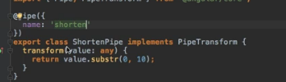

you can specify the name for the pipe by simply adding name and then for example, shorten. Now by setting it up like this, you can now go to your template and on the server instance type, which is, excuse me on the server name,

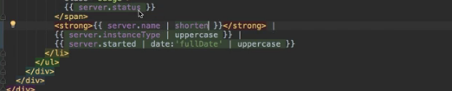

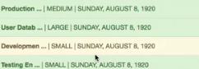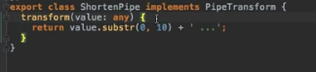  
So here I first check if value length is greater than 10 characters because only if it is greater,

only in this case I want to shorten it, otherwise I will return the unchanged value.

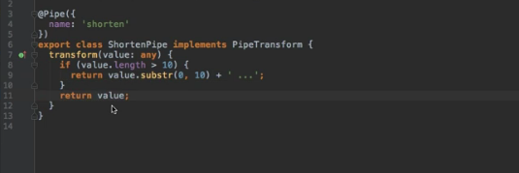

Key points

the important part about pipes is that you

a) add this pipe decorator,

b) make sure you have the transform method possibly enforced by adding the PipeTransform interface which is a good idea, which is a good practice and

c) by adding your pipe to the declarations array in your app module.

And with that, you're good to use your own pipe and to create your own pipes and adjust them to your needs.

Parameterizing a custom pipe

**Old class review-** In the last lecture, we created our first pipe, the ShortenPipe and it's already working quite well

**Concept-**

**Scenario-** but it would be nice if we could allow the user to specify the number of characters at which point you want to shorten the pipe or shorten the value.

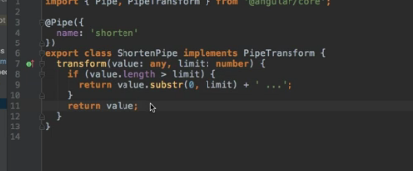

**-** Now limit would be what you then use here in the check,

so only if it's greater or if it has more characters than you want to shorten it

and then of course you use limit here in your substring method too.

**-** Now with this little change, you allow the user to pass a parameter to the pipe because now you receive

a second argument in the transform method

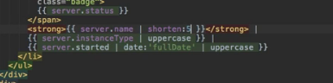

but if we do pass a parameter and remember, we do this by adding a colon and then the value, let's say

five, if we do this and save this,

now you see we're shortening after five characters

**Creating a filter pipe**

**Old class review-**

**Concept-**

**Scenario-** Let's add a new element here above our unordered list and this should be an input field,

so input of type text.

- Now I want to build a pipe which I can apply to this list somehow, which allows me to then only view

the servers which do indeed fulfill the requirements here.

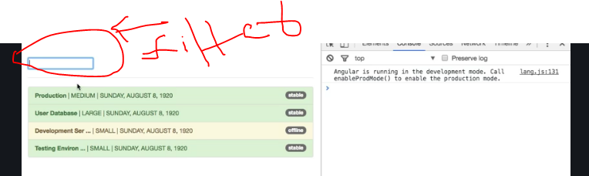

I want to allow the user to filter our servers, for example by status so that once you type stable

in there, you'll see servers with the status stable.

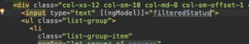

or example, this of course would be a new property I set up here in my component,

so below all my servers, I have filteredStatus which is an empty string at the beginning, filteredStatus

like this.

- Now I want to build a pipe which I can apply to this list somehow, which allows me to then only view

the servers which do indeed fulfill the requirements here.

- So to do this, I will add a new pipe here and for this, I will now use the CLI, so ng generate pipe would

be the shortcut here or just g p and then the name of your pipe and I will name it filter, filter pipe.

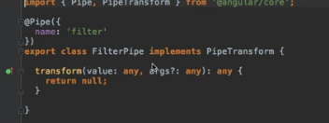

so the filter string you could say and this will be a string.

Well and then here, I want to implement some logic which allows me to only return the elements of the

array which fulfill this argument or which fulfill this filter string here where the status of the server matches this filter string to be precise. For this, I will

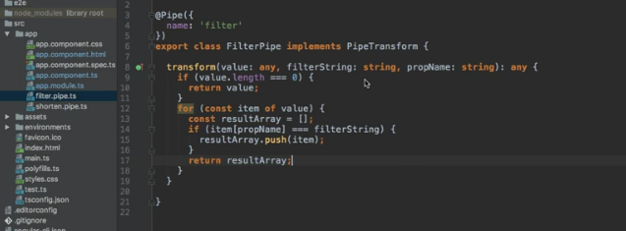

So here, I want to check if the value.length is zero, so if it's empty, in which case I will just return

values, so I will basically just quit, there is nothing to display.

And now after checking this, the interesting part happens here.

I simply want to check where I want to loop through all my items in my value and value here will

be an array, keep this in mind and then I want to check if my status of each server matches the filter string up here. So for this, I can simply check if item.

Status and of course you could write this more generic and pass the to be filtered property here as a second argument, like propName which is a string and then you could simply say item propName in square brackets, so if this equals my filter string. Only if this is equal, only in this case I want to return it.

-  make sure that you add filter pipe to declarations and add your import at

the top and then in the app component,

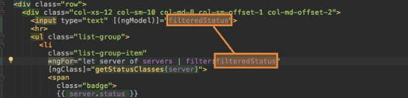

we apply it here in the ngFor loop.

And this might sound strange because before we only used it in string interpolation

but keep in mind that I said at the beginning of this module that pipes transform your output and an

ngFor loop is simply part of your output.

Therefore of course you can add a pipe here too, to my servers and then I simply say filter, of course

we need to pass two parameters here.

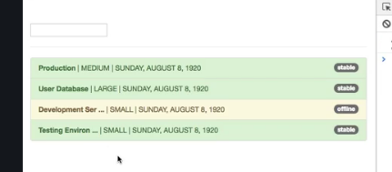

The first parameter is the filteredStatus, this property which holds my string for which I want to filter

and the second argument is my propName,

Pure and impure pipes

Concept-Pipe generally will not update everytime as default,due to some performance issues,so we have to explicitly definepure to decorator to false.

Scenario-but now if we add it it is adding and it is not filtering.

**Understanding Asynchronous pipes**

**Concept-Asyncronous data**

**Scenario-**for example I am writing a appstate property where will be used to wait for some time.Written in promise.

Then if I get that property then itwill be a object,after 2 sec also it will be object.

-Angular by default treats promise as object,you have to specify appstate | async

Async-async recognises it is a promise and work with observables internally and subscribe automatically.

Making HTTP Requests

247-274- 27videos/5 ->5 shifts

Module Introduction

**Concept-**So the part that runs in the browser which is your angular app that this does not work standalone but that it is able to communicate to some server to store data there to fetch data from there to do whatever you need to do in your application.

And that is exactly what will have a look at and this module will learn how angular communicates with

a backend with a database and so on.

-You'll learn how to send H to the p requests and also how to transform data.

If you need to you might remember that observable section where I gave you a first introduction to that.

Now we'll take a closer look.

How does Angular Interact with BackEnds

**Concept-**How to connect to a angular database

->The thing is you don't connect angular to a database directly.

-Because the front end code can be read by user.

-so we use Restapi or graphql api

->we need to interact with api not only to store dasta but some analytics.

**Scenario-**Well of course it is a use case that you will often have in your angular app you generate data like posts or recipes or whatever you have in your application and you want to store that data in a database and also fetch it from there when your app restarts when a user revisits your page and so on and it

The thing is you don't connect angular to a database directly.That means you don't enter your database credentials into your angular app or anything like that.

-This would be highly insecure because everyone can read your angular code since it's a front end javascript application everyone can inspect the code there and that is fine.

But that also means you must not store credentials in there for example and you will learn how you can

still often had users and so on later in the authentication section but you definitely don't want to

store database credentials.

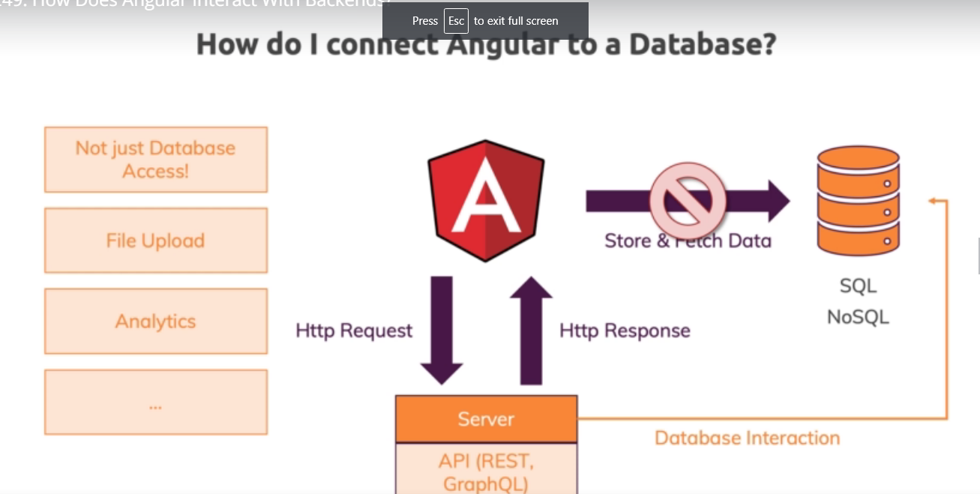

-Well you send H to the p requests and you get HDTV responses to and from a server a server in the end

is defined as an API here.\ That means it is for example a REST API or a graph que el API.

You are communicating with and in discourse will use a REST API which is the most common form of API.

-You work with now such a API in the end is almost like a normal Web site.

But when you wizards it's you or else you're not getting back HTML. But you're getting back data

mostly the Jason format and if you want to learn more about the rest api is in general you'll also find

some helpful resources related to that.

-**like node J S or PSP instead but you can communicate with these API APIs with angular and on that server you then can have code that does interact with a database to store and fetch data and of course there are more reasons for communicating with a server than for storing or fetching data.**

**It's not just about database access you could be uploading files or you could be sending some analytics to a back end or any other reason for why you might need to talk to some back end server.**

Now in this module we will not write such a back end from scratch since this is way beyond the scope

of the course and totally not angular job **but I will show you how to use a free dummy backend which**

**could of course be replaced by any real back and you have queue send requests to use responses and so**

**on.**

The Anatomy of HTTP requests

Concept-

- HTTP request is made up of a couple of core parts which will all have a look at in this module

here when it comes to configuring them when sending a request.

-The most important part about a request of course is the URL you are sending the request to. That's also called the API endpoint and it is something like your domain dot com slash post slash one



However when communicating with a RESTful API it's not just about the are L but also about the.

http Verb using something like post get put this defines which kind of request you want to

send.



-To that end point do you want to store in your data. Do you want to fetch data. Do you want to replace existing data.

HTTP work makes that clear but it always depends on the API you're working with which end points and

which VERBS for d end points are available.



-Now when we're sending a request it's nice to know where and how to send it to that place but you often also need to set additional metadata the so-called headers of a request.

-Now these are kind of optional or to be precise some default headers will be appended to a request for

you by the browser and by angular but you can also append your own headers and data stay for all thesomething we'll have a look at.

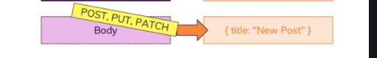

-FOR SOME HTTP VERBS You can also add a body to your request. That's the core data that is attached to a request.

-For example if you're sending a post request to create a new piece of data on the server well then of

course you should attached the information about that piece of data to your request and you would do

that in the request body.

-Therefore our request body can be set on post put and patch requests which are requests that do alter

data on the server by adding or replacing it.

Backend FIREBASE setup

firebase. Sounds like it's a database only.

Instead it's a whole back end solution which gives us a REST API as well.

And it's a perfect solution for this course in this module because it's free to get started with and

we can send requests there we can send different types of request we can easily see the changes we make through these requests and we can store data there and therefore it's perfect.

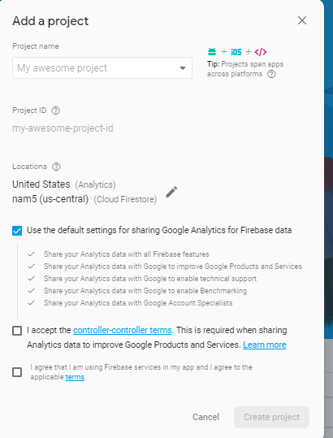

firebase dot com and there simply click on Add project. Now give that project any name you want.

And you can leave the other default settings and then check both checkmarks here.

Now this will create a new firebase project for you.

-Now once it's loaded you'll see an interface that looks something like this and here we'll go to database.

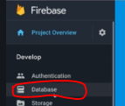

It's not an alternative to mongo TB or anything like that.

It's more than a database.

It's a complete back and service.

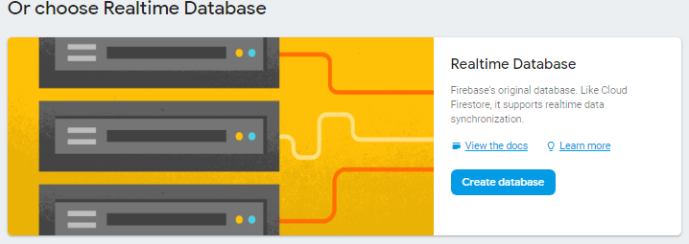

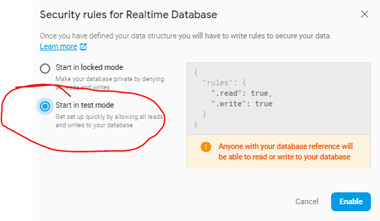to this url we can send request now

https://testpro-2a35d.firebaseio.com/



Sending a post Request

Concept-

Scenario-

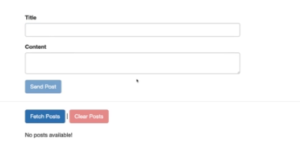A template driven forum

where we can enter a title content and then send that post here . and assemble block to store it on a firebase.

-And later we all want to add logic to fetch all posts that we stored on Firebase and to clear all posts there.

-But for now let's say go with creating a new post for that if we have a look at our code.

-You only have the app component and there in the app component t s file you have on create post which

will actually get some post data in this format.

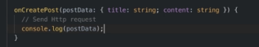

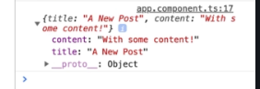this the goal now of course is to not just log that here

but to instead send an HDTV request and

for dead.

We need anglers help  We need to unlock a new feature so to say in the app module we have to add a new core Angular module or a new module baked into the angular framework.

  
So that package name is at angular , Now you add that edge to be client module here in your imports array just like that. This now unlocks the client angular offers in your whole project and with that we can now start sending

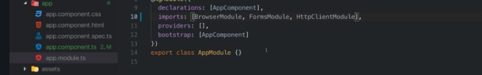



So make sure to add this import at the top of your path. Now whether it imported we can use it to send HDP requests.

-Now let's say here in on create post once we got that post data we want to send it to Firebase for it

is we can use that injected the PS service and there you have a couple of methods.

These methods are mostly named like http verbs

-o you have get you have to lead you have posed and that will allow you to send different kinds of requests. Now here since I want to store data I'll start with a post request.

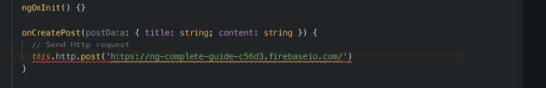

-The first argument is the url you want to send this request to and that is the URL you can

find in your firebase real time database.

This URL or at least this URL is a part of your l will send the request to so paste that in here

but this is not the entire u r l.

-Now on a custom or on different the rest api you were communicating with you would have clearly defined

endpoints like Slash posts ad or something like this to what you have to send your request NATO official

box off the API you're working with what tell you which API endpoint you sent the request to for via

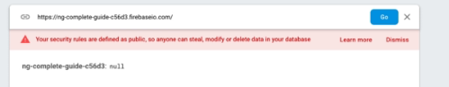

base it's a bit differently you have this starting point you are L here and then you can add your own

segments after THAT and this will get replicated as folders in this database.

So to say and this looks like your directly talking to the database.

**You are still communicating with a rest api provided by firebase.**

**They just translate your path you're sending it to to a folder structure in your database.**

**You're not communicating directly with the database here and I'm stressing this because it is important\ to keep in mind that you never communicate directly with a database from inside your angular app.**

And important for firebase you need to add dot Jason. This simply is a firebase requirement.

It's not a angular requirement not a rest api requirement. Only a requirement byte at Firebase rest api.

This now allows us to send a post request to that you are L now.

Since it's a post request it doesn't work just like this however a post request also needs a request

body. Now this post method here works such that it takes more than one argument

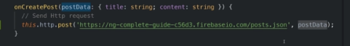

**-**The second **argument being the request body so we** pass one additional arguments here and that could be **our post data** so the data we want to store this data now very important.

You normally send Jason data when interacting with a restful API and actually that will happen here

as well.

But the angular http the client will take our javascript object here and automatically convert it to Jason

data for us so it will still send Jason data and we'll see this in a second when we inspect that request

**-**So in the browser developer tools and the Chrome developer tools go to Network tab.

Here you see a bunch of network requests actually. These are all the files that are downloaded as part of your angular application and all the JavaScript files on.

Let's clear that. Let's simply send another post and we don't see any request here.

**-**Angular heavily uses observable as you already learn and HDP requests are also managed via observable because they are a perfect scenario or a use case for observable. We can wrap them and we can. Denzel gripe to them to get informed about the response and to handle errors and so on.

**-So to say if you're not subscribing to that prepared HTTP request you could say so too that observable that wraps your http request if you're not subscribing to it then angular and rsjx it know that no one's interested in their response and therefore the request doesn't even get sent because if no one's interested in the response then it won't send their request so post indeed will return and observable**

**-**It gives us an observable. That wraps your request and to get access to the response you have to call.

Subscribe here and this will then be your response date actually because angular date should be client.

I should say we'll do even more than just giving you the response it will automatically extract the

data attached to the response.

So the response body and give you that though you also have ways of accessing the full response as you

will learn later.

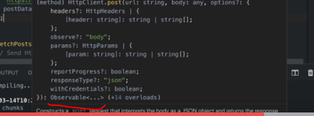

And there we all to see that request now. We actually see two requests even two requests to the post end point. Now that's just a characteristic of browsers when sending post requests so not to slash posts but of

type posts. Then they always send two requests.

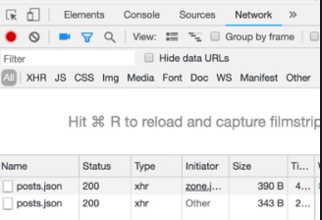

The first one if you click on that is of type options.

That's a different HTTP work that will first of all check Weber to post request is allowed to be sent.

And if that gets a success response it will send the actual request which is this one.

And there you see that was off type post.

This was the year url sent it to.

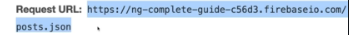

and here in the request payload.

You also see that Jason data that was attached for you.

You can also of course see the response here which is the response we locked to the console.

So this is how we send HTTP requests.

And besides the general syntax the core takeaway is that requests are only sent when you subscribe.



Using a service for http Request

Concept-

Scenario-

Drawbak-

But in bigger applications and maybe even in this one we already have a quite big component with a lot of code that is only indirectly related to the user interface. Of course we want to send the request when a button is clicked then we want to display that response data.

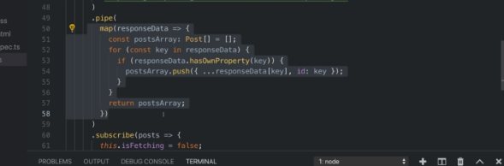

-But for example transforming the result transforming the data we can do it here.

It's not inherently bad but it is a nice practice to outsource that into services so that services are

departs and your angular application that do the heavy lifting the dirty work and your components are

relatively lean as lean as they can be and are mostly concerned with template related work.

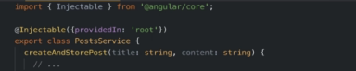

-can use at injectable

-what's my idea behind that service in this service I want to have

my age to p request methods so the methods that do the HDP requests and I only want to get the responses

or the message whenever we're done with the request in my front end.

-So therefore in this service I will add a new method create and store post you can of course name as whoever you want it there. I expect to get a title which is a string and the content which is a string as an argument let's say. And here

I want to send my HDP request.

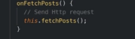

I also want to send a request.

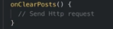

However for this to work we need to inject the HDP service into this postal service.

So let's add a constructor and with the help of that constructor we inject the h to be client and we

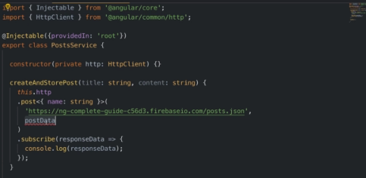

Now that's supposed data we're sending and now we can call create and store post to send that request.

So back in the app component I now only to inject my own postal service private post service like this

and make sure to add that import pop here at the top.

You need to import postal service from there.

And now in on create post I simply called this post service.

Create and store post I get an error here because I need to pass some data to that method.

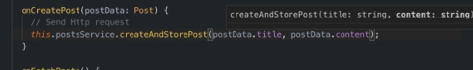

Problem-

However what you will see of course is that now we have no posts available because whilst we're running

that code in the service and indeed you can see that if I click fetch posts I H to the repeated request

is sent and we are fetching the posts while it's all of that is happening.

We're not seeing the posts here because we lost the connection between the data we fetched in the service

and our template.

Let's fix that.

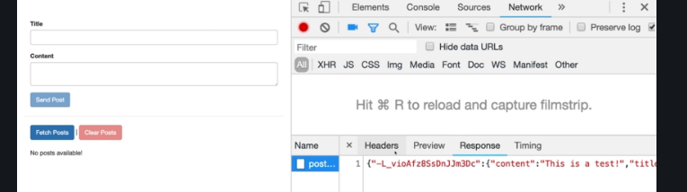

Services and components working together

Concept-Moving the services seperetly into a service.

Scenario-You don’t need to subscribe it o the service,you subscribe in the component level

-Now to fix that we have two possible ways of doing that.

The first alternative is that we use a subject in the postal service where we next our posts where we

got them and we subscribe to that subject in the app component.

And this would be a fine pattern.

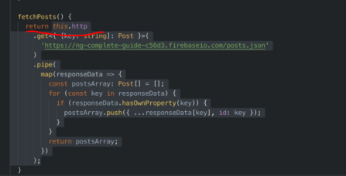So here where I call fetch posts I can now subscribe again and I get my posts.

And now here we can set.

This is fetching two falls and I want to set.

This is fetching to true here right before I start sending that request and even more importantly we

can set this loaded post equal to the posts we get back.

-The alternative and maybe a bit more suited here because the subject would be perfect if we have multiple

components interested in the posts. That's not the case here. So a simpler end for this scenario a better solution would be to simply return the result of our get

method and off the pipe method thereafter. And that would be our observable.

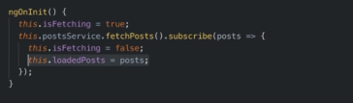

So I don't want to subscribe here.

Instead I only returned the prepared observable here in fetch posts and therefore right now no H to

the p request gets sent because as you learned requests are only sent when someone is interested.

So here I'm not subscribing but now that I returned this year I can and I have to subscribe in the app

component.

This is not a code snippet I can all the copy to on fetch posts.

And yes you could of course also outsourced is into a separate private method again to avoid this code

duplication here if you want to.

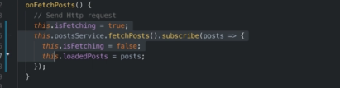

So now we moved the result handling so to say into the component.

**But the more heavy lifting the part detached from the template and from the UI which is the sending of the request and the transformation of the data that now lifts in the service**

**And this is a best practice when working with angular and H to BP requests move.**

**The part that is related to your template which in my case here is managing the loading status and managing**

**the load of data move Dad into the component and be informed about the result of your age to DP request by subscribing into component but moved the rest into the service and simply returned the observable there so that you set up everything in the service but you can subscribe and the component now of course**

Sending a Delete Request

Concept-

Scenario-Deleting posts at the backend

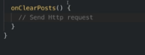

sure that whenever it is on clear posts method runs which will happen when we click that clear posts

button up there that whenever this method runs that you send a request that deletes all the posts on

the back end.

-Now let's keep the structure off sending the requests in the postal service.

So in there I will add a new method which I'll name delete post.

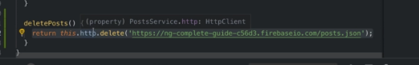

Of course you can name it also clear post or whatever you want.

Now in there I will use the HDP client because that is our central client for all HBP requests.

You want to send from inside our angular app and there we can now use the delete method which will send.

Well DELETE request now this method requires a you are L2 which it should send the request in is.

I want to clear all posts.

I will grab this year L which targets the overall posts snowed and send my request there so that all

the posts there get deleted now if I want to be informed about that deletion process in the component

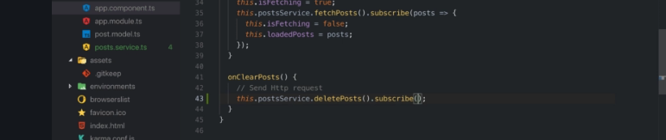

the app component in all clear posts I can reach out to the postal

service and call delete posts. And since this returns and observable we now have to subscribe here.

I know that this function here will only run if it succeeded and therefore here I will then simply just

set this loaded post equal to an empty array again to reset it and with these changes to the service

and to the component.

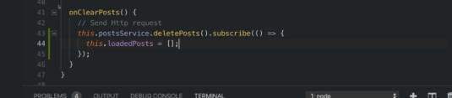

Problem-So with that we had a thorough look at different kinds of requests we can send.

Now what if something goes wrong.

Handling Errors

Concept-

Scenario-

Chances of failing a request

but of course when interacting with servers things can go wrong.

You might not have a internet connection or you're sending a request with incorrect data.

Some hold because you have a bog in your program or whatever it is or your server fails.

Maybe it's off line or there's an error on the server or you're not authenticated.

There are dozens of things that can go wrong and we can simulate such a thing that can go wrong by going

Seeing in fire base

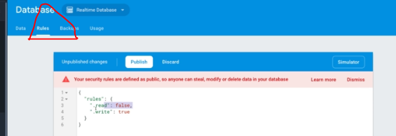

to Firebase and they're in the database. Let's go to rules and remember that when we created that database we enabled test mode which essentially

means dead. Read and write access to this database is granted to everyone.

You don't need to authenticate yourself. Now we will add authentication in the authentication module later in the course and they offer. For now we open this up to everyone.

Now if y locked us down those if I say you're not allowed to read for example you can still write but

you're not allowed to read.

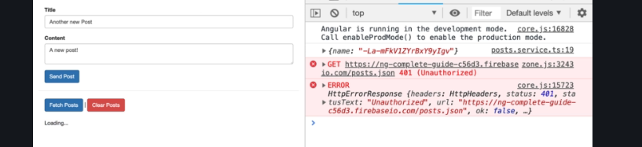

So if I locked this down what happens is that if I now try to fetch posts here you see we get an error

and that of course happens.

Errors occur but it is important how we react to that error for now.

For example here we stay in this loading state and that is not a great user experience because now we

as a user have no idea that there was an error and that something failed.

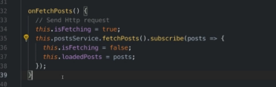

Therefore a proper error handling matters.

Now how can we handle errors.

There are different ways of doing that.

Let me demonstrate the first possible way here on fetch post fails because well we have an error.

Now as you learned in the observable section you can pass more arguments to subscribe.

And the second argument is a function that triggers whenever an error is thrown in there we will get

the error object as an argument.

And now here we can do something to handle that error to do something to provide a better user interface

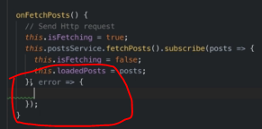

rror and set this to null initially. So we have no error. Initially if this is not now.

So if we do have an error and we'll add logic to change that soon I want to add a div here with the

classes alert and alert danger which are bootstrap classes where I simply have let's say age 1 tag an

error or occurred and below that I want to output error because error in my case and this application

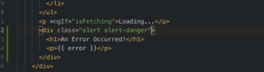

Now the idea is that this year this diff is only shown if we have an error so if error is true ish which

it is not if it is null initially it's null and efforts treat that as a false value and therefore initially

dis will not show up but as soon as we set this to some string it becomes true ish.

And then this will show up.

This also means that I only want to show loading if we are fetching and we're not having an error because

if we have an error I never want to show loading.

I want to show my alert your now.

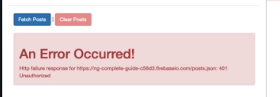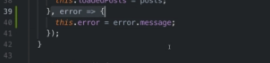  
 by default error objects have a message.

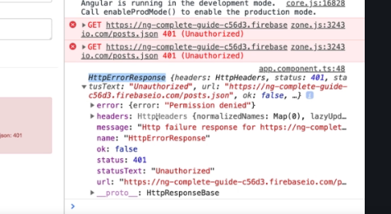

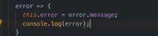

You can dive into that in more details and if you for example need more information from the error response. Well let's have a look at the error or we got here. Let me save that.

Now if a fetch posts this is getting locked and you see when I log here is indeed a full error response

object. Now there you see that message.

your own API might not be sending this or might be sending different data so it's always important to

understand which API you're working with and what this API sends back.

In the case of a success message or in the case of an error if you'd need more information about the

arrow though and not just a generic message then you can dive into that error object you're getting

which is that object were logging here and there you see you can also get information about the headers

you can get the exact status code that was thrown which can be very helpful in showing a more useful

message and so on.

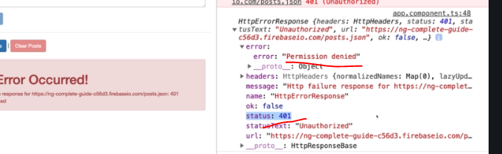

Using subjects for error handling

Concept-

Scenario-

-This our way of handling errors could be interesting in cases like when you send a request and don't subscribe to it in your component.

-It's easy for us to react to an error in the component here. If we do return you observable and we subscribe and you component because then we can past this second argument to subscribe which is this error handling function.

-But what about creating a post there. I subscribe in the service.Now obviously you could just return the observable there too and simply subscribe in the component instead.

And that would not be wrong but you can of course also implement a different pattern of handling that error.

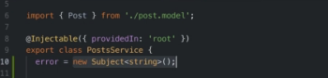

-You could use a subject and that is especially useful if you have multiple places in the application

that might be interested in your error.

So for example here you could have your error or property which is a new subject and subject needs to

be imported from our access and the dead will let's say eventually give us a string that error message.

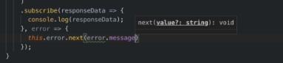

And the idea then simply is that here where we subscribe where we get that error we now use that subject.

So this error we call next and we pass on error message.

And now do the remaining steps that we subscribe to that subject in all the places we're interested

in that error message.

So here in this example we would subscribe and enjoin in it for example like this and whenever we get

our error message here we could set this error equal to the error message.

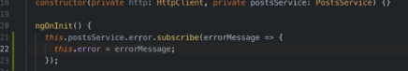

If you get rid of this component so I'll add a new property error sub which is a subscription and therefore

we need to import subscription from our ex J.S. like this and now we can store our subscription in that

property

here in engine in it.

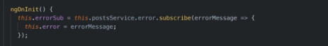

And now we just need to add on the straw here this interface and import that from at angular core as

well and add NGO and destroy they are for maybe here at the end of the component and there we now just want to unsubscribe. So this error is sub unsubscribe.

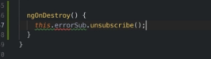

Using catch error operators

Concept-Generally catch error responses we will get the same data that we will get in subscribe.

If there is some requirement

->sent it to analytics,log the information some where.

->Thowerror yields a new observable by wrapping error.

-throwerror yields a new observable by wrapping error.

Scenario-

Error handling and UX

Concept-

Scenario-lets think we will display an error,and we will click okay to close it.Which is not preferable.

So we have to reset this fetching property.when we got error we are not going to fetch again.

Setting Headers

Concept-

Scenario-lets think if you want to set an authorization it look for authorization header.

-any http request method has a extra large argument.

-Header takes header object

Adding Query Parameters

Concept-directly in url if you want to use params link print:pretty etc.

This you can do directly by adding into url,but that is not recommended.

We use like set(‘print’,’pretty’)

Observing different types of responses

Concept-

-sometimes you need the complete body,for example to get error code

-extra parmeter obseve which will parse as js object ->body

-observe->response(you will get the full (response)

-to every status code

-with observe you can change the data that you get back

We will have

observe->’events’

changing the response body type

concept-

responsetype-you can configure the response type even,basically the response type is json

-responsetype:’text’ or ‘blob for files’

.

Introducing inteceptors

Inteceptors

-if you want to hqve header for all the requests

Let think you want to authenticate,and you want the same header,then you can add intecetors.

-Create the service Auth-inteceptor.service

-impliments HTTPInterceptor

-have intercept method(two arguments)

First-httprequest

Sec –(next)-function will forward the request

Manipulating request objects

Concept-modify the request object

-create a new one with clone

Req.clone(add new url,new header

U change the request and send the modified request.

Response interceptors

-interact with response

-can be done by using handle.you could add map to change the response.

-ou can get events

Multiple interceptor

Logging interceptor